


United Nations Development Programme
Country: South Africa
PROJECT DOCUMENT

Project Title: South Africa Wind Energy Project (SAWEP) - Phase II

UNDAF Outcome(s): Strategic Cooperation Framework SCF 2013-2017): The transition to a ‘green economy is accelerated through policies that promote the creation of green jobs, increased energy production from renewable sources, greater energy efficiency and increased reliance on low carbon development.

UNDP Strategic Plan Environment and Sustainable Development Primary Outcome: Outcome 1 - Growth and development are inclusive and sustainable, incorporating productive capacities that create employment and livelihoods for the poor and excluded.

UNDP Strategic Plan Secondary Outcome: Output 1.5 - Inclusive and sustainable solutions adopted to achieve increased energy efficiency and universal modern energy access (especially off-grid sources of renewable energy).

Indicator 1.5.1 Number of new development partnerships with funding for improved energy efficiency and/or sustainable energy solutions targeting underserved communities/groups and women.

Indicator 1.5.2 Extent of change in: a) energy efficiency, and/or b) modern energy coverage by users and specific sectors

Expected CP Outcome(s): Stabilisation and reduction of carbon emissions and climate change mitigation and adaptation strategies fully operational. By 2016, the governance systems, use of technologies and practices and financing mechanisms that promote environmental, energy and climate adaptation have been mainstreamed into national development plans.

Expected CPAP Output(s):
- Design of scaling-up programmes for energy technologies and financing options for PPPs
- Design and implementation of capacity development programmes/integrated energy policy
- Implementation of scaling-up technologies

Project Components: 1: Optimisation and improvement of local content targets in wind energy procurement mechanisms; 2: Resource-mapping and wind corridor development support for policy-makers; 3: Support for the development of small-scale wind sector; 4: Training and human capital development for the wind energy sector.

Executing Entity/Implementing Partner: Department of Energy (DoE)

Following the promulgation of regulations governing the creation of new generation capacity in 2011, the Government of South Africa initiated a large-scale procurement programme for grid-connected renewable energy power generation. Known as the RE Independent Power Producer Programme (REIPPPP), the Programme has resulted in the procurement of 3,916 MW of new RE capacity, of which 1,983 MW was based on wind energy. However, as the country progresses towards the procurement of a cumulative total wind energy power generation capacity of 3,320 MW by 2018/19, a number of imperatives require attention. These are: (i) assessment of performance in relation to local content requirements; (ii) extension of the wind resource map that was developed with support from a previous phase of the South Africa Wind Energy Project (SAWEP); (iii) development of the small-scale wind sector, and, (iv) training and human-capital development in support of wind farm operations, and the implementation of an envisaged Wind Energy Localisation Roadmap. SAWEP II proposes to respond to these imperatives by supporting such initiatives as: (i) the development of a Monitoring and Verification (M&V) system for capacity-building in localisation; (ii) acquisition of wind masts and supporting the analysis of the resulting wind resource data; (iii) support for a small-scale pilot wind project, and, (iv) jointly with the South African RE Technology Centre (SARETEC) and participating Technical and Vocational Education and Training (TVET) colleges, extending the implementation of training programmes focusing on wind farm operations and nascent local value-chains. This would include the acquisition of selected training equipment and kits for SARETEC and participating TVET colleges.

Program Period: 2013-2017  Atlas Award ID: 00090545  Project ID: 00096249  PIMS # 5256  Start date: Aug 2015  End Date: Aug 2019  Management Arrangements: NIM  PAC Meeting Date: July 29, 2015 |  | Total resources required (total project fund)  Total allocated resources (UNDP managed funds)  - UNDP TRAC  - GEF  Other (partner managed sources)  Government | 39,222,186  200,000  3,554,250  35,467,936
  - DOE
  - DOT&I
  - DoHE&T
  - DoEA
  - DoS&T
  - GIZ
  - DANIDA
  - SAWEA
  - Adventure Power
  2,229,814
  100,332
  9,316,770
  120,142
  621,118
  13,910,000
  2,160,000
  1,508,429
  5,501,331

Agreed by (Government):
Date/Month/Year

Agreed by (Executing Entity/Implementing Partner):
Date/Month/Year

Agreed by (UNDP):
Date/Month/Year

TABLE OF CONTENTS
1. Situation analysis 8
1.1. Context and Global Significance: Environmental, Policy and Institutional 8
1.2. Barrier Analysis 15
1.3. De-risking Renewable Energy Investment (DREI) Analysis 18
1.4. Stakeholders 20
1.5. Baseline analysis 29
1.6. Coordination with Other Initiatives 31
2. Strategy 32
2.1. Project Rationale 32
2.2. Country Ownership: Country Eligibility and Buy-in 34
2.3. Design Principles and Strategic Considerations 36
2.4. Project Objective, Outcomes and Outputs 38
2.5. Key Indicators, Risks and Assumptions 48
2.5.1. Impact Monitoring 48
2.5.2. Risks 50
2.6. Incremental reasoning: Expected Global, National and Local Benefits 53
2.7. Cost-Effectiveness 58
2.8. Sustainability 59
2.9. Replicability 59
3. Project Results Framework 61
3.1. Project objectives, indicators, risks and assumptions 61
3.2. Total Budget and Work Plan 66
3.3. Consultants to be hired for the project 70
4. Management Arrangements 72
4.1. General management of the project 72
5. Monitoring Framework and Evaluation 75
5.1. M&E Workplan and Budget 79
6. Legal Context 80
Annex 1: Letters of Co-Financing Commitment and Cooperation 81
Annex 2: CCM Tracking 102
Annex 3: De-Risking Energy Investment (DREI) Analysis 103
Annex 4: Terms of Reference for Key Project Staff 110
Annex 5: Project Implementation Schedule 113
Annex 6: Comments from SAWEA Workshop (29 May 2014, Cape Town) 116
Annex 7: Greenhouse Gas Emissions Reduction Analysis 119
Annex 8: UNDP Environmental and Social Safeguards 123

ACRONYMS

ABP | Annual Budget Plan
AMEU | Association of Municipal Electricity Utilities
AWP | Annual Work Plan
BoP | Balance of Plant
BUR | Biennial Update Report
CCGT | Closed-cycle gas turbine
CCM M&E | Climate Change Management Monitoring and Evaluation
CCMTT | Climate Change Mitigation Tracking Tool
CEF Group | Central Energy Fund Group
CPD | Country Partnership Document
CPUT | Cape Peninsula University of Technology
CSDP | Competitive Supplier Development Programme
CSIR | Council for Scientific and Industrial Research
DANIDA | Danish Development Agency
DEA | Department of Environmental Affairs
DERO | Desired Emissions Reduction Outcomes
DHET | Department of Higher Education and Training
DOE | Department of Energy
DPE | Department of Public Enterprises
DST | Department of Science and Technology
DTI | Department of Trade and Industry
DTU | Technical University of Denmark
ED | Enterprise Development
EDD | Economic Development Department
EIA | Environmental Impact Assessment
ER | Emissions Reduction
FDI | Foreign Direct Investment
FET | Further Education and Training
GEF | Global Environment Facility
GHG | Greenhouse Gas
GoSA | Government of South Africa
HRDCSA | Human Resources Development Council of South Africa
IDZ | Industrial Development Zone
IEC | International Electrotechnical Commission
IEP | Integrated Energy Plan
ILAC | International Laboratory Accreditation Cooperation
IPAP | Industrial Policy Action Plan
INEP | Integrated National Energy Programme
IRENA | International Renewable Energy Agency
IRP | Integrated Resource Plan
ISMO | Independent System and Market Operator
LED | Local Economic Development
LTMS | Long-term Mitigation Scenarios
MD | Ministerial Determination
MRA | Mutual Recognition Agreement
MW | Megawatt (= million watt)
MYPD | Multi-Year Price Determination
NAD | National Artisan Development
NC(V) | National Certificate (Vocational)
NDP | National Development Plan
NEDLAC | National Economic Development and Labour Council
NERSA | National Energy Regulator of South Africa
NGP | New Growth Path
NMMM | Nelson Mandela Metropolitan Municipality
NSDS | National Skills Development Strategy
NSF | National Skills Fund
OEM | Original Equipment Manufacturer
O&M | Operations and Maintenance
PEC | Port Elizabeth College
PIF | GEF Project Identification Form
PMO | Project Management Office
PPR | Project Progress Report
PSDF | Provincial Skills Development Forum
REDZ | Renewable Energy Development Zone
REIPPPP | Renewable Energy Independent Power Producer Programme
REPG | Renewable Energy Power Generation
RfP | Request for Proposals
SABS | South African Bureau of Standards
SAGEN | South Africa-German Energy Programme
SALGA | South African Local Government Association
SANAS | South African National Accreditation System
SANBI | South African National Biodiversity Institute
SANEDI | South African National Energy Development Institute
SAREC | South African Renewable Energy Council
SARETEC | South African Renewable Energy Technology Centre
SAWEA | South African Wind Energy Association
SAWEP | South African Wind Energy Programme
SAWS | South African Weather Service
SDGJ | Skills Development for Green Jobs
SEA | Strategic Environmental Assessment
SETA | Sector Education and Training Authority
SIP | Strategic Infrastructure Projects
TAC | Technical Advisory Committee
TLIU | Technology Localisation Implementation Unit
TNC | Third National Communication
TVET | Technical and Vocational Education and Training
UCT | University of Cape Town
UNDP | United Nations Development Programme
UNEP | United Nations Environment Programme
UNIDO | United Nations Industrial Development Organisation
US | University of Stellenbosch
WASA | Wind Atlas for South Africa

Situation analysis

Context and Global Significance: Environmental, Policy and Institutional

- Primary energy consumption in South Africa has historically been dominated by coal, as illustrated in Figure 1. Eskom, South Africa’s national electricity utility, is currently building two coal-fired power stations – Medupi and Kusile – which are rated at 4,764 MW and 4,800 MW, respectively. At the same time, the utility is building a pumped-storage power plant – Ingula – that will provide 1,332 MW of peak capacity.

Figure 1: Total Primary Energy Consumption in South Africa - 2012
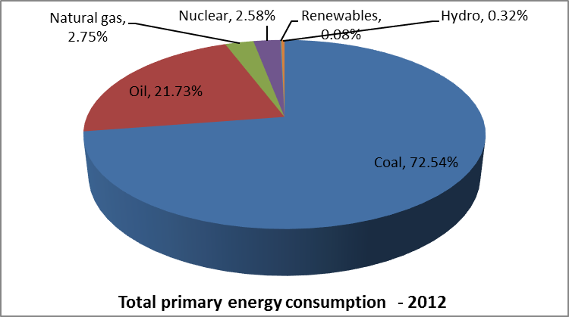

- The energy mix is reflected in the nation’s greenhouse gas (GHG) emissions profile: the energy sector is the largest contributor in the period 2000-2010. According to a Department of Environmental Affairs (DEA) report on GHG emissions during this period, the energy sector accounted for approximately 85 percent of total GHG emissions in 2010. Within the energy sector, electricity generation was the largest contributor, accounting for 60.4 percent of the sector’s cumulative GHG emissions in the period 2000-2010. This is illustrated in Figure 2. With respect to CO₂ alone, the DEA report states the energy sector accounted for 88.9 percent of the emissions in the period 2000-2010.

Figure 2: Share of GHG emissions - energy sector (2000 - 2010)
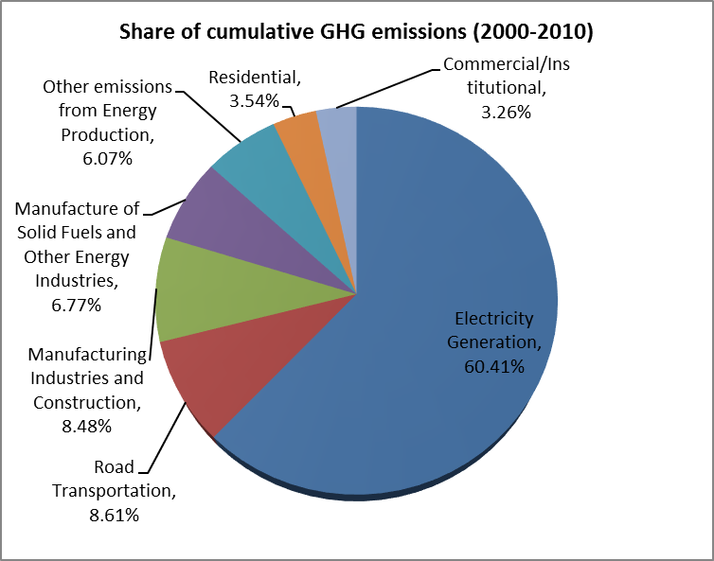

- In 2014, the Government announced its intention to add more nuclear and coal capacity for base-load supply. The nuclear capacity projected in the Integrated Resource Plan (IRP) of 2011 – amounting to 9,600 MW – will be used as a reference for planning purposes. The new coal generation capacity, capped at a maximum of 2,500 MW, is expected to be procured by means of a multi-phase bidding window system. The primary reason for these initiatives is to close a demand-supply imbalance that first manifested itself with black-outs in the Western Cape in 2006, before spreading to the rest of country, reaching their peak in 2008.

With respect to renewable energy power generation (REPG), the projection in the IRP is that, by 2030, renewable energy technologies are expected to provide capacity in the following manner: solar PV (8,400 MW), Concentrated Solar Power (1,200 MW) and wind (9,200 MW). The total projected capacity by 2030 of 89,532 MW implies that REPG will account for 21 percent of South Africa’s energy mix, with accounting for 10 percent. In terms of South Africa’s Electricity Act, the Minister of Energy determines the short-term measures to be taken in order to meet the aforementioned long-term IRP targets, by means of regulatory instruments known as Ministerial Determinations.

With respect to wind energy, the Ministerial Determination that was promulgated in 2011 specified 1,850 MW as the capacity to be procured by 2016. This was followed by a Ministerial Determination in 2012 that specified the procurement of a further 1,470 MW of wind generation capacity by 2020. This combined allocation of 3,320 MW informs the main objective of the second phase of the South African Wind Energy Project (SAWEP II), which is to support progress towards the target of 3,320MW of wind generation capacity by 2018/19.

- In the process of translating the IRP into an implementation programme, and realising the targets specified in the 2011 and 2012 Ministerial Determinations, the Government of South Africa commenced in 2011 with the large-scale introduction of solar and wind power, in the form of a public-private partnership (PPP) process known as the RE Independent Power Producer Procurement Programme (REIPPPP). As of November 2013, after three Bidding Windows of the REIPPPP, 3,916 MW of renewable power generation capacity had been selected or contracted, with wind power making up 1,983 MW (or 51 percent) of this total.

- The multi-phase bidding process has been characterised by progressive reductions in the prices offered by RE independent power producers (IPPs), as well as increases in local content and levels of employment in the RE sector. The salient trends, pertaining to the wind component of the REIPPPP, are illustrated in Table 1.

Table 1: Salient trends of REIPPPP - Wind Power
 | Bidding Window 1  (Aug 2011 – Nov 2012) | Bidding Window 2  (Aug 2012 – May 2013) | Bidding Window 3  (Aug 2013 – Dec 2014)
Average prices (US c/kWh) | 14.25 | 11.34 | 7.05
Investment (USD billion) | 1.66 | 1.37 | 1.62
Average local content (%) | 27.4 | 48.1 | 46.9
Number of jobs - construction | 1,810 | 1,784 | 2,612
Number of jobs - O&M | 2,461 | 2,238 | 8,506

- Despite these positive developments, the trajectory towards the 2030 IRP targets that were promulgated in 2011 is not straightforward, and challenges remain. For instance, linked to a slow GDP growth rate, electricity consumption has fallen below the projections that were used in developing the IRP in 2011. This was illustrated in a 2013 review of the IRP, which is reproduced below as Figure 3.

Figure 3: Comparison of projected and actual electricity demand - IRP
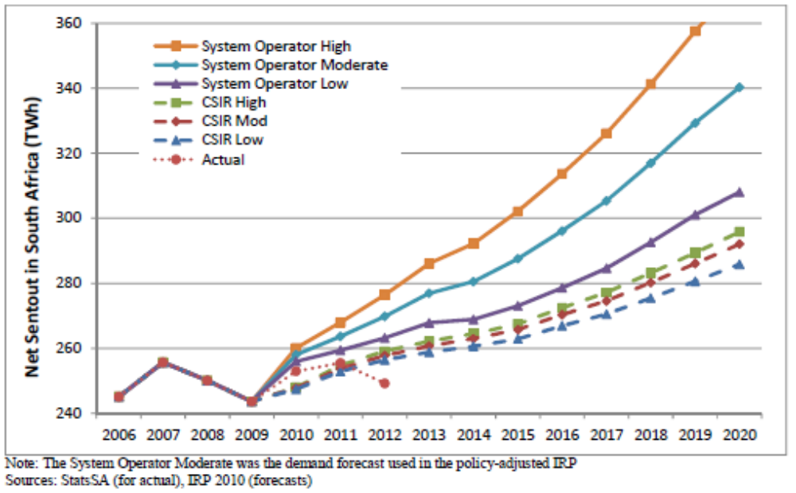

- One of the key implications of the lower-than-forecast demand considered in the review of the IRP is that some of the generation capacity additions planned for the long-term may have to be postponed. Another implication is the possibility of a reduction in the allocation for wind capacity by 2030, to 4,360 MW. Concerns about demand certainty also explain projected increases in the allocation of closed-cycle gas turbine (CCGT), solar PV and CSP, as these technology options offer a greater degree of modularity, relatively shorter project delivery times and thus more flexibility to respond to demand fluctuations. This means that the continuation of the successes that were realised in the initial stages of the REIPPPP, as summarised in Table 1, cannot be taken for granted. The importance of ensuring that momentum is not lost cannot be over-emphasised. SAWEP II stands to play a crucial role in maintaining this momentum.

- A more recent development is the possibility of the large-scale introduction of natural gas into the South African economy, including for power generation. This is due to the potential exploitation of shale gas in the Karoo region of South Africa, the technically-recoverable reserves of which have been estimated to be 390 tcf.

- Depending on the extent to which shale gas is developed, it has the potential to either allow for more RE capacity – including wind power – or less. This is because the introduction of closed-cycle gas turbines (CCGTs) could facilitate more wind generation, by providing the stand-by capacity required to respond to effects of intermittency. Alternatively, the introduction of shale gas might reduce electricity prices to a point where wind power generation becomes uncompetitive, thereby losing its share of South Africa’s future energy mix. Either way, it will be crucial for the wind energy industry to participate meaningfully in strategic discussions with policy-makers, especially regarding investments that have been made in wind farms and segments of the value-chain. Having information on the impacts of the REIPPPP – for instance, with respect to renewable energy production, localisation and socio-economic development – is a critical requirement in this regard, noting the Government of South Africa’s drive to increase employment levels through the development of green economy. SAWEP II stands to contribute towards this process as well, by enhancing the capability to systematically monitor and evaluate the implementation of localisation and socio-economic development commitments related to REIPPPP wind projects.

- The distributed nature of the newly-introduced RE capacity has also resulted in the requirement to strengthen the transmission system. The Northern Cape and Eastern Cape, which have traditionally only been load-centres, have now also become injection points from which power must be evacuated. The Wind Atlas that was developed with the support of the first phase of SAWEP assisted Eskom – in conjunction with the Department of Environmental Affairs (DEA), the South African National Biodiversity Institute (SANBI) and the Council for Scientific and Industrial Research (CSIR) – in the development of new transmission corridors that reflect the effects of siting wind farms in areas traditionally considered as load-centres only. These transmission corridors, which are illustrated in Figure 4, are used in planning transmission capacity increases. The designation of such corridors recognises the fact that constraints on the capacity to evacuate power from solar parks and wind farms, if not addressed adequately and in a timely manner, will hamper the further development of grid-connected REPG, including wind power generation.

Figure 4: Transmission corridors
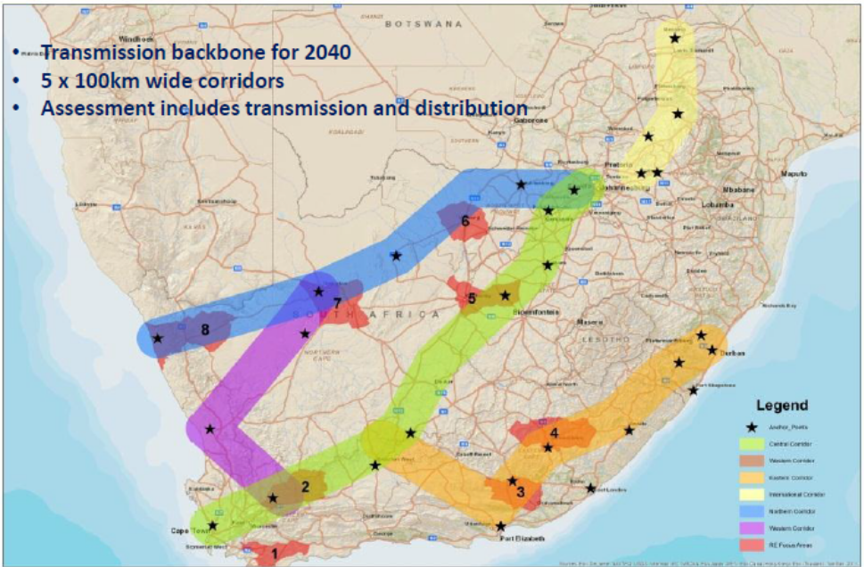

- Given the high national unemployment rate, the Government has sought to position the REIPPPP – in the same manner as other infrastructure development initiatives – as a catalyst for economic and industrial development. So, in addition to facilitating growth by providing the assurance of energy security for other productive sectors of the economy, the RE IPP sector is also expected to contribute towards employment-creation. Towards this end, targets for local content form part of the REIPPPP bid evaluation process. SAWEP II will enhance the capability to systematically monitor and evaluate the implementation of localisation and socio-economic development commitments related to REIPPPP wind projects. Almost all the major wind turbine components required for Bidding Windows 1 and 2 projects were imported, the exception being wind towers for two international wind energy original equipment manufacturers (OEMs), starting in Bidding Window 2. These were ordered from a manufacturing facility situated at Coega Development Zone, Nelson Mandela Metropolitan Municipality (NMMM), which has a production capacity of 110-150 wind towers per annum.

- An important question that arose during the project preparation phase concerned how the interaction between the creation of local manufacturing capacity, on the one hand, and improvements to energy security, on the other hand, could be optimised. For instance, investors in manufacturing capacity require certainty that the procurement of wind power projects by the Department of Energy (DoE) will result in volumes of components that will be adequate to generate required returns. But, in terms of the Electricity Act, ‘firm’ new wind power generation capacity is capped in the short-term by the Ministerial Determination and REIPPPP evaluation processes – despite the existence of large, long-term IRP capacity allocations. Furthermore, due to network constraints in some areas, the inability to integrate new wind farms into the power grid places an additional cap on the demand for components. While the expedited procurement of new wind power generation projects in the context of the REIPPPP is designed to ease electricity supply constraints, it also has the effect of placing upward pressure on available manufacturing capacity, due to the requirement to supply orders relating to the development of multiple wind farms at the same time. Rapid additions to manufacturing capacity, where possible, may keep up with demand in the short-term. But there is a risk that demand may not be sustained in the long-term, especially where ‘one-off’, low-maintenance components such as wind towers are concerned. The need to develop a thorough understanding of the trade-offs implied by the requirement to balance the core elements of the REIPPPP – namely energy security, socio-economic development and price competition – cannot be over-emphasised.

- As an energy security measure, there is a process to complement centralised grid-based supply with distributed generation. This is, however, dependent for its success on the extent to which such technological options as solar-water heaters, roof-top solar PV and small-scale wind can be reliably harnessed in the process of relieving the effects of electricity supply constraints. While this represents an opportunity for small-scale wind energy, there is a requirement to develop a better understanding of the sub-sector, from the perspective of technological performance, economics and finance, configuration in relation to the grid (i.e. grid-connected, off-grid and hybrid options), as well as regulatory requirements.

- Consideration of these centralised and distributed energy supply options takes place against the backdrop of the country’s commitment to reduce the historically high levels of greenhouse gas (GHG) emissions that have resulted from reliance on coal for electricity generation. Renewable energy power generation (REPG), of which wind power is an important element, as well as a combination of other low-carbon supply-side measures, energy efficiency measures and demand-side management, stand to play a leading mitigating role. However, the effects of the prevailing policy and regulatory environment require constant consideration to ensure progress towards desired outcomes.

- The topical policy and regulatory issues forming the backdrop of the project preparation phase included:

- Review of the IRP – particularly in terms the possibility that the projected capacity allocation for wind power generation capacity would be reduced;
- Development of the Integrated Energy Plan – which seeks to integrate traditionally disparate energy planning processes;
- Planned promulgation of the Strategic Environmental Assessment (SEA) framework – which aims at facilitating the expedited consideration of environmental impact assessment (EIA) applications;
- The potential re-introduction of the Independent System and Market Operator (ISMO) Bill to Parliament. A key objective of the ISMO Bill is the separation of the transmission function from the rest of Eskom’s business, as one of the measures to facilitate the further introduction of IPPs;
- The continuation of the REIPPPP, with the salient issues being the extent to which prices will continue to fall, investor appetite to participate in further bidding processes should investment returns become unattractive, as well as whether there will be increased annual commitments to procure new capacity in terms of Ministerial Determinations (e.g. 1,000 MW/annum of new capacity);
- The development of the Wind Energy Localisation Roadmap, which amongst other outcomes is expected to spell out priority components for localisation, re-define local content requirements, consider interactions between project finance requirements and localisation, as well as provide an outline of the employment-creation potential of local value-chains.

- The key institutions with oversight on the electricity sector, together with their responsibilities, are outlined in Table 2.

Table 2: Institutions with Oversight of the Energy Sector in South Africa
Functions relating to Energy Sector | Institutional Responsibility
Legislative oversight, including processing of new legislation and monitoring implementation of existing legislation | Parliamentary Portfolio Committee on Energy
Develop energy policies, strategies and action plans, legislation and regulations | Department of Energy (DoE)
Approve energy policies and strategies | Cabinet
Implement energy policies, strategies and action plans, legislation and regulations | DoE, Eskom, Central Energy Fund CEF Group, private investors
Regulation of electricity industry in terms of the Electricity Regulation Act | DoE, National Energy Regulator of South Africa NERSA
Transmission and distribution of electricity | Eskom and municipalities (latter only distribution)
Production of electricity | Eskom/IPPs/Co-generation
Ownership of Eskom on behalf of the state | Department of Public Enterprises (DPE)
Develop industrial policies, strategies and action plans, legislation and regulations | Department of Trade and Industry (DTI)
Develop economic development policies, strategies, and action plans, legislation and regulations | Economic Development Department (EDD)
Oversight on IPP-related transactions concluded on private-public partnership basis, as well as financial backing to Eskom | National Treasury (NT)
Coordination of policy among government, organized business, organized labour and civil society | National Economic Development and Labour Council (NEDLAC)

Barrier Analysis

- While the REIPPP has resulted in rapid growth of the South African RE power generation sector, it has also highlighted a number of barriers that require attention if the wind energy sector is to advance further. The most salient of these barriers include local content requirements, inadequate supportive environmental permitting and transmission grid planning processes, lack of capacity in the small-scale wind energy sector, and skills shortages. These are outlined below.

- Barrier 1: Challenges in the definition of, and progress towards, local content targets: The DTI has set local content requirements to be met by REIPPPP bidders. As illustrated in Figure 5, and focusing on wind energy, the local content requirements in the first Bidding Window were a minimum threshold of 25% and a target of 45%. For the second Bidding Window, the minimum threshold remained unchanged while the target was increased to 60%. Both measures were increased in the third Bidding Window, to 40% and 65% respectively. In response, the average local content levels that were achieved by preferred bidders in the wind energy sector in the three Bidding Windows were 27.4%, 48.1% and 46.9%, respectively. While the minimum thresholds were exceeded, the targets were not met.

Figure 5: REIPPPP local content requirements
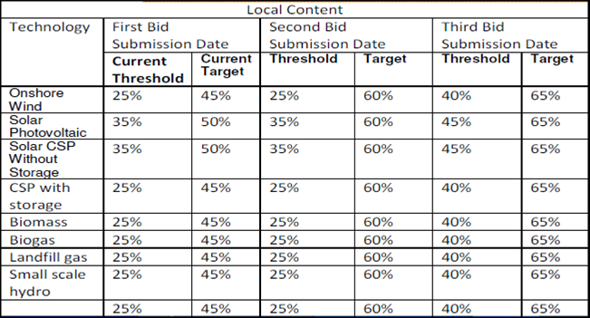

The rapid pace at which the REIPPPP has been rolled-out, while commendable from energy-security and foreign direct investment (FDI) perspectives, has been such that the capacity to manufacture selected wind turbine components locally has lagged behind. Where manufacturing capacity has successfully been created, questions have surfaced regarding how long into the future the RE IPP procurement process will continue, and thus create certainty of demand for locally-produced components. Further questions have arisen in respect of the extent to which the minimum thresholds and targets will be increased further, whether the definition of ‘local content’ will be revised, and how the downward pressure on prices will impact the ability to meet local content requirements. The implication is that, over time, it may become increasingly difficult to progress towards IRP targets if the nexus between the pace and quanta of generation capacity additions, REIPPPP prices and development of local value-chains is not managed optimally. It is for this reason that the implementation of the localisation process, in the context of related industry dynamics as outlined below, requires assessment.

- Barrier 2: Incomplete wind resource mapping and identification of all potential sites for harnessing wind energy: Due to the substantial interest in the REIPPPP, the Department of Environmental Affairs (DEA) has spent considerable resources reviewing and approving individual Environmental Impact Assessment (EIA) applications. Compounding the challenge has been the fact that not all the projects for which EIA applications are lodged proceed to implementation, which raises questions about efficiency. In some cases, the siting of large projects has triggered the requirement for the strengthening of transmission capacity, resulting in delays to the connection of RE sites that are ready to produce energy where planning has not been coordinated. Furthermore, the ability of environmental authorities to strike a balance between promoting wind energy development and minimising adverse environmental impacts has been impaired by the lack of an integrated view of any competing requirements that may be placed on a particular geographical area. It is for these reasons that the development of a Strategic Environmental Assessment (SEA) platform, which supports spatial decision-making, formed one of the salient outcomes of the first phase of the Wind Atlas South Africa (WASA I) project. As a result of this project, wind resource maps for all of the Western Cape, as well as parts of Northern Cape and Eastern Cape provinces (collectively known as WASA I sites), were developed.

Expanding the wind atlas to cover all of the Northern Cape, Eastern Cape, KwaZulu-Natal and parts of Free State Provinces (collectively known as WASA II sites ) will result in the capture of at least 80% of South Africa’s wind resource-base. The effect will be to open up a larger area for potential wind farm development, as well as related industrial development opportunities across these provinces. In turn, this will contribute to a more predictable wind resource (averaged out across a more diverse set of sites). In addition, this will result in better planning for environmental management purposes and future procurement mechanisms. As more wind farm developments are considered as part of the REIPPPP, the need for strategic planning will increase significantly. In the context of a competitive bidding process, a SEA tool can reduce transaction costs for both Government and business.

While the definition of WASA I wind farm development corridors was completed during the SAWEP II project preparation phase, a similar process for WASA II sites will only commence in 2018 if there is no funding for the preliminary processing of WASA II data once it becomes available by the end of 2015 or in early 2016. By means of a budgetary allocation, SAWEP II aims to close this “funding gap”.

- Barrier 3: Lack of capacity in small-scale wind sector: The bidding process for the small RE IPP programme is more cumbersome and demanding than the large-scale programme, involving multiple stages and phases before preferred bidders are selected. Given that the project developers that have an interest in this sub-sector do not have the same resources as those focusing on utility-scale developments, participation in the small-scale RE programme is considerably more difficult. The small-scale wind energy sector faces additional challenges due to competition from other RE technologies (e.g. roof-top solar PV), as well as uncertainty about its viability in South Africa. Additionally, one of the areas with excellent wind resources – the Eastern Cape Province – has not been exposed to skills development opportunities in the same manner as other areas of the country with comparable wind resources. It is for these reasons that SAWEP II aims to support the implementation of a small-scale wind energy pilot project as a capacity-building measure.

- Barrier 4: Lack of adequate vocational training schemes targeted at the wind energy sector: While the training of the technicians required to support wind farm operations – for instance through the South African RE Technology Centre (SARETEC) – has received attention, there has not been the same level of focus regarding vocational training relating to the manufacturing of wind turbine components. Unless this is addressed, it will result in constraints to the development of local value-chains for wind turbine components. Examples in this regard include mould-making for composite materials (e.g. if turbine blades are manufactured locally), as well as forging/casting processes (e.g. if hubs and nacelle base-plates are manufactured locally). Furthermore, the scale and pace of wind farm developments implies that pre-existing programmes for the development of skills in wind farm operations and maintenance will require replication over time.

The development of wind energy expertise will be undertaken in conjunction with the private sector and Department of Higher Education and Training (DHET), taking into account such frameworks as the National Skills Development Strategy (NSDS) as well as successful vocational training models from countries that have had experience developing wind energy skills in response to demand. Capacity-building will build on the processes that have been initiated in conjunction with the public Technical and Vocational Education and Training (TVET) college system in South Africa. The approach will be complemented by collaboration with SARETEC, taking into account the opportunity to support the development of wind energy skills in the Eastern Cape province – a traditionally economically-depressed area of South Africa, but one endowed with some of the country’s most attractive wind resources.

De-risking Renewable Energy Investment (DREI) Analysis

- To deepen the understanding of barriers confronting the South African wind sector, Derisking Renewable Energy Investment (DREI) analysis, developed by UNDP, was undertaken. Detailed results are presented in Annex 3. The theory of change underlying the DREI methodology is that one of the principal challenges for scaling-up renewable energy in developing countries is to lower the financing costs that affect renewables’ competitiveness against baseline technologies – i.e. primarily fossil fuels. As these higher financing costs reflect barriers and associated risks in the investment environment, the key entry point for policy-makers to promote renewable energy is to address these risks and thereby lower the overall life-cycle costs of RES. Taking this approach, the DREI methodology allows policymakers to quantitatively compare different packages of measures to promote renewable energy and to compare their cost-effectiveness.

- The DREI methodology acknowledges that barriers act as drivers of investor risk, and the existence of a barrier (e.g. lack of clear responsibility of different agencies for renewable energy approvals) increases the probability of negative events (e.g. delays due to poorly-administered licensing) affecting the renewable energy project. In turn, the negative events result in financial impacts for investors (e.g. transaction costs; delayed revenues; under- or no investment). The sequence of events and impacts due to risks arising from barriers is shown in Figure 6.

Figure 6. Drivers and components of investor risk for renewable energy investment
(Source: Waissbein et al. (2013), pg. 47)

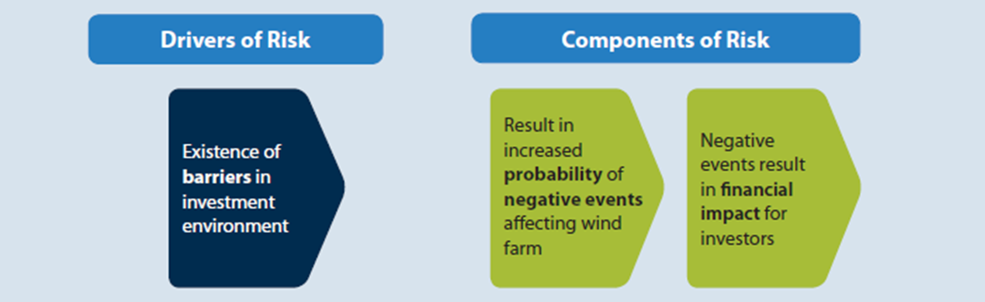

- The risk waterfall chart arising from the DREI analysis is shown in Figure 7. Risks that are caused by barriers increase the cost of both equity and debt in South Africa’s wind sector compared to the cost of capital in the best-in-class country (Germany). Germany has been chosen as a benchmark country because it offers an appropriate private-sector investment environment wherein the cost of capital is among the lowest in the world. The low cost of capital corresponds to a low investment risk environment.

- Based on interviews with investors, the cost of equity in South Africa is estimated at 15%, and the cost of debt at 7.5%. The generic risk categories used in the DREI methodology are broader than the specific barriers identified in Section 1.2 above. Nonetheless, the impacts of local content requirements, wind resource mapping deficiencies and sectoral skills gaps are clearly evident in the large cost-of-capital (i.e. risk) increments associated with power market risk and connectivity risk, adding approximately 1.8 percentage points to the cost of equity and 1 percentage point to the cost of debt.

Figure 7. Impact of risk categories on financing costs for wind energy investment in South Africa, business-as-usual scenario
Business-as-Usual Financing Costs
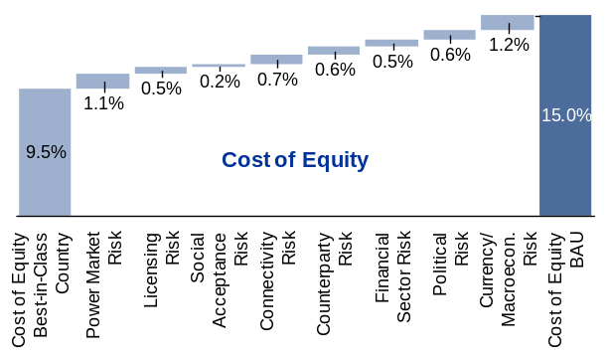 |  | 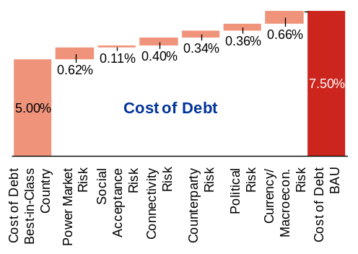
Source: interviews with wind energy investors and developers; modelling exercise.

Stakeholders

- Table 3 provides an overview of the stakeholders with whom consultations were held as part of the baseline assessment during the project preparation phase. The table also provides an outline of the salient outcomes of the discussions, specifically focusing on stakeholders’ potential roles in the implementation of SAWEP II. In addition, comments received from a workshop with South African Wind Energy Association (SAWEA) members are included in Annex 6.

Table 3: Key energy sector stakeholders
Organisation | Activities
Deutsche Gesellschaft für Internationale Zusammernarbeit (GIZ) | GIZ is supporting the DoE IPP Unit in reporting on the REIPPPP, including local content requirements and their implementation. This takes place in the context of the Implementation Agreements (IAs) that the DoE has with all the IPPs that reach financial close. It is important to note that, according to GIZ, the support has focused only on the development of a reporting software application and assignment of a technical specialist to the DoE IPP Unit for capacity-building purposes. Therefore, the support has not included the actual reporting process (i.e. content) or verification of reports submitted by IPPs. Consequently, there is a gap in respect of feedback to IPPs regarding potential improvements in compliance with local content requirements and implementation of socio-economic development programmes.  SAWEP II’s activities related to building the capacity of key participants to meet local content requirements and implement socio-economic development programmes through the proposed monitoring and verification (M&V) system will improve on, and complement, the existing reporting system. GIZ’s experience with the development of the REIPPPP reporting system will be helpful for ensuring that the proposed local content (and socio-economic development) M&V system is designed and implemented effectively.  GIZ is also in a good position to complement SAWEP II’s training activities, by facilitating access to expertise that was used in supporting the Department of Higher Education and Training (DHET) with the development of curricula on wind farm operations and maintenance. This expertise will be helpful in extending SAWEP II’s contribution to the extension of training to TVET colleges in areas of the Eastern Cape where additional wind resources are to be explored (e.g. as part of WASA II), including providing input towards the acquisition of training equipment on behalf of TVETs and SARETEC.  GIZ has been providing support towards the development of standards and frameworks for distributed solar photovoltaic (PV) facilities located within municipal electricity distribution networks. GIZ is thus in a good position to provide advisory services on the integration of small-scale wind power generation at the municipal level. This is one of the key aspects of the small-scale wind power generation demonstration project that forms part of SAWEP II’s scope of work.
Danish Agency for International Development (DANIDA) | Due to its extensive support for the development of the Wind Atlas, the DANIDA-sponsored WASA II Project Implementation Unit (PIU), hosted by the South African National Energy Development Institute (SANEDI), has been instrumental in the development of SAWEP II’s support for extension of the Atlas to parts of the Northern Cape province. This support has been in the form of providing information on the budget to be used for SAWEP II-sponsored Wind Atlas extension, as well as the key activities that should be undertaken.  The input has also included an indication of the support that will be required from SAWEP II in processing the preliminary wind resource data that will be sourced from the new sites in the Eastern Cape, KwaZulu-Natal and Free State provinces that will form part of the DANIDA-sponsored Wind Atlas extension.  As a result, SAWEP II will work with the DANIDA-sponsored WASA II PIU in processing preliminary wind resource data from the new Eastern Cape, KwaZulu-Natal and Free State sites. The processing of preliminary wind resource data for WASA II, starting end-2015 or early-2016, will enable the early commencement of the Strategic Environmental Assessment (SEA) and development of Renewable Energy Development Zones (REDZs) associated with the new sites, enhancing the chances for expedited permitting and transmission expansion activities in support of the future development of wind farms around these sites.
Department of Science and Technology (DST) | Based on its experience with the Competitive Supplier Development Programme (CSDP), the Department of Science and Technology (DST) is well-placed to provide support to SAWEP II in the development of local component manufacturing value-chains. An area of potential interest is linkages with the local foundry industry, noting that such wind energy components as hubs, nacelle base-plates and shafts require types and sizes of castings that South Africa has historically not produced. DST’s support will focus on advice on the approaches that are most effective in developing the technological base of industry participants that have an interest in manufacturing these components in South Africa. The experience of DST’s Technology Localisation Implementation Unit (TLIU) - which is hosted by the Council for Scientific and Industrial Research (CSIR) - will be helpful in this process.  The specific collaboration approach adopted by SAWEP II and DST in this regard will depend on the Department of Trade and Industry’s (DTI’s) Wind Energy Localisation Roadmap, which is expected to outline the approach that will be followed in developing local wind energy-related value-chains. The development of the localisation roadmap commenced in June 2014 and is expected to be finalised by the end of 2014. The relevance of the localisation roadmap to SAWEP II and collaboration with DST is in the context of the proposed localisation M&V system, noting that the system is expected to highlight aspects of local value-chains that require capacity-building. In conjunction with the priorities of the localisation roadmap, the indication of capacity-building requirements, as defined by means of the localisation M&V system, will serve as input towards DST’s advice on the technology support activities that are most appropriate in developing local value-chains.
South African National Energy Development Institute (SANEDI) | Due to its hosting and management of the DANIDA-sponsored extension of the Wind Atlas to the Eastern Cape, KwaZulu-Natal and Free State provinces (or WASA II project), as well as the South Africa-German Energy Programme (SAGEN), SANEDI will provide a point of coordination with the relevant SAWEP II components. The relevant SAWEP II components are those related to the extension of the Wind Atlas to the remaining parts of the Northern Cape province, as well as wind energy-related training and human-capital development.  Coordination with SANEDI with respect to the extension of the Wind Atlas began during the project preparation phase, with the SANEDI-hosted WASA II Project Implementation Unit (PIU) providing information that was used to develop the budget, scope of work and timelines for the portion of the Wind Atlas extension that will be supported by SAWEP II (i.e. extension of the Wind Atlas to the remaining parts of the Northern Cape province). Once approved as part of the SAWEP II scope of work, the implementation of the extension of the Wind Atlas to the remaining parts of the Northern Cape will be coordinated by the WASA II PIU, in consultation with the SAWEP II Project Coordination Unit (PCU), which will be hosted by DoE. Additionally, coordination will include SAWEP II’s support for the processing of preliminary wind resource data from the new DANIDA-sponsored Wind Atlas sites in the Eastern Cape, KwaZulu-Natal and Free State provinces end-2015 or early-2016.  Coordination with SAGEN will focus on SAWEP II’s support for training and human-capital development at Technical and Vocational Education and Training (TVET) colleges and the South African RE Technology Centre (SARETEC). This will be in the form of SAWEP II gaining access to expertise gained through the GIZ-supported ‘Skills for Green Jobs’ programme at the TVET college level, as well as capacity-building at SARETEC (e.g. acquisition of a training wind turbine nacelle and the integration thereof with the relevant SARETEC training activities).
Eskom Transmission Grid Planning and Energy Planning | Eskom has been one of the organisations working with the Department of Environmental Affairs (DEA) in the development of a Strategic Environmental Assessment (SEA) framework and the Renewable Energy Development Zones (REDZs). Eskom’s specific focus has been in the transmission system expansion requirements of the REDZs, as part of initiatives aimed at unblocking permitting and planning impediments to expedited development of wind farms and other infrastructural projects. As a result, Eskom will play a similar role in the development of REDZs associated with new Wind Atlas sites in the Northern Cape, which will be mapped through SAWEP II support.  Eskom had also indicated interest in obtaining SAWEP II support for an assessment of the software and processes used by other utilities in planning the integration of wind farms. However, Eskom did not confirm this requirement, despite requests to do so. Eskom’s relevance to SAWEP II is therefore primarily in respect of the development of the REDZs, as outlined above.
Department of Higher Education and Training (DHET): University Branch | DHET’s University Branch focuses on the development of skills in wind energy through SARETEC, which is housed at the Cape Peninsula University of Technology (CPUT). The role primarily focuses on policy issues affecting the development of skills at university and university of technology level.  The initial indication that SARETEC required support in respect of acquiring wind energy-related training equipment was provided by the Head of DHET’s University Branch. This requirement was later confirmed by SARETEC during the consultation process. The key training equipment that will be acquired through support from SAWEP II include a wind tower (for ‘working-at-heights’ training), as well as a wind turbine electrical simulator).
Department of Higher Education and Training (DHET): National Skills Fund (NSF) | The NSF will provide finance for the training of artisans in the wind-energy related manufacturing sector, in support of localisation. This will complement the training interventions, sponsored by GIZ, that have focused to date on wind farm operations. The NSF will also provide support to wind-energy related training offered at Technical and Vocational Education and Training (TVET) colleges on wind farm operations. In both cases, the Eastern Cape province will receive priority attention.  The NSF also provides the finance for the operations of SARETEC, to address both its capital and operational expenditure requirements.
Department of Higher Education and Training (DHET): Further Education and Training (FET) Branch | The primary role of the Further Education and Training (FET) Branch of DHET will be the development of customised curricula for training related to the manufacturing of wind energy-related components. This will fall under an existing National Certificate (Vocational) – NC(V)) – qualification: Engineering and Related Design. The reason for selecting this qualification stream is that it makes provision for courses in such vocations as engineering fabrication and welding.  The Branch will also play a key role in the extension of training interventions to WASA II sites, as well as facilitation of linkages between TVET college programmes and wind farms in the Eastern Cape, as and when the relevant curricula become effective. This will be undertaken through the Eastern Cape’s Provincial Skills Development Forum – which is coordinated by the Premier’s Office – and any other similar structures that offer coordination and the involvement of the highest levels of provincial leadership and wind energy executives.  The Branch will also provide input towards the acquisition of training kits on behalf of TVET Colleges that are ready to implement the Electrical Infrastructure Construction curriculum as customised for wind energy. A similar role is envisaged in respect of the proposed Engineering and Related Design curriculum. The focus will be on Eastern Cape-based colleges due to the need to contribute to this region’s capacity-building requirements, taking into account the abundance of good wind resources, the associated development of large-scale wind farms and the fact that the region is one of the most economically depressed in South Africa.
South African National Accreditation System (SANAS) | SANAS is responsible for the accreditation of institutions that offer testing, certification and related services to the local wind energy sector. Due to SANAS being a signatory to the International Laboratory Accreditation Cooperation (ILAC) Mutual Recognition Agreement (MRA), South Africa subscribes to the principle ‘inspected, tested and certified once and accepted everywhere’. This means wind turbine components certified by signatories to the ILAC MRA that are located in other countries are accepted for deployment in South Africa, while wind turbine components certified in South Africa by SANAS-accredited institutions are acceptable in other jurisdictions that are signatories to the ILAC MRA.  Requirements for testing, certification and related services are expected to be outlined in the DTI’s Wind Energy Localisation Roadmap, which is expected to be completed by the end of 2014. The role of SANAS will be to support the implementation of activities aimed at meeting such requirements. An example of such support will be cases where the localisation M&V system indicates a requirement for the development of local capacity to undertake the testing and certification of wind energy-related components.
South African Wind Energy Association (SAWEA) | As an industry association, SAWEA’s role is to create a platform for interaction between its members and other societal actors, including the Government. SAWEA also provides an entry point for SAWEP II into the recently-formed association of industry associations, the South African Renewable Energy Council (SAREC). With support from SAWEP II, SAWEA will benefit from technical assistance for the development of capacity to undertake self-monitoring of progress towards meeting the local economic development (LED) requirements of the REIPPPP. This will form part of the implementation of the localisation M&V system, which incorporates an assessment of LED activities related to the REIPPPP, as proposed by SAWEA during the project preparation consultation process. The same will apply with respect to the LED aspects of the small-scale wind energy sector, which will be assessed as part of the proposed small-scale wind energy demonstration project.
Department of Environmental Affairs (DEA): Strategic Environmental Assessment (SEA) | The Department of Environmental Affairs (DEA) spearheads the development of the Strategic Environmental Assessment (SEA) programme and Renewable Energy Development Zones (REDZs) scheme. The SEA and REDZs are intended to expedite environmental impact assessments (EIAs) and related permitting processes, as well as transmission capacity planning – both of which will be of great benefit to wind project development.  SAWEP II will support the processing of the preliminary data from WASA II sites located in the Eastern Cape, KwaZulu-Natal and Free State provinces, which is expected to be available from end-2015 or early-2016. This will enable a seamless transition from the SEA process for WASA I sites (i.e. ‘SEA I’) to a similar process for WASA II (i.e. ‘SEA II’). The wind resource modelling related to WASA II sites will be refined as more data becomes available.  The conceptualisation of new transmission grid corridors that will result from the wind resource modelling of WASA II sites will be undertaken as part of this process, jointly with Eskom.  DEA is also willing to facilitate engagement with the Northern Cape provincial authorities in support of a seamless transition to the inclusion of WASA II sites in SEA II, including sharing the key lessons-learned from SEA I.
South African Bureau of Standards (SABS) | The South African Bureau of Standards (SABS) has adopted and published the 61400-1 series standards that apply to large-scale wind turbines. SABS will also finalise the development of IEC 61400-2 series standards, which apply to small-scale wind turbines. This will be helpful in considering options for the testing of locally-manufactured small-scale wind energy components as part of the proposed SAWEP II-sponsored small-scale wind energy demonstration project.
Department of Energy (DoE): IPP Unit | The IPP Unit will receive SAWEP II support in building capacity to implement a local content Monitoring and Verification (M&V) system. Such support will cover training and institutional development. As the administrator of the REIPPPP, the IPP Unit will play a crucial in providing information required for tracking SAWEP II progress towards its objectives and goals. Development of the M&V system will take into account GIZ’s support to the IPP Unit on REIPPPP reporting.  As mentioned in the section of this table detailing the GIZ’s role, the M&V system will complement the REIPPPP reporting system by providing the capability to verify reports on the implementation of localisation and socio-economic development aspects of the REIPPPP, as well as building the capacity required to improve performance in these aspects. The reporting software application developed with the GIZ’s support does not incorporate the verification and capacity-building attributes that will form part of the M&V system.
South African Renewable Energy Technology Centre (SARETEC) | SARETEC will play a critical part in the development of wind energy service technicians in preparation for their participation in wind farm operations and maintenance activities. SARETEC will also provide training for TVET college lecturers as part of developing wind energy-related skills.  SARETEC also plans to play a part in creating a pool of trained wind energy service technicians, by providing training for candidates who are not necessarily nominated by companies active in the wind energy sector. This will be departure from current practice, where trainee technicians are first recruited by individual companies before being nominated for training. This, however, contributes to the time taken before skilled technicians are available to take up productive operations and maintenance activities.  Creating a pool of trained wind energy service technicians will reduce the time taken for their productive deployment, while also increasing their numbers. Where deserving candidates face financial difficulties, SARETEC will coordinate the provision of funding by SAWEP II, as per guidelines that will be agreed during the implementation phase of the project. This type of support will be helpful in instances where trainees are not necessarily affiliated to any company, thus putting them in a position to apply for wind energy service technician employment opportunities as they arise.  While SARETEC’s focus is on training for wind farms operations, the Centre has indicated willingness to support the development of skills required in the local production of turbine blades (e.g. training of TVET college lecturers that will provide training in the processing of composite materials). The details of such support will be developed as part of consideration of the human capital development implications of the DTI’s Wind Energy Localisation Roadmap, which is expected to be completed by end-2014.
Department of Higher Education and Training (DHET): Indlela Artisan Development (NAD) Centre | The National Artisan Development (NAD) Branch facilitates the vocational training of artisans, as well as linkages among trainees, TVET colleges and employers. In addition, the Branch facilitates access to funding for the training of artisans, through primarily the NSF and relevant Sector Education and Training Authorities (SETAs).  The NAD Branch has also offered to facilitate engagement with the Human Resources Development Council of South Africa (HRDCSA), a high-profile multi-stakeholder advisory body that was established in 2010 to drive national human resource development programmes in support of inclusive economic growth.  Crucially, the NAD Branch supports Strategic Infrastructure Projects (SIPs) by facilitating the development of the required skills, and as such will be in a position to make its platform available for the development of skills related to the localisation of the wind energy value-chains. Funding for approved vocational training programmes is split 53 percent and 43 percent between employers and grant providers (e.g. the NSF), respectively.  The requirements for collaboration with SAWEP II will depend on the outcomes of DTI’s Wind Energy Localisation Roadmap, which is scheduled for completion by end-2014, and will outline the skills development requirements associated with the establishment of local value-chains. SAWEP II’s contribution will be in the form of facilitating access to additional trainees, as well as the technical expertise required to develop and support the implementation of wind energy-related vocational programmes. As NAD trades are not sector-specific, work-place training and mentorship will be crucial in developing the specific experiential learning required for wind energy components – a gap that SAWEP II is well-placed to help close.
Department of Trade and Industry (DTI): Industrial Development: Policy Division (Renewable Energy) | While the PIF envisaged support for the development of the Localisation Roadmap, the findings of the project preparation phase indicated that it is prudent to, instead, focus on supporting the implementation of the Roadmap. This is because the Department of Trade and Industry (DTI) had already begun the development of the Localisation Roadmap by the time the SAWEP II project preparation phase commenced (e.g. by undertaking the procurement of consultants, who began the development of the Roadmap in June 2014). The Wind Energy Localisation Roadmap is expected to be completed by end-2014.
Department of Environmental Affairs (DEA): Climate Change Mitigation | The CCM Chief Directorate of the Department of Environmental Affairs is responsible for a number of initiatives that have relevance to SAWEP II. These include collaboration with the Department of Science and Technology on mitigation technology planning, climate-change related inputs to the IRP, and the specification of sectoral Desired Emission Reduction Outcomes (DEROs) – which will also extend to the company-level in some cases. The Chief Directorate has undertaken a Mitigation Potential Analysis, which will be made available after approval by the Cabinet. There is also a process underway to develop a CCM Monitoring and Evaluation (M&E) system, which is expected to be completed in mid-2015. The M&E system will require inputs from line departments such as DTI and DoE. The relevance to SAWEP II lies in the fact that the CCM M&E system will have the capability to determine the emissions related to the creation of local value-chains.
Technical and Vocational Education and Training (TVET) College | The Port Elizabeth College (PEC) has participated in the initial phases of wind energy-related skills development programmes, in conjunction with DHET and GIZ. The College is expected to support skills development by providing vocational training in collaboration with SARATEC.  PEC will be a recipient of SAWEP II support, which will be in the form of funding for the training of lecturers who will provide wind energy-related tuition, as well as qualifying trainees who will proceed to SARETEC for further development as wind energy service technicians.
Adventure Power: South Africa-based medium-scale wind turbine manufacturer | Adventure Power has a South African-based facility to produce turbines rated at 300kW. The company has been in contact with DTI regarding the development and implementation of a small-scale wind energy demonstration project. The company’s participation in the demonstration project, through support from DTI, will complement SAWEP II’s support for technical assistance (e.g. conduct of feasibility studies, monitoring, etc.), by ensuring that the necessary investments in the required small-scale wind turbine facilities.

Baseline analysis

- A number of baseline activities were underway in the South African renewable energy sector during the project preparation phase. In addition, some of the baseline activities identified in the PIF had been completed by the time the project preparation phase commenced and were therefore no longer categorised as baseline. Others had to be framed differently due to requirements that became apparent from engagements with stakeholders. Finally, several new initiatives emerged during the project prepration phase and have been incorporated into the project design as baseline and/or co-financing programmes. Key changes from the PIF to the Project Document are highlighted in Table 4 below:

Table 4: Changes in Co-finance from PIF to CEO Endorsement Request
Sources of Co-Financing | PIF Amount (USD) | Actual Amount (USD) at CEO ER | Description
Department of Energy (DoE) | 1,000,000 | 2,229,814 | The amount of co-financing at CEO ER stage is an updated indication of the DoE’s in-kind contribution towards SAWEP II activities relating to renewable energy. These include overseeing the implementation of SAWEP II, feasibility studies related to the development of a 5GW solar park in the Northern Cape and curriculum development at SARETEC.
Department of Trade and Industry (DTI) | 2,500,000 | 100,332 | The co-financing amount has been reduced in line with the conservative approach reflected in DTI’s co-finance letter, which includes only the amounts budgeted for the conduct of the Wind Energy Localisation Study and staff salaries related to wind energy. The estimate used in the PIF included the various incentive schemes administered by DTI, which run into millions of Rands annually.
Department of Science and Technology (DST) | 800,000 | 621,118 | The amount at CEO ER stage reflects updated information received from DST and as reflected in the co-financing letter.
Department of Higher Education and Training (DHET) | 6,500,000 | 9, 316,770 | The amount at the PIF stage reflected the level of funding committed to the establishment of SARETEC at the time (i.e. R49 million, early 2013), which is a fraction of the total amount allocated for this purpose. The amount at the CEO ER stage reflects the fact that the establishment of SARETEC has begun, resulting in the release of the full amount (R105 million).
Department of Environmental Affairs (DEA) | 533,333 | 120,142 | The updated amount is based on the co-financing letter received from DEA, which lists support for climate change and energy policy interventions, as well as the salaries of staff members in the Department’s Climate Change Energy Mitigation section. The PIF included a budget for the procurement of consultants to undertake the initial development of RE Development Zones (REDZs), which was completed in 2014.
Eskom – Strategic Grid Planning Division | 266,667 | 0 | No co-financing letter received.
South African National Accreditation System (SANAS) | 50,000 | 0 | As South Africa is already a signatory to the International Laboratory Accreditation Cooperation (ILAC), there is no need to provide for the SANAS-related activities that were envisaged at the PIF stage.
GIZ | 13,000,000 | 13,910,000 | The amount remains materially the same as at the PIF stage.
DANIDA | 2,090,000 | 2,160,000 | The amount in Danish Krone (DKK) is the same. The nominal change is due to USD/DKK exchange rate varations.
South African Wind Energy Association (SAWEA) | 700,000 | 1,508,429 | The change is due to the use of SAWEA’s updated budget, which forms part of the industry association’s February 2014 business plan.
SA-based wind turbine manufacturer (Adventure Power) | 0 | 5,501,331 | The amount was obtained during the stakeholder consultations undertaken during the project preparation phase. Its relevance only became apparent during the preparation phase, as a result of the proposed small-scale wind demonstration project.  The focus at the PIF stage was only on providing support to participation by municipalities and community-based organisations (CBOs) in the small-scale Renewable Energy Independent Power Producer (REIPP) programme. There was no consideration during the PIF stage of the commissioning of a small-scale demonstration project.
UNDP | 200,000 | 200,000 | No change – included herein for completeness.
Total | 27,640,000 | 35,667,936 | Overall increase of 29 percent from PIF to CEO ER.

Coordination with Other Initiatives

- A number of other ongoing national and provincial projects relevant to renewable energy will provide opportunities for collaboration, information-sharing and lessons-learned with the SAWEP II project. These include:

- Other GEF-financed activities, including the Standards and Labelling project implemented in conjunction with DoE and UNDP; preparation of South Africa’s Third National Communication (TNC) and Biennial Update Report (BUR) in collaboration with UNEP; and UNIDO’s promotion of market-based adoption of integrated biogas technologies in small-medium and micro enterprises SMMEs. Opportunities for collaboration and/or coordination will take different forms, depending on such factors as objectives and management arrangements. For instance, the Standards and Labelling project, which is located at DoE, will provide an opportunity for sharing some of the project implementation costs. The TNC process will include in its scope-of-work updates to South Africa’s GHG inventory, as well as a review of the country’s emission factors. These reviews will assist in assessing the effect of the REIPPPP on emission reductions, as well as informing future SAWEP II reviews (e.g. use of an updated grid emission factor in estimating SAWEP II-related emission reductions in future project reviews).

- The GIZ-sponsored project that focuses on addressing issues related to solar PV connections to municipal distribution systems, which forms part of the South Africa-German Energy Programme (SAGEN) and which will be implemented during the tenure of SAWEP II. Through this project, which involves the South African Local Government Association (SALGA) and the Association of Municipal Electricity Utilities (AMEU), the SAWEP II-sponsored small-scale wind pilot project will gain valuable lessons in respect of connecting small-scale RE generating systems to municipal distributions networks. Furthermore, the capacity built in local government regarding the concept of ‘embedded generation’ from solar PV will facilitate better understanding of the issues related to the small-scale wind sector. Examples include the manner in which municipalities manage applications to connect RE generating systems to their distribution networks, as well as the development and implementation of applicable regulatory frameworks (e.g. power purchase agreements in the context of municipal legislation).

- The UNIDO-GEF project aimed at promoting biogas projects in SMMEs will have relevance to the SAWEP II component that is envisaged to support the small-scale wind sector. This will be in the form of the exchange of information and lessons-learned relating to the involvement of SMMEs in RE value-chains. This will be achieved in part by including in the scope of work for the small-scale wind energy demonstration a review of reports generated from the UNIDO-sponsored biogas project.

- The National Artisan Development (NAD) programme and the Competitive Supplier Development Programme (CSDP), which are led by state-owned entities including Transnet (rail transportation and ports) and Eskom (electricity generation). As the names imply, these programmes aim to create the skills-base necessary to undertake operational tasks related to major infrastructure projects, as well as to establish viable local manufacturing value-chains. The participation of the national Department of Higher Education (DHET) and Department of Science and Technology (DST) in SAWEP II will provide access to the valuable experience gained from these programmes, for the purpose of supporting the development of skills related to wind energy component manufacturing, as well as the development of local value-chains. SAWEP II’s access to DHET and DST experience in skills capacity-building will be within the context of the Department of Trade and Industry’s Wind Energy Localisation Roadmap, which is expected to define the approach to be taken by South Africa in the creation of wind energy-related local value-chains, and is scheduled for completion by end-2014.

- The monitoring function established in 2014 at the DoE IPP Unit, which focuses on the implementation of approved projects that form part of the REIPPPP. The proposed localisation Monitoring and Verification (M&V) system will play a complementary role, including in respect of capacity-building within the wind energy industry and Government. As the monitoring function was introduced towards the end of the SAWEP II project preparation phase, the coordination requirements will be finalised as part of the SAWEP II inception process.

Strategy

Project Rationale

- In 2011, the Government of South Africa adopted the Integrated Resource Plan (IRP) as a blueprint for the energy mix in the period up to 2030. This blueprint indicated the Government’s clear intention to diversify the nation’s energy mix away from coal-fired power generation. In addition to other national policies, such as the Industrial Policy Action Plan (IPAP) and New Growth Path (NGP), diversifying the energy mix was also expected to enable the country to take advantage of the potential to create new industries and reduce unemployment by promoting the Green Economy.

- The current IRP, adopted in 2011, includes an ambitious ramp-up of renewables, with wind generation capacity projected to grow to 8,400 MW by 2030. In the short-term, and as determined by the Minister of Energy, the total wind generation capacity to be added by 2018-20 is targeted at 3,320 MW. By end-2013, 1,983 MW of wind generation capacity had been procured over three rounds of the country’s large-scale RE IPP programme. According to the Department of Energy, wind farms representing 255 MW of the 634 MW (or 40 percent) of the capacity that was procured in the first round were at their commercial operation phase as of June 2014.

Much of the progress in the development of the South African wind industry and allocation of wind power under the REIPPPP can be attributed to the first phase of the UNDP-implemented, GEF-financed South African Wind Energy Project (SAWEP I). However, despite the achievements of SAWEP I and the removal of many key institutional and regulatory barriers, there remain many major strategic obstacles to the medium-term achievement of the wind energy allocations and co-benefit targets set out in the IRP, as well as those outlined in the Green Economy Accord and National Climate Change Response White Paper Policy. These obstacles were analysed in detail in the SAWEP I Terminal Evaluation (TE), which – based on the many challenges still facing the nascent wind industry – recommended the development of a second phase of SAWEP (SAWEP II). The recommendation was that SAWEP II should focus on supporting the expansion/refinement of the wind atlas; wind turbine and components testing and certification capacity; on-going awareness and engagement between Government and industry participants; implementation of a Wind Industrial Strategy; and wind energy education and training.

- SAWEP Phase II will continue to build on the innovation and market-based approach that was pioneered by SAWEP Phase I. It is illustrative of, and modelled on, the approach presented in the UNDP and GEF publication, Transforming On-Grid Renewable Energy Markets (2012), in that it proposes a combination of policy de-risking instruments to lower transactions costs and improve strategic planning of grid-fed wind energy. It also supports the findings of a complementary UNDP report, Derisking Renewable Energy Investment: A Framework to Support Policymakers in Selecting Public Instruments to Promote Renewable Energy Investment in Developing Countries, which identifies that “rather than a problem of capital generation, the key challenge of funding the transition towards a low-carbon energy system is to address existing barriers that affect the financing costs and competitiveness of renewable energy in developing countries.” In South Africa, with a large 8.4 GW wind target, the modelling from that report estimates that USD 40 million in policy de-risking instruments can result in a USD 2.3 billion reduction in the price premium required over the 20-year target, a savings leverage ratio of over 50.

- The primary objective of SAWEP II is to assist the Government and industry stakeholders overcome strategic barriers to the successful attainment of South Africa’s Integrated Resource Plan target of 3,320 MW of wind power generation online by 2018/19. This will have the effect of contributing to a further reduction of CO₂ emissions and increased socio-economic development. The achievement of this objective will depend on the following goals being met:

- Clearly-defined local content targets that are reflective of an evidence-based cost-benefit calculus and adequate capacity within the wind energy manufacturing industry to meet them;
- A suitable framework for the testing and certification of wind energy components manufactured in South Africa according to internationally recognised standards. Such local manufacturing is, in the near-term, likely to be limited to small-scale wind turbines;
- As far as possible, an accurate estimation of the maximum wind energy resources in South Africa;
- Enhanced prospects for the development of a viable small-scale wind energy sector;
- An enhanced skills-base to meet the requirements of the wind energy sector, taking into account a deliberate bias towards specified geographical regions, as well as segments of the local value-chain most in need of support and gender equity.

The design of the UNDP-implemented, GEF-financed SAWEP II project seeks to address these goals while taking into account the successes achieved under SAWEP I, complementary activities that are sponsored by other institutions, and the interest created by the REIPPPP in South Africa as an attractive wind energy investment destination.

Country Ownership: Country Eligibility and Buy-in

- The UNDP-South Africa Country Partnership Document (CPD) 2013-2017 notes that South Africa is facing the challenge of balancing requirements for rising social spending with the promotion of fixed capital formation (e.g. investments in energy and transport infrastructure), in an environment characterised in some instances by frustration with service delivery levels.

- As one of the means of responding to this challenge, UNDP and the Government of South Africa have undertaken to cooperate on a number of initiatives, focusing on climate change mitigation actions that have potentially substantial multiplier effects and inclusive growth benefits. An example is infrastructure-driven job creation and the use of new technologies and practices to boost the creation of ‘green’ jobs, by scaling-up proven renewable energy in the context of the Government’s flagship REIPPPP. Building upon – amongst others – the SAWEP I project, one of the major focus areas of SAWEP II is increased support for capacity-development among youth and women.

- In order to increase the effectiveness of the project, SAWEP II will be integrated with a number of policies, plans and complementary activities, including:

- National Climate Change Response (NCCR) White Paper: Relevant aspects include the optimisation of environmental and socio-economic imperatives (e.g. balancing high-carbon intensity mitigation and preservation of employment by promoting green jobs), introduction of sectoral strategies as part of climate change mitigation actions on the basis of Desired Emissions Reduction Outcomes (DEROs), as well as consideration of targets derived from the Department of Environmental Affairs’ Long-Term Mitigation Scenarios (LTMS) study.

- Climate Change Management (CCM) Monitoring and Evaluation (in terms of the NCCR White Paper): Relevant aspects include the recognition that the nexus between development and environmental impact should be measured, reported on and verified for CCM purposes (e.g. linkages among REIPPPP-related investments in wind generation capacity, development of local manufacturing value-chains, capacity-development and local economic development).

- National Skills Development Strategy (NSDS III): Relevant aspects include a focus on human-capital development, particularly vocational training in support of the re-industrialisation of the South African economy.

- National Development Plan (NDP), Industrial Policy Action Plan (IPAP) and New Growth Path (NGP): Relevant aspects include an increased focus on the role of green industries in the development of local manufacturing value-chains and job-creation.

- Competitive Supplier Development Programme (CSDP): The key relevant aspect is the use of procurement to develop local suppliers, a process that found traction in state-owned entities falling under the Department of Public Enterprises (e.g. Eskom), has received technical support from the Department of Science and Technology (DST), and which can provide valuable lessons in support of realising the REIPPPP’s local content aspirations. Examples of how SAWEP II will benefit from the CSDP include the approach to be followed in designating wind energy-related components used in REIPPPP wind projects that should be manufactured locally, and the associated supplier capacity-building requirements that should be met. DST will focus on the development of the technological capabilities that are required by qualifying local wind energy-related manufacturing companies.

- Integrated Resource Plan (IRP) and Integrated Energy Plan (IEP): The IRP provides the basis for South Africa’s aspirations to decarbonise the electricity sector (e.g. through specifying the generating capacity allocations that inform the implementation of the REIPPPP), while the IEP provides a platform to consider electricity planning in the context of the plan for the broader South African energy economy. Jointly, these planning processes will also benefit from the SAWEP II-sponsored wind-resource mapping, especially in the context of the ability to better appreciate available resources and their geographical distribution across South Africa.

- Strategic Environmental Assessment (SEA) programme: The Wind Atlas has played a key role in assisting the Department of Environmental Affairs (DEA) to develop an approach for minimising delays associated with environmental impact assessments (EIAs) and related permitting processes. In addition, co-operation with Eskom in the delineation of Renewable Energy Development Zones (REDZs) will minimise delays faced by IPPs in gaining access to the transmission network from non-traditional power generation locations, such as those resulting from the REIPPPP.

- Second phase of the Wind Atlas of South Africa (WASA II): SAWEP II will coordinate closely with the DANIDA-funded WASA II process in the mapping of wind resources in additional geographical areas. SAWEP II will provide funding for extending wind resource mapping to parts of the Northern Cape that were not covered in the first phase of the WASA.

- Capacity-development and regulatory review processes: SAWEP II will coordinate closely with GIZ on processes related to skills development (e.g. vocational training programmes implemented with the Department of Higher Education and Training), and enhancing the ability of industry participants to realize the local content aspirations of the REIPPPP.

Design Principles and Strategic Considerations

- From 2011, when the Integrated Resource Plan (IRP) was promulgated, followed by the first Request for Proposals (RfP) from parties with an interest in the RE IPP Procurement Programme (REIPPPP), there was rapid movement in the development of the South African wind energy sector. As a result, of a total wind power generation capacity allocation of 3,320 MW, 1,983 MW has been procured after three Bidding Windows following 2011.

- Given that the South African wind energy sector has experienced growth since commencement of the REIPPPP in 2011, SAWEP II is designed in such a way as to provide targeted support, and thus address specific issues that could cause the further development of the sector to reach a plateau prematurely. Collaborating with DANIDA and SANEDI in the further assessment of wind resources, the Department of Trade and Industry on the implementation of the Localisation Roadmap, DHET on training, and SAWEA in all the components, will assist in better targeting the envisaged support. The same principle is applied in the planned assessment of the small-scale wind sector by means of a pilot project, which will be used to assess the key aspects associated with this sector, such as access to municipal electricity distribution networks, pricing and financing, as well as socio-economic development.

- The timing of the targeted initiatives under the UNDP-implemented, GEF-financed SAWEP II project takes into account the lag between preferred bidder selection, financial close and the commencement of commercial operations. For instance, by the time the implementation of SAWEP II commences in May 2015, the projects selected as preferred bidders in 2013 during Bidding Window 3 will not have commenced commercial operations due to the time it takes to get to financial close. This provides scope for SAWEP II to have an impact on progress towards the target of 3,320 MW, during the project’s implementation period of 2015 to 2018, taking into account that 1,983 MW of this capacity was awarded during the first three REIPPPP Bidding Windows between December 2011 and November 2013. This means SAWEP II activities will contribute towards the remaining 1,337 MW (i.e. 3,220 MW minus 1,983 MW), and thus allow for the attribution of emission reductions to SAWEP II. Such attribution will take into account the adjustments that should be made in recognition of the extent of causality between the project and progress towards the 2018/19 installed wind capacity.

- The significant focus on training and human-capital development is based on an appreciation of the adverse impact skills shortages have on meeting the stated objectives of Government renewable energy policy. The approach will see SARETEC and participating TVET colleges working in a collaborative manner to ensure optimum outcomes are realised. For instance, SARETEC will offer training to lecturers, who, in turn, will provide training at TVET colleges. After Level 4 TVET training, interested and qualifying trainees will be able to proceed to SARETEC to train as wind energy service technicians.

- Taking into account the high unemployment rate in South Africa, which for the quarter to June 2014 was recorded as 25.5 percent, the Government has prioritised job-creation from the introduction of new industries (e.g. ‘green industries’) and restoration of the country’s industrial base. SAWEP II aims to support the realisation of these priorities by enhancing the monitoring of progress towards localising selected wind energy value-chains in the context of DTI’s Wind Energy Localisation Roadmap. The Localisation Roadmap, which is scheduled to be completed by end-2014, is expected to define the approach that will be followed in establishing the capacity to manufacture locally-specified wind energy components (e.g. blades, nacelles, hubs, etc.). One of the key factors that will be considered in this respect is the cost of locally-manufactured components as compared with imports.

Project Objective, Outcomes and Outputs

Project Objective: To assist the Government and industry stakeholders overcome strategic barriers to the successful attainment of South Africa’s Integrated Resource Plan target of 3,320 MW of wind power generation online by 2018/19.

- Building on the successful outcomes of SAWEP Phase I, the project aims to facilitate further investments in the wind sector, by strategically targeting specific areas that remain as barriers. This takes place in the context of the REIPPPP, South Africa’s flagship programme that has resulted in the procurement of 1,983 MW of wind power generation over the period 2011-2013.

- The main barriers to further expansion of the wind energy sector include the industry’s capacity to respond to local content targets, skills shortages, an absence of a systemic approach towards the development of small-scale wind, as well as timing constraints experienced in respect of environmental permitting and grid-access processes.

- Due to timing, the SAWEP II project is likely to either kick-start some of the interventions (e.g. targeted support for the development of skills required in wind energy manufacturing, depending on the outcomes of the DTI’s Wind Energy Localisation Roadmap), or scale-up/replicate others (e.g. training of wind energy service technicians and extension of the Wind Atlas). Some of the outcomes will be realised during project implementation. Examples in this regard include the training of wind energy service technicians. However, due to the project’s catalysing nature, the principal impacts will be realised post-project implementation. Examples in this regard include the development of local manufacturing value-chains, use of the Wind Atlas for new sites in the Northern Cape, and further developments in the small-scale wind energy sector.

- The intention is to adopt an inclusive approach, which draws in key actors from Government and industry in achieving the outputs that relate to the project’s components, as outlined below.

Component 1: Monitoring and Evaluation of the implementation of local content requirements

SAWEP II will focus on the implementation of the DTI-led Localisation Roadmap, by funding the development and implementation of a localisation Monitoring and Verification (M&V) system. In conjunction with an existing reporting tool located at the DoE IPP Unit, the M&V system will enable the production and dissemination of information on the localisation process in support of policy and investment decision-making. This will be in the context of facilitating continued attraction of investments to the South African wind energy sector, thus further contributing to global environmental benefits by reducing CO₂ emissions. The M&V system will be designed to provide objective, evidence-based assessment and verification of local content requirements and the tracking of progress in implementing localisation initiatives, taking into account the outcomes of the Wind Energy Localisation Roadmap process and pre-existing reporting arrangements related to the REIPPPP. The UNDP-implemented, GEF-financed project will provide the needed evidence-based data regarding implementation progress, costs and benefits that will allow the Government and other interested stakeholders (including other governments) to assess the cost/benefit performance of the local content requirements. As part of the M&V activities, evaluations will be drawn up at regular intervals to assess the extent of the barriers (cost- and implementation-related) posed by the local content requirements so as to inform adaptive modifications of the requirements.

Output 1.1: Monitoring & Verification (M&V) system developed and implemented to facilitate the localisation process

- Taking into account the outcomes of DTI’s Wind Energy Localisation Roadmap process, the development and implementation of the M&V system will complement an existing IPP progress reporting tool that is administered by the DoE IPP Unit. The M&V system will create the capability to verify the information submitted through the existing reporting tool, and thus facilitate the institutionalisation of the positive aspects of the localisation process and enable participants to learn from the not-so-positive aspects. The reports that are currently submitted by RE IPPs by means of the existing reporting tool are not verified, feedback is not provided to the RE IPPs and opportunities for re-calibrating local content requirements are lost. As a remedial measure, the M&V system will form a common platform for the generation of reports on the implementation of REIPPPP projects, primarily focusing on progress in the creation of local wind energy-related capabilities and capacity. The system will also make provision for assessing progress towards the local socio-economic development (SED) and enterprise development (ED) goals of wind energy projects. The involvement of SAWEP II in this process will support progress towards the 3,320 MW cumulative target of wind capacity by 2018/19, by providing evidenced-based information on localisation and opportunities for improvement – which, in turn, will enable RE IPPs to build new wind generation capacity.

The key activities will include:

- Development of M&V system specification, taking into account relevant systems (e.g. the REIPPPP reporting system at the DoE IPP Unit), as well as processes related to Integrated Energy Planning (IEP) and Integrated Resource Planning (IRP). The M&V system will provide data on such aspects as manufacturing capacity (and utilisation thereof) and job-creation, as well as facilitating the assessment of the effect of planned wind capacity allocation on localization initiatives. The system specification will also make provision for relevant information and analysis related to the small-scale wind energy sector – including such aspects as the potential of local and export markets, manufacturing capacity and its utilisation, etc.
- Development of the M&V plan, implementation approach and supporting institutional arrangements. The latter should note that SAWEA is the primary industry representative body, which will in turn coordinate interactions with the South African Renewable Energy Council (SAREC). The DoE IPP Unit will form the coordinating centre on behalf of other Government departments.
- Definition of M&V skills required and approach to their development. This will apply to both DoE and SAWEA.
- Development of the M&V software application and its deployment for the benefit primarily of DoE, DTI and SAWEA, but also participating manufacturing firms.
- Provision of the capability for the M&V system to be used for capacity-building in Government, SAWEA and relevant parts of the value-chain by, for instance, enabling the generation of evidence-based reports on successes and challenges associated with manufacturing localisation, SED and ED. To enable the evaluation of outcomes, the system will have the capability to assess such aspects as sustainability, effectiveness and impact.
- Close consultation with at least DoE, DTI, DST, DHET, DEA, IDC, DBSA, SAWEA and HRDCSA in the process.

Output 1.2: Capacity developed in Government and targeted value-chain sectors to facilitate compliance with local content requirements

- This Output is based on the appreciation that the capacity of local manufacturing value-chains to produce required components will determine the ability of RE IPP project developers to meet local content requirements. As such, this activity will provide targeted support towards the development of the required capacity. DTI’s Localisation Roadmap and the localisation M&V system will form the basis for SAWEP II’s interventions, which will primarily consist of:

- Engagement with management and technical personnel of qualifying manufacturing value-chain participants on approaches towards wind energy-related brownfield or greenfield capacity expansions.
- Providing information on such aspects as the impact of local manufacturing on costs (e.g. based on RE IPP bidding prices), emissions and job-creation, taking into account the components selected for localisation (e.g. towers, blades, nacelles, etc). This will provide the basis for engagement of Government, industry participants and stakeholders on the localisation process.
- Facilitation of coordination amongst at least DoE, DTI, DEA, DST, DHET, SAWEA and HRDCSA, on the development of local value-chains, taking into account at least the M&V system’s outputs, DTI’s Localisation Roadmap and the approach applied in the implementation of the Department of Public Enterprises-led Competitive Supplier Development Programme (CSDP).

Component 2: Resource-mapping and wind corridor development support for policy-makers:
- The focus of this Component is to support the extension of the Wind Atlas to new sites, and thus enable access to strategic and policy planning tools in support of future REIPPPP wind power generation capacity. This will supplement a similar undertaking in the Eastern Cape, KwaZulu-Natal and Free State provinces that is supported by the Danish Agency for International Development (DANIDA), and implemented by the South African National Energy Development Institute (SANEDI). In addition, this will build on the Strategic Environmental Assessment (SEA) project undertaken by the Department of Environmental Affairs (DEA) in relation to the initial Wind Atlas sites, by supporting a similar SEA project for the new sites. The component has both ‘investment’ and ‘technical assistance’ outputs, as outlined below.

Output 2.1: Verified Wind Atlas extended to the Northern Cape province

- SAWEP II will support the extension of the Wind Atlas to sites in the Northern Cape that could not be included in the first phase of the Wind Atlas (WASA I) due to budgetary constraints. Working closely with SANEDI, SAWEP II’s contribution will primarily be in support of the acquisition and installation of wind masts and related equipment, as well as the required modelling, analysis and application of the wind resource data generated.

The key activities, mainly focusing on the acquisition and installation of wind masts, will include:

- In conjunction with the DANIDA-sponsored WASA II project, confirmation of new Northern Cape sites for the Wind Atlas, including final arrangements for access to land with the relevant parties.
- Finalisation of the project plan and budget.
- Procurement of wind masts and related equipment and services.
- Overseeing the installation of the wind masts and related equipment, as well as the collection and public dissemination of wind resource data once systems are operational.
- Close coordination with SANEDI, including leveraging experience gained in the implementation of the Wind Atlas.

Output 2.2: Preliminary WASA II results analysed through the SEA tool for policy-makers to identify wind development corridors in WASA II sites as per DEA criteria.

- As a technical assistance (TA) intervention, SAWEP II will facilitate the processing of preliminary WASA II data, generated under the auspices of the DANIDA-funded phase II project, in support of the expedited commencement of the SEA-REDZs process for the new sites. This will entail at least:

- Coordination with DEA and SANEDI on requirements for implementing the SEA process in respect of WASA II sites.
- Facilitation of the procurement of the technical expertise required for the preliminary processing of wind resource data available end-2015 or early-2016.
- Overseeing the processing of the wind resource data.
- In conjunction with DEA, overseeing the initial delineation of Renewable Energy Development Zones (REDZs) on the basis of the new sites.
- Jointly with the DEA and Eskom, overseeing the initial specification of transmission grid corridors around the new sites.
- Continuation of the aforementioned process as new wind resource data becomes available. This will exclude the procurement of technical expertise for the processing of wind resource data: once technical expertise is procured as in bullet-point 2 above, there will be no need to do so as more wind resource data is sourced. This provides flexibility to accommodate the sequencing of data processing depending on the readiness of measuring points.

Output 2.3: Wind resource data publicly disseminated and used for policy and planning

- In order for the WASA II process to facilitate policy decision-making and planning, the data and information generated will be made publicly available. In addition, WASA II information will be used to build capacity amongst the targeted groups of users.

The key ‘technical assistance’ activities will be:

- Public dissemination of wind resource and REDZ data and/or information via the WASA website. The DoE, with the support of the SANEDI-hosted WASA II PIU, will manage the dissemination of wind resource data towards relevant policy processes (e.g. IRENA’s Global Wind Atlas initiative).
- Development of short, thematic wind energy policy and planning case-studies for capacity-building activities targeted at industry participants, as well as national, provincial and municipal Government levels – focusing primarily on issues related to the SEA and REDZ processes.

Component 3: Support for the development of small-scale wind sector

- It became clear during the project preparation phase that an approach that was based only on supporting municipalities, community-based organisations and small-scale wind project developers towards participation in the small RE IPP programme was inadequate. This was primarily due to the observation that small-scale wind projects did not feature prominently in the early stages of the IPP programme, resulting in the requirement for SAWEP II to rather focus on facilitating better understanding of the reasons for the non-competitiveness of small-scale wind energy. The approach outlined herein focuses on a targeted assessment of the small-scale wind sector as a way of building the necessary capacity, both for policy-making and project implementation purposes.

Output 3.1: Options that have the best prospects for implementation in support of the small-scale wind sector outlined

- Given a number of key questions that arose during the project preparation phase with regard to the small-scale wind sector in South Africa, the focus in this instance will be an assessment of options that have the best prospects of addressing these questions. A key outcome will be the definition of a demonstration project that will be used to assess the practical considerations on which the viability of the small-scale wind sector will likely depend. The key activities will include at least:

- A review of studies on the small-scale RE sector, focusing on wind energy.
- A review of UNIDO reports on the promotion of SMMEs in the biogas sector, for lessons that are relevant to the small-scale wind energy sector
- A review of the performance of the small-scale wind sector in the context of the Small RE Programme, which DoE introduced as an alternative for small-scale projects but which could not effectively compete with the large-scale REIPPPP. The review will include consideration for such aspects as complexity, pricing, programme size (MW), grid-connection requirements and arrangements, local content requirements, review of ownership arrangements and community involvement in project life-cycle activities.
- Assessment of the potential of the small-scale wind sector to provide off-grid, mini-grid and/or hybrid renewable energy supply. Relevant experience gained from the DoE-led solar PV concessionaire programme will be taken into account. This will include comparisons with grid-connected configurations, in order to assess the full range of options for the deployment of small-scale wind energy generation facilities.
- Assessment and recommendation of options to address hurdles faced by small-scale wind energy project developers, focusing on such issues as technical performance, availability of wind resources and their location – noting the lower hub-heights that are typically applicable – potential project sizes, testing and certification requirements and arrangements, regulatory requirements related to wind-based embedded generation, finance, pricing and local economic development models. Relevant experience gained from the GIZ-supported regulatory framework review of embedded generation (e.g. solar PV) will be taken into account. Examples in this regard will include standards for the connection of RE generation facilities to municipal electricity distribution networks.
- Specification of a demonstration project for small-scale wind, including a clear indication of the organisations that will participate – including their roles and financing arrangements. The specification will also include an outline of the M&E arrangements that will be put in place to assess the demonstration project’s performance and outputs.
- Close consultation with the Integrated National Electrification Programme (INEP), DTI, SANEDI, South African Local Government Association (SALGA), Association of Municipal Electricity Utilities (AMEU), GIZ and SAWEA.

Output 3.2: Demonstration project for small-scale wind implemented

- In order to test the viability of the recommendations related to Output 3.1, a 1.8 MW project – consisting of 6 small-scale turbines (average size 300 kW) – aimed at demonstrating the practical considerations relating to the small-scale wind sector will be commissioned. The key activities will include:

- Specifying the technology configurations that will be investigated – e.g. grid-connected, off-grid, mini-grid, hybrid or any feasible combinations of the aforementioned mentioned technology configurations.
- Finalising the budget and confirming funding availability, including from co-financing and/or technology partners.
- Finalising the Terms of Reference (ToRs) and site selection in regard of the demonstration project – noting that the site is likely to be in the Eastern Cape according to DTI.
- Procuring the companies that will implement the demonstration project.
- Overseeing the project’s implementation, including the implementation of the M&E framework.
- Generation of analytical reports, including consideration for scaling-up should the demonstration project so justify.

Component 4: Training and human capital development for the wind energy sector

Under this Component, support will be provided to the vocational training of apprentices and wind energy service technicians, focusing on building a skills-base targeted at wind farm operations and maintenance. In addition, the programme will support the training of artisans as a way of building capacity in wind energy manufacturing value-chains.

Output 4.1: Vocational apprenticeship training programme involving TVETs, SARETEC and wind farms developed and implemented

- Support for a vocational apprenticeship programme for wind farm operations and maintenance developed by DHET’s Further Education and Training (FET) Branch and GIZ. Training will be up to NC(V) Level 4. The focus will be on Eastern Cape-based TVETs, due to the province’s developmental challenges. This builds on training activities that have already taken place through support from GIZ as part of the Skills Development for Green Jobs (SDGJ) initiative. The key activities will include:

- Taking into account progress in the implementation of the wind-energy related NC (V) curriculum (Levels 2, 3 and 4), provide support to eligible trainees in their acquisition of skills for operating and maintaining wind turbines. Due to budgetary constraints, the number of trainees, all from the Eastern Cape, will be limited to 20.
- In order to provide trainees with opportunities to develop practical skills, the programme will facilitate linkages between the relevant Eastern Cape-based TVET colleges and wind farms in the province. This could be through a database that provides information on participating TVET colleges and trainees as well as on-the-job training and/or employment opportunities related to wind farms in the province.
- Definition of how the Eastern Cape Provincial Skills Development Forum (PSDF), which is coordinated from the Premier’s Office, can be used as a platform for facilitating linkages among trainees, SARETEC and wind farms.
- Promoting the participation of women in the programme.

Output 4.2: Wind Energy Service technician training programme involving SARETEC, TVET colleges and wind farms implemented

- Support for SARETEC’s training programme for wind energy technicians, noting the expectation that the minimum entry qualification will be NC(V) Level 4 – obtainable at TVET level. The programme will also support the development of TVET lecturers on the basis of the ‘Trainer-of-Trainers’ principle. A bursary scheme for financially distressed prospective trainees will be established. The training platform will also be used to develop additional capacity-building products and services that will contribute towards SARETEC being financially viable. The key activities will include:

- Curriculum development for short, technical, wind energy courses.
- Curriculum development for Trainer-of-Trainers (i.e. training of TVET trainers for delivery of wind energy training at identified Eastern Cape TVET colleges).
- Training Materials development (textbook, workbooks and teaching materials) for the Wind Turbine Service Technician qualification.
- Training delivery for the Trainer-of-Trainers programme.
- Facilitation of access to SARETEC by suitably qualified trainees (e.g. Level 4 TVET graduates) who do not have adequate financial resources for training purposes. This will be in the form of a bursary scheme administered by the DHET (e.g. National Skills Fund (NSF)) or SARETEC, targeted at academically suitable trainees, and who have not been recommended for training by an employer. A means-test will be used to select deserving trainees.
- Assistance in bringing national experts to SARETEC to deliver workshops and short courses.
- Facilitation of linkages involving trainee technicians and wind farms (and OEMs or O&M contractors).
- Coordination with GIZ, DANIDA, SARETEC and participating TVET colleges to avoid duplication of effort.
- Promoting the participation of women in the programme.

Output 4.3: Artisan development programme involving the National Arisan Development (NAD) programme, TVETs, selected Original Equipment Manufacturers (OEMs) and Tier 1 and 2 suppliers, established. This will be linked to the Government’s localisation strategy

- Support for the development and implementation of a vocational training programme targeted at building skills in manufacturing value-chains that are relevant to the wind energy industry, taking into account the outcomes of DTI’s Wind Localisation Roadmap project. This will be in collaboration with DHET’s National Artisan Development (NAD) programme. These initiatives will be aligned with the National Skills Development Strategy (NSDS). The key activities will be as follows:

- In conjunction with DHET’s NAD Unit, finalise the trades that are relevant to the wind energy-related manufacturing value-chain. This will be informed by DTI’s wind energy Localisation Roadmap.
- In conjunction with DHET’s NAD Unit, identify and enlist manufacturing companies that are relevant to the wind energy value-chain. Qualifying manufacturing companies will provide practical, work-place training, as well as co-fund the wind energy training-related expenses of individual candidates.
- Facilitation of the approval of participating manufacturing companies by the NAD Unit, which will also lead the process of securing funding for the training of selected trainees (e.g. from the National Skills Fund). The NAD Unit will also facilitate linkages with retired craftsmen for mentorship purposes.
- Facilitation of access to the technical expertise required to ensure that the curriculum offered – though generic – meets the basic requirements of the relevant aspects of wind energy-related manufacturing.
- Assessment and reporting on the potential cost-effectiveness of training the aforementioned mentors in wind energy-related manufacturing. The mentors will then be expected to provide support to learners on an on-going basis until agreed milestones are reached.
- Maintaining close contact with the process of developing DTI’s wind energy Localisation Roadmap, while also being sufficiently flexible to support interventions that are justifiably driven by investment activity in the sector pending the implementation of the Roadmap – e.g. skills requirements relating to investments in the manufacture of towers that have taken place before the finalisation of the localisation strategy.
- Promoting the participation of women in the programme.

Output 4.4: Technical advisory services provided in the development of a bespoke curriculum for a wind energy training programme, focusing on ‘engineering fabrication’

- Support for the development of a bespoke curriculum for wind energy manufacturing, taking into account national priorities as formalised in national programmes, for instance DTI’s wind energy Localisation Roadmap. The following key activities will be undertaken:

- Facilitation of access by DHET’s FET Branch to specialists who will support the development of a training programme, which may form part of the ‘engineering fabrication’ stream of the NC(V) qualification if suitably accredited.
- If required, facilitation access to ad-hoc support that may be required in the approval or accreditation of the customised training programme by relevant authorities.
- Consideration of the requirements of the wind energy Localisation Roadmap (e.g. indication of priority skills depending on the wind turbine components slated for localisation) and related policies.

Output 4.5: Training of TVET lecturers who will implement the wind energy-related ‘engineering fabrication’ curriculum

- Support for the development of a programme of training of lecturers in specialised methods used in the manufacture of wind energy components. This will depend on the priority components as determined by the wind energy Localisation Roadmap (e.g. turbine blades, nacelles, hubs, etc). The key activities will be inclusive of the following:

- Facilitation of access by SARETEC to specialists who will support the development of a programme for training TVET lecturers in wind energy-related manufacturing (e.g. composites, etc).
- Facilitation of access to ad-hoc support that may be required in the approval or accreditation by relevant authorities of the customised TVET lecturer training programme.
- Facilitation of the training of TVET lecturers in the administration of the wind energy-related training programme, which may form part of a NC(V) qualification if accredited accordingly.
- Coordination with GIZ, SARETEC and participating TVET colleges.
- Consideration for the requirements of the Localisation Roadmap (e.g. indication of priority skills according to the components slated for localisation) and related policies.
- Promoting the participation of women in the programme.

Output 4.6: Participating TVETs and SARETEC equipped with standardised training kits, materials and/or equipment in support of the delivery of approved wind energy-related curricula

- Support for specialised training kits and equipment to enable experiential learning as a complement to the teaching of theory. This will also serve to prepare trainees for training on equipment and components as provided by respective Original Equipment Manufacturers (OEMs) and other relevant industry suppliers. The activities will include:

- Procurement of a wind turbine tower for “working at height”, rescue and safety training – on behalf of SARETEC.
- Procurement of a wind turbine power electrical simulator on behalf of SARETEC.
- Procurement of 10 wind energy training kits (which include miniature wind turbines), as well as 20 sets of training materials, personal protective equipment (PPE) and tool boxes on behalf of participating TVETs.
- Where required, formulation of detailed requirements for training kits in conjunction with the DHET FET Branch.
- Overseeing procurement processes, to ensure that such aspects as (technical) suitability of equipment, cost-effectiveness and transparency are realised.
- Obtaining assurance that SARETEC and participating TVETs will be able to maintain the training equipment sustainably using their own resources.
- Close coordination with GIZ and DANIDA, noting that the former has a programme that focuses on training (i.e. Skills Development for Green Jobs), while DANIDA will provide information on Denmark’s experience with wind energy-related vocational training.

Output 4.7: Training of national, provincial and municipal Government officials and industry professionals on wind energy

- Support for training on strategic aspects of wind energy projects. The focus will be on assisting SARETEC to establish a platform from which it will enhance its prospects for commercial viability while contributing to the sustainability of the wind energy sector by deepening managerial and professional capacity. Key activities will include:

- Facilitation of SARETEC’s access to specialists who will support the development of short executive courses for Government officials and industry professionals, focusing on the policy, regulatory, economic, environmental and technnical aspects of wind energy projects.
- Supporting the accreditation of the executive programme with the necessary institutions.

Key Indicators, Risks and Assumptions

Impact Monitoring

61. In accordance with the GEF’s Focal Area Objective #3 to “Promote Investment in Renewable Energy Technologies” of the GEF-5 Climate Change Strategy, the key success indicators of the project are:

- Extent to which policies and regulations for decentralised RE are adopted and enforced;
- Volume of investment mobilized; and
- Tonnes of CO₂-equivalent avoided.

These are outlined in Table 5.

Table 5: Key Indicators for Impact Monitoring
Impact to Be Monitored | Indicators | Verification Means
Assistance to the Government and industry stakeholders in overcoming strategic barriers to the successful attainment of South Africa’s Integrated Resource Plan target of 3,320 MW of wind power generation online by 2018/19. | - Generation from wind farms (GWh) - produced or contracted by Year 4 of project implementation.  - Number of individuals benefiting from wind-generated electricity by Year 4 of project implementation.  - Incremental tonnes of CO₂ emissions reduction due to wind energy capacity contracted by Year 4. | DoE IPP Unit reports.  Eskom System Operations.
Mechanisms put in place for objective, evidence-based assessment and verification of progress in implementing localisation initiatives. | - Enhanced, technology-enabled capability among Government and industry stakeholders to monitor and verify implementation of local content requirements.  - Enhanced capacity among Government wind industry stakeholders to objectively monitor and verify factors related to the success or failure of project sponsors to meet local content requirements and socio-economic development commitments. | REIPPPP reports / discussions with DoE IPP Unit.
Expanded verified wind atlas (WASA Phase II) completed for additional provinces in support of future wind power project development and procurement mechanisms.  Strategic wind corridors/areas identified and formally approved for all WASA Phase II sites.  Fully capable policy-makers, regulators and local authorities efficiently dealing with grid connections at all WASA sites. | - Geographical extension of verified Wind Atlas developed for Northern Cape.  - Preliminary and final WASA II data processed for use in definition of RE Development Zones (REDZs) in WASA II sites.  - Enhanced capacity within Government to use wind atlas data for energy planning at policy and strategic levels. | WASA II PIU reports.  WASA II website.  Project reports from DEA.  Relevant website(s).
Capacity developed among relevant stakeholders on technical, financial, regulatory and socio-economic aspects of small-scale wind projects. | - Establishment of small-scale wind demonstration project  - Enhanced capacity of project sponsors to develop small-scale wind energy projects. | SAWEP II project reports.  Small RE programme reports.
Enhanced local stakeholders’ capacity to manage, operate and maintain wind farms in a given area based on best practice models developed in other countries.  Enhanced skills of local stakeholders to manufacture and/or assemble wind energy components based on the Government of South Africa’s localization strategy, taking into account international best practices. | - Increased number of Technical and Vocational Education and Training (TVET) colleges participating in wind energy vocational apprenticeship programme.  - National Artisan Development (NAD) programme extended to include wind energy training. | Project reports.  DHET reports/ publications.  SARETEC reports.  Project reports; DHET reports / publications.

Risks

Table 6: Risks and Risk Mitigation Measures
Description | Date identified | Risk type | Impact and Probability  (1 = low; 5 = high) | Mitigation measures
The draft update to the IRP indicates a substantial drop in the allocation of wind power by 2030, from 9,200 MW to 4,360 MW. A reduction in allocation will severely restrict localisation potential. | PPG phase | Policy | I = 5  P = 2 | Engagement with policy-makers, based on highlighting the socio-economic benefits of localisation, in line with the promotion of green jobs.  Engagement to further highlight risks to localisation initiatives already underway (e.g. local wind tower manufacturing).  Specifying level of wind capacity that should be procured over the IRP planning horizon (i.e. to 2030) to support localisation.
The Ministerial Determination (MD) process puts a limit on the capacity that can be procured over a period of time. Despite the medium-term IRP targets, the short-term capacity allocation caps resulting from the MD process create uncertainty, which may reduce prospects for the development of local component value-chains. | PPG phase | Regulatory | I = 4  P = 2 | Engagement with Government policy-makers to consider increasing allocations per Ministerial Determination.  The SAWEP-sponsored Wind Atlas should contribute towards developing a better picture of available wind generation potential.  Specifying level of wind capacity that should be procured over the IRP planning horizon (i.e. to 2030) to support localisation.
While an independent transaction, planning and system operations facilitator would boost IPP investments, the introduction of an Independent System and Market Operator (ISMO) seems unlikely given Eskom’s currently stretched balance-sheet (e.g. bond-holders are more likely to reject the alienation of transmission assets in favour of a separate entity). | PPG phase | Legislative  Policy  Financial | I = 2  P = 4 | Supporting DoE’s IPP transaction management capacity mitigates the lack of an ISMO. SAWEP II will work jointly with GIZ and DANIDA to ensure that the capacity that has been built through establishing the DoE IPP Unit is institutionalised and sustained. SAWEP II’s contribution will be in the form of the localisation M&V system, which will be used to capture and codify the knowledge gained from implementing the REIPPPP. While the system’s focus is on localisation, it will consider all the relevant issues (e.g. adequacy and rate of wind capacity procurement, pricing, socio-economic development, etc). It is this systematic knowledge management approach that will contribute towards institutional capacity-building.
The unavailability of published standards for small-scale wind turbines could hamper the development of the related local wind energy component value-chains. | PPG phase | Regulatory | I = 4  P = 2 | SABS will finalise the adoption and publication of 61400-2 standards for small-scale wind before the implementation of the small-scale wind energy demonstration project. This will take place as part of SABS’s normal course of business, and will not be dependent on SAWEP II support.
Overlapping mandates and lack of coordination among different participants could hamper implementation. | PIF phase | Institutional | I = 3  P = 1 | The consultative process undertaken in developing the PIF and during the project preparation phase has spelt-out the role of the various parties expected to contribute towards SAWEP II’s success. For instance, with respect to the localisation M&V system, while the Department of Trade and Industry (DTI) defines localisation targets, whether these are met or not depends on the manner in which the Department of Energy (DoE) implements the REIPPPP. The participation of both Departments on the PSC of SAWEP II will ensure coordination. Therefore, one of the priorities will be for the members of the PSC to discuss roles and coordination requirements at the Inception Workshop, as part of developing the PSC’s Terms of Reference. (The development and adoption of PSC Terms of Reference by PSC members has historically been successful in enhancing the governance of nationally-implemented projects in South Africa).
Follow-on funding for meeting IRP targets or further REIPPPP phases fails to materialise because of higher costs and/or lower REIPPPP prices.  Commercial funding for small-scale wind energy remains challenging to secure. | PIF and PPG phases | Financial | I = 5  P = 3 | Facilitating a risk-reward profile for wind that attracts developers and investors in the long-term is crucial. Key to this will be sector-wide approaches such as localisation (with a view to lower LCOE), incorporation of wind resource data in IRP processes, facilitation of risk guarantee instruments and provision of low-cost debt facilities. Financing instruments administered by development finance institutions (DFIs) such as the Industrial Development Corporation (IDC) will play a key role.
The industry raised concerns that the declaration of RE Development Zones (REDZs) for approved Wind Atlas sites could hamper current existing developments outside such zones.  Additional concerns have been raised that the establishment of such zones could result in land speculation and thus inflated property prices in affected areas. | PPG phase | Business  Financial | I = 3  P = 2 | The DEA has provided assurance that the EIA process to be followed for areas outside REDZs will be the same as has been followed previously for other REIPPPPP processes and will not exclude applications outside REDZs. However, the expedited processing of EIA applications in REDZs, as well as pro-active grid expansion planning by Eskom, will remove key constraints in the project development process. An additional benefit is that areas with excellent wind resources but no infrastructure will become more attractive than they otherwise would have been.  The declaration of REDZs should not result in inflated land prices as private developers would enter into bilateral negotiations with land-owners (as has historically been known). Land price speculation typically occurs when the Government seeks to purchase land, which is not the case in respect of the REDZs.
Skills development and training needs change based on new circumstances or technology specifications. | PIF phase | Market  Institutional | I = 5  P = 4 | Developing skill development models and predicting employment trends in a fast-moving industry like the wind sector is challenging, but the project intends to mitigate this risk through support for several different approaches (support for both on-the-job apprenticeship programs as well as formal training via SARETEC), This will help increase flexibility, and diversify from a “one size fits all” approach.
Inadequate or inaccurate GIS wind data. | PIF phase | Technical | I = 4  P = 3 | As has been successfully undertaken through the initial wind resource mapping exercise (WASA I), micro-scale wind resource mapping will cover all identified provinces. It has been shown that, by utilising appropriate meso- and micro-scale models, it is possible to calculate and develop wind atlases in half the time and much less cost as it extends the wind atlas beyond physical wind monitoring. However, physical wind monitoring is still required to verify the numerical wind atlas and will be done under SAWEP Phase II. Application of the numerical wind atlas enables the accurate prediction of key parameters such as the mean wind speed and mean wind power density at each numerical wind atlas data point (“virtual” wind mast), spanning the entire wind atlas area.
The project will not be able to keep up with a fast-moving industry. | PIF phase | Technical  Institutional | I = 4  P = 2 | An adaptive management approach will be adopted for SAWEP Phase II, as was done in SAWEP Phase I. SAWEP II will be effectively adapted to the needs and circumstances of different stakeholders during implementation.

Incremental reasoning: Expected Global, National and Local Benefits

- Although South Africa’s Integrated Resource Plan (IRP), which was promulgated in 2011, has an allocation of 9,200 MW for wind generation, the actual generation capacity additions depend on guidance from the Department of Energy – in the form of Ministerial Determinations – as well as investor interest. Amongst a number of factors, a view of the feasibility of adding capacity plays a critical role in the process. Taking into account the downward pressure on prices over the first three REIPPPP Bidding Windows, the relationships among future wind capacity allocations, investments in wind farms and localisation requirements have become increasingly important in this regard.

- For instance, a reduction in future wind capacity allocations will reduce investments in local manufacturing capacity – due to inadequate demand for locally-produced components. A sustainable reduction in REIPPPP prices, on the other hand, requires large future wind capacity allocations – as a way of fostering economies of scale. An additional factor that requires consideration is the cost of building human capital, which will be required to fall if prices are to exhibit a downward trend.

SAWEP II is envisaged to contribute towards addressing these issues, by facilitating the following project components:

- Component 1: The development and implementation of the localisation M&V system, which will, for instance, be used to assess the effect of local content requirements on such attributes of the REIPPPP as costs, prices and investment, as well as provide a platform for learning and engagement for the Government, the wind energy industry and stakeholders (e.g. socio-economic development practitioners).

- Component 2: The use of wind resource data for the delineation of Renewable Energy Development Zones (REDZs) is expected to contribute to the streamlining of environmental permitting and grid expansion planning processes, thus lowering the related durations and costs, in support of further RE investments.

- Component 4: Support for vocational training programmes, focusing on wind farm operations and maintenance (e.g. wind energy service technicians), selected aspects of the wind energy manufacturing value-chain (e.g. artisans), as well as training equipment for SARETEC and participating TVET colleges. This is expected to reduce the costs of acquiring skills and socio-economic development (e.g. employment creation).

In this way, SAWEP II is expected to contribute directly to the realisation of the remaining capacity additions by 2018/19 (i.e. the maximum 1,337 MW), and beyond this period through the replication of its interventions by the wind energy sector. This will take place in the context of the Ministerial Determination process, which prescribes the quanta of capacity additions over time. Although possible, it is not envisaged that SAWEP II will directly motivate additional wind capacity, which means the remaining capacity after the third Bidding Window - equal to 1,337 MW - is taken as a given.

- The calculation of direct emission reductions (ERs) is based on a grid emission factor of 1.03 tCO₂/MWh for the South African electricity system, as well as the cumulative capacity of baseline REIPPPP wind projects that are expected to reach financial close between 2015 and 2018. Such projects are expected to proceed as part of the REIPPPP process, even without support from SAWEP II. However, the proposed SAWEP II interventions, as outlined in the foregoing paragraphs, will contribute towards reducing costs on an industry-wide basis, thus increasing prospects for further investments in the period 2015-2018.

- Based on experience from the REIPPPP process – for instance, the effect of such issues as constrained grid capacity – a key assumption is that a maximum 50 percent of such projects in each Bidding Window (BW) attain their commercial operation status two years after each respective financial close date. The time lapse between financial close and commercial operation means that the baseline electricity capacity that is relevant to SAWEP II will be added to the system between 2017 and 2021 – having reached financial close between 2015 and 2018.

This model is summarised in Table 7. The model does not in any way purport to be representative of the manner in which additional REIPPPP capacity will be added up to the year 2021, but is adequate for calculating ERs.

Table 7: Generation capacity additions (2017-2021)
Bidding Window | Bidding Window Year | Financial Close Year | Capacity (MW) | COD | Capacity online as at COD (MW) | Capacity added during SAWEP II (MW) | Annual generation during SAWEP II (GWh) | Cumulative generation during SAWEP II (GWh)
1 | 2011 | 2012 | 634 | 2014 | 317 | -
2 | 2012 | 2013 | 562 | 2015 | 598 | -
3 | 2013 | 2014 | 787 | 2016 | 674.5 | -
4 | 2014 | 2015 | 400 | 2017 | 593.5 | 200 | 455.52 | 525.60
5 | 2015 | 2016 | 400 | 2018 | 400 | 400 | 911.04 | 1,366.56
6 | 2016 | 2017 | 400 | 2019 | 400 | 400 | 911.04 | 2,277.60
7 | 2017 | 2018 | 137 | 2020 | 268.5 | 268.5 | 611.54 | 2889.14
 |  |  |  | 2021 | 68.5 | 68.5 | 156.02 | 3,045.15
Total |  |  | 3,320 |  | 3,320 | 1,337 | 3,045.16

- During the SAWEP II implementation period – from 2015 to 2018 – assuming a capacity factor of 26 percent, the baseline projects generate a cumulative 1,366.56 GWh. This corresponds to 1,407,557 tCO₂ in cumulative ERs.
Over a 20-year useful lifetime for each group of projects that comes online between 2017 and 2021, the combined cumulative ERs amount to 62,730,115 tCO₂, at an abatement cost of 0.07 US$GEF/tCO₂.
Applying a causality factor of 5% (“the GEF contribution is weak, and most emission reductions can be attributed to the baseline”) to the cumulative baseline ERs results in adjusted direct project ERs of 3,136,506 tCO₂. This approach gives a conservative estimate of direct ERs that takes into account that the baseline projects are part of existing Ministerial Determinations, but will benefit from SAWEP II’s interventions (e.g. use of wind resource data in the definition of RE Development Zones or REDZs, and training) that will result in lower LCOEs, enhanced uptime and shorter maintenance intervals. The causality factor provides a measure of the enhancements that SAWEP II interventions will likely bring to the baseline projects, which also allows a more realistic calculation of the cost-effectiveness of such interventions. In this scenario, the abatement cost is 1.13 US$GEF/tCO₂.
Additional direct ERs are possible as a result of SAWEP II’s support for a 1.8 MW small-scale pilot project. The project is expected to be commissioned jointly with the Department of Trade and Industry and the East London Industrial Development Zone (EL IDZ), in order to address issues that are relevant to the development of the small-scale wind energy sector. These include economics, finance, technical performance and the certification thereof, localisation and socio-economic development. The direct emission reductions attributable to 1.8 MW wind capacity operated over 20 years at a capacity factor of 26 percent are 84,453 tCO₂.

In total, therefore, direct emission reductions are estimated as 3,220,959 tCO₂, at an abatement cost of 1.10 US$GEF/tCO₂.

Indirect GHG emission reductions

- Following a conservative approach, indirect ERs have been calculated using both the top-down and bottom-up approaches.

Bottom-up approach
Based on a replication factor of 0.5, the adjusted direct project ERs of 3,220,959 tCO₂ result in indirect ERs of 1,610,480 tCO₂, and an abatement cost of ~2.21 US$GEF/tCO₂. The indirect ERs correspond to the addition of 2,676 MW in the 10-year post-project “influence period”. This is a conservative level of replication, in the context of the wind generation capacity that remains available for allocation post the 2011 and 2012 Ministerial Determinations – i.e. 5,080 MW remaining available after the procurement of 3,320 MW by 2020, considering the 2011 IRP target of 8,400 MW by 2030. Consistent with a conservative approach, the proposed level of replication is also lower than the potential addition of wind generation capacity at a rate of 1,000 MW per annum, as suggested in the latest update to IRP modelling assumptions.

Top-down approach

Taking into account the IRP target of 8,400 MW wind generation capacity by 2030, and assuming 3,320 MW of this will be procured through the REIPPPP by 2020, the remaining market potential is 5,080 MW over 10 years. Assuming an average capacity factor of 26 percent, this translates into a cumulative 115,702 GWh over ten years, or 11,570 GWh per annum. Over a useful lifetime period of 20 years, the equivalent wind generation is 231,404 GWh, which corresponds to ERs of 238,346,285 tCO₂. Using a weak causality factor of 5 percent results in indirect ERs of 11,917,314 tCO₂. This equates to an abatement cost of approximately 0.30 US$GEF/tCO₂.

- SAWEP II will create national and local socioeconomic benefits for various stakeholder groups in the country. National benefits will be in the form of investments in the wind energy sector and facilitation of specialist wind energy-related training. For instance, SAWEP II’s support for activities related to the Wind Atlas will facilitate the demarcation of RE Development Zones (REDZs), which, in turn, will facilitate the streamlining of environmental permitting and transmission grid expansion planning processes in support of investments in wind farms;

- Based on the remaining wind generation capacity of 1,337 MW (i.e. taking into account the total of 3,320 MW resulting from the 2011 and 2012 Ministerial Determinations), an estimated USD 2.5bn could be invested in wind farms as part of the REIPPPP by 2018/19. This would be in addition to USD 4.65bn invested over three REIPPPP Bidding Windows between 2011 and 2013. Part of this investment is attributed to the procurement of locally-produced goods and services, as can be seen in Table 8. It should be noted that the project local content level of 65 percent is based on the target that was applicable to Bidding Window 3.

Table 8: Investment and job creation patterns - REIPPPP
 | Bidding Window 1 | Bidding Window 2 | Bidding Window 3 | Projected
Investment (USD bn) | 1.66 | 1.37 | 1.62 | 2.5
Average local content (%) | 27.4 | 48.1 | 46.9 | 65
Number of jobs – construction | 1,810 | 1,784 | 2,612 | 4,245
Number of jobs - O&M | 2,461 | 2,238 | 8,506 | 5,325

- At the local level, and taking into account trends from the first three Bidding Windows, 4,245 and 5,325 construction and O&M jobs could be created, respectively, as a result of allocating the remaining 1,337 MW in the period leading up to 2018/19. In furtherance of South Africa’s gender equity priorities, 30 percent of the jobs created could be taken up by women, provided the required mechanisms are put in place (e.g. a deliberate effort to open up vocational training opportunities for women, as SAWEP II intends to). These efforts will complete the socio-economic development initiatives associated with the REIPPPP, which focus on uplifting communities in the vicinity of REIPPPP wind farms.

- Taking into account shortages of skilled personnel and the high unemployment rate in South Africa, SAWEP II will contribute towards developing human resource capacity. For instance, aspirant wind energy service technicians and artisans will have the opportunity to receive training and, depending on market demand, employment opportunities. The intention to work with Technical and Vocational Education and Training (TVET) colleges that are situated in the Eastern Cape province of South Africa presents an opportunity for SAWEP II to make a contribution in an area that has historically been one of the most economically-depressed in the country. Support for the South African RE Training Centre (SARETEC) will assist the institution to build its capacity to serve more aspirant wind energy service technicians – an outcome that will outlive SAWEP II.

- Given national priorities, these socio-economic development initiatives will be crucial in the allocation of the remaining wind energy capacity. This takes into account the fact that the REIPPPP evaluation process requires that such iniaitives are included in bidders’ submissions.

Cost-Effectiveness

- SAWEP II takes places against the backdrop of increased interest in the South African grid-connected renewable energy sector – primarily as a result of the RE IPP Procurement Programme. This creates opportunities for SAWEP II to more effectively leverage its resources, and thus enhance the cost-effectiveness of planned interventions.

- The project’s direct reduction of CO₂ emissions are expected to be an outcome of enabling investments in the remaining 1,337 MW (out of 3,320 MW) by 2018/19. Adjusted by a causality factor of 5 percent, the direct emission reductions are estimated at 3,220,959 tCO₂ over 20 years.

- With respect to indirect emission reductions, the use of the top-down and bottom-up approaches results in estimates that vary substantially. Using a conservative replication factor (0.5), the bottom-up approach results in indirect emission reductions of 1,610,480 tCO₂. With respect to the top-down approach, the large ‘potential market size’, as defined by the capacity that remains unallocated to 2030, in terms of the 2011 IRP (5,080 MW) after two sets of Ministerial Determinations and three Bidding Windows of the RE IPP Procurement Programme, results in indirect emissions reductions amounting to 11,917,314 tCO₂. This is based on a conservative causality factor of 5 percent.

- With a GEF contribution to the project of USD 3,554,250, the unit abatement cost that will be achieved by the project is USD 3,554,250 / 3,220,959 tCO₂, = US$GEF 1.10 per tonne of CO₂ reduced. The project’s contribution towards the monitoring and evaluation of localisation, wind resource-mapping and wind energy training will further promote the transformation of the South African wind energy sector. The indirect CO₂ emission reductions produce unit abatement costs of USD 3,554,250 / 1,610,480 tCO₂= US$GEF 2.21 per tonne of CO₂ reduced (bottom-up approach using a conservative RF of 0.5) or USD 3,554,250 / 11,917,314 tCO₂ = US$GEF 0.30 per tonne of CO₂ reduced (top-down approach using a causality factor of 5%). Additional details on all of the above calculations and the assumptions underlying them are provided in Annex 8. The summary below presents the targeted CO₂ emission reductions from the project, as well as their cost effectiveness.

Table 9: Summary of emission reductions and cost-effectiveness
Source of Emission Reductions | Emission Reductions
Direct emissions reductions | 3,220,959 tCO₂
Indirect Emission reductions
Bottom-up | 1,610,480 tCO₂
Top Down | 11,917,314 tCO₂
Cost Effectiveness of emission reductions
GEF Contribution (USD) | 3,554,450
Direct Cost-Effectiveness (USD/tCO₂) | $1.10
Indirect Cost-Effectiveness (USD/tCO₂) – range | $0.30-$2.21

Sustainability

- The local Monitoring and Verification (M&V) system will contribute towards building capacity, as its implementation will encourage a deeper understanding of the wind energy value-chain. In addition, it will also assist in the codification of knowledge about the techno-economic and socio-economic attributes of wind energy generation, including a systematic recording of lessons-learned. An added benefit of such learning is the advent of ‘experience curve’ effects, which will positively impact costs over time, across the value-chain. Given the competitive pressures that saw average bid prices drop from 114c/kWh to 74c/kWh between REIPPPP Windows 1 to 3 between 2012 and 2014, reductions in costs will play a mitigating role.

- The provision of technical assistance (e.g. information dissemination) to organisations that wish to participate in the nascent local value-chains, as well as support for vocational training, will contribute to reducing the costs of acquiring new skills and capabilities. This takes into account that SAWEP II’s support will be packaged together with the assistance from other parties (e.g. the National Skills Fund), thus enhancing the cost-effectiveness of such support.

- Support for wind resource-mapping in additional Northern Cape sites will enable the definition of further Renewable Energy Development Zones (REDZs). Once approved, such zones will outlive the project, and thus enable the further development of the wind energy sector by removing barriers related to environmental permitting and transmission grid expansion requirements for power evacuation purposes.

Replicability

- Support for SARETEC in the context of wind energy curriculum development, acquisition of training equipment and training delivery will create a platform that will enhance the institution’s interventions to be more effectively replicated by OEMs. For instance, this will be achieved by ensuring that the skills possessed by the institution’s graduates are such that they create a solid foundation for OEM-specific training, subsequent deployment in wind farm operations and maintenance (O&M) functions.

- Depending on wind farm project implementation arrangements applicable to various RE IPP projects, the training platform will be available to project companies should they wish to build in-house capacity in preparation for assuming O&M responsibilities on the expiration of contracts entered into at financial close.

- The implementation of the wind energy training programme in conjunction with an initial group of participating TVET colleges will contribute towards building the necessary experience from which additional TVET colleges will learn. For instance, this will be particularly relevant in skills development processes related to TVET colleges located in WASA II sites.

- Given that SAWEP II takes place within the context of a multi-phase REIPPPP, the earlier the envisaged training interventions are developed and implemented, the greater the chance of their replication across various bidding windows. One of the implications is that the time taken to establish SAWEP II’s project management capacity should be minimised. The longer it takes to establish SAWEP II’s project management capacity, the longer it will take to commence with the vocational training that is, in turn, required for the employment of qualified wind energy technicians by wind farm project companies.

- The localisation of training, for instance through SARETEC and TVET colleges as applicable, will contribute to a reduction in related training costs, thus enabling additional trainees to access training opportunities. The implementation of a bursary scheme will support this process, by increasing the scope to include eligible trainees who may otherwise not participate due to personal financial constraints.

- The approach taken in developing a training platform for wind energy service technicians can be replicated in support of skills development relating to wind energy component manufacturing, taking into account the requirements of the wind energy Localisation Roadmap.

Project Results Framework

Project objectives, indicators, risks and assumptions

This project will contribute to achieving the following Country Programme Outcome as defined in CPAP or CPD: Stabilisation and reduction of carbon emissions, and climate change mitigation and adaptation strategies fully operational. By 2016, the governance systems, use of technologies and practices and financing mechanisms that promote environmental, energy and climate adaptation have been mainstreamed into national development plans.
Country Programme Outputs: Design of scaling-up programmes for energy technologies, financing options for PPs ; design and implementation of capacity development programmes/integrated energy policy; implementation of scaling-up technologies
Primary applicable Key Environment and Sustainable Development Key Result Area:
1. Mainstreaming environment and energy OR 2. Catalyzing environmental finance OR 3. Promote climate change adaptation OR 4. Expanding access to environmental and energy services for the poor.
Applicable GEF Strategic Objective and Programme: GEF Focal Area Objective #3 to “Promote Investment in Renewable Energy Technologies” of the GEF-5 Climate Change Strategy.
Applicable GEF Expected Outcomes:
- Favourable policy and regulatory environment created for renewable energy investments
- Investment in renewable energy technologies increased
- GHG emissions avoided
Applicable GEF Outcome Indicators:
- Extent to which policies and regulations for decentralized RE are adopted and enforced;
- Volume of investment mobilized; and
- Tonnes of CO2-equivalent avoided.
Objectives/Outcomes | Indicators | Baseline (Year 0) | Target | - Sources of Verification | Assumptions
Project Objective:  To assist the Government and industry stakeholders overcome strategic barriers to the successful attainment of South Africa’s Integrated Resource Plan target of 3,320 MW of wind power generation online by 2018/19. | Generation from wind farms (GWh) - produced or contracted by Year 4 of project implementation.  Number of individuals benefiting from wind-generated electricity by Year 4 of project implementation.  Incremental tonnes of CO₂ emissions reduction due to wind energy capacity contracted by Year 4. | 1,983 MW from W1 to W3 of REIPPPP.  980,990 individuals benefit per year from wind-generated electricity installed under W1-W3 of REIPPPP.  102,423,216 tCO₂ over 20 years, as at 2017 | 1,367 GWh cumulative by end-2018.  74,230 individuals will benefit annually from project-supported new wind-generated electricity.  Direct greenhouse gas reductions of 70,378 tCO₂ cumulative by end-2018 (using a conservative 5% project causality factor). | DoE IPP Unit reports  Eskom System Operations | Production estimate based on Bidding Windows 1, 2 and 3 (BW1, BW2 and BW3) capacity and average capacity factor of 26%.
Component 1: Monitoring and verification of the implementation of local content requirements for wind energy procurement mechanisms
Mechanisms in place for objective, evidence-based assessment and verification of progress in implementing localisation initiatives, taking into account any correlations between local content requirements, investment metrics (e.g. generation capacity, financial returns, costs, prices, etc) and socio-economic development (e.g. employment creation). | 1.1 Enhanced, technology-enabled capability among Government and industry stakeholders to monitor and verify implementation of local content requirements  1.2 Enhanced capacity among Government wind industry stakeholders to objectively monitor and verify factors related to the success or failure of project sponsors to meet local content requirements and socio-economic development commitments | 1.1 GIZ-supported reporting system in place at DoE IPP Unit. Quarterly reports filed by IPPs but no verification. No systematic review and consolidation of lessons learned.  1.2 Implementation of a Climate Change Mitigation M&E system by DEA, expected to become operation mid-July 2015. | 1.1 M&V system and supporting business processes defined, developed and implemented at the DoE (IPP Unit) by end-2015.  1.2 Twelve quarterly reports on localisation and socio-economic development (SED) published and 6 workshops convened by 2018. | REIPPPP reports / discussions with DoE IPP Unit; | M&V system will be compatible with GIZ-sponsored Reporting System used by DoE IPP Unit and DEA’s Climate Change Mitigation M&E (CCM M&E) system that is expected to become operational in 2015. It is also expected that the CCM M&E system will be used to assess the CO₂ emissions effects of localisation.  M&V system to focus on at least: (i) additional investments (ZAR billions) in wind farms by Year 4 of project implementation; (ii) trends in share of procurement spend attributed to locally-produced components and related services, taking into account DTI’s Localisation Roadmap; (iii) trends in REIPPPP prices correlated with requirements for local procurement of components; and, (iv) trends in socio-economic development, job-creation, and enteprise development.
Component 2: Resource-mapping and wind corridor development support for policy-makers
Expanded verified wind atlas (WASA Phase II) completed for additional provinces in support of future wind power project development and procurement mechanisms.  Strategic wind corridors/areas identified and formally approved for all WASA Phase II sites.  Fully capable policy-makers, regulators and local authorities efficiently dealing with grid connections at all WASA sites. | 2.1 Geographical extension of verified Wind Atlas developed for Northern Cape.  2.2: Preliminary and final WASA II data processed for use in definition of RE Development Zones (REDZs) in WASA II sites.  2.3 Enhanced capacity within Government to use wind atlas data for energy planning at policy and strategic levels. | 2.1 The installation of 5 masts and related equipment and systems required for the DANIDA-sponsored phase two of WASA (WASA II) underway from mid-2014. Focus on Eastern Cape, KZN and Free State provinces.  2.2 DEA, CSIR and Eskom scheduled to complete development of WASA I (REDZs) during second half of 2014.  2.3 REDZs in WASA I sites defined, on the basis of WASA I data. | 2.1 4 masts and related equipment installed in the Northern Cape for SAWEP II-sponsored phase two of WASA (or WASA II) – by 2016.  2.2.1 Preliminary REDZs around DANIDA-sponsored WASA II sites in the Eastern Cape, Free State and KwaZulu Natal provinces defined – by end-2016.  2.2.2 Final REDZs around all SAWEP II-sponsored sites in the Northern Cape province defined – by end-2018.  2.3 REDZs in WASA II sites defined, on the basis of WASA II data. | WASA II PIU reports;  WASA II website.  Project reports from DEA.  Relevant website(s).  WASA II PIU reports. | WASA II PIU established at SANEDI will coordinate the implementation of SAWEP II-sponsored WASA II sites.  Methodologies similar to those used in the development of WASA I REDZs will be applicable.  The website used for WASA I will be available for WASA II.
Component 3: Support for the development of the small-scale wind sector
Capacity developed among relevant stakeholders on technical, financial, regulatory and socio-economic aspects of small-scale wind projects. | 3.1 Establishment of small-scale wind demonstration project  3.2 Enhanced capacity of project sponsors to develop small-scale wind energy projects. | 3.1 No small-scale wind farms installed.  3.2 GIZ support for SALGA and AMEU towards integration of small-scale solar PV in municipal distribution systems, as well as DTI’s study on small-scale RE. | 3.1 1.8 MW small-scale wind farm demonstration project –developed.  3.2 Publicly available Monitoring and Evaluation (M&E) Report on demonstration small-scale wind farm project. | SAWEP II project reports.  Small RE programme reports. | SAWEP II’s role will be limited to technical assistance only.  The East London Industrial Development Zone (IDZ), in conjunction with DTI, will be responsible for procuring and managing the companies that will implement the pilot project.
Component 4: Training and human capital development for the wind energy sector
Enhanced local stakeholders’ capacity to manage, operate and maintain wind farms in a given area based on best practice models developed in other countries.  Enhanced skills of local stakeholders to manufacture and/or assemble wind energy components based on the Government of South Africa’s localization strategy, taking into account international best practices. | 4.1 Increased number of Technical and Vocational Education and Training (TVET) colleges participating in wind energy vocational apprenticeship programme.  4.2 National Artisan Development (NAD) programme extended to include wind energy training. | 4.1 TVET college actively pursuing participation in wind energy vocational skills development.  4.2 The NSF has a financial support mechanism targeted at developing artisans in support of national capacity-development programmes (e.g. the DPE’s CSDP). | 4.1 Number of TVETs = maximum 5.  4.2 Number of apprentice artisans trained by end-2018 = 20; percentage of women participating in training programme – by end-2018 = 30%. | Project reports.  DHET reports/ publications.  SARETEC reports.  Project reports; DHET reports / publications. | Close collaboration with DHET, SARETEC, GIZ and SAWEA members with operations in the Eastern Cape in place.  Close collaboration with Indlela artisan training centre, NSF, DHET, GIZ and HRDCSA members with operations in place.

Total Budget and Work Plan
Award ID / Project ID | 00090545/ 00096249
Business Unit: | ZAF 10
Project Title: | South Africa Wind Energy Project (SAWEP) - Phase II
PIMS no. | 5256
Implementing Partner (Executing Agency) | Department of Energy (DoE)

Project Outcome / Component | Impl. Agent | Fund ID | Donor Name | ATLAS Budget Code | Atlas Budget Description | Amount Year 1 (USD) | Amount Year 2 (USD) | Amount Year 3 (USD) | Amount Year 4 (USD) | TOTAL | Notes
Component 1: Monitoring and Evaluation of the implementation of local content requirements | DoE | 62000 | GEF | 71300 | Local Consultants | 75,000 | 0 | 0 | 0 | 75,000 | 1
 | DoE | 62000 | GEF | 71400 | Contractual Services - Individ | 43223 | 15121 | 15870 | 0 | 74,214 | 2
 | DoE | 62000 | GEF | 71200 | International Consultants | 59172 | 0 | 0 | 0 | 59,172 | 3
 | DoE | 62000 | GEF | 71400 | Contractual Services - Individ | 25619 | 25618 | 25618 | 25618 | 102,473 | 4
TOTAL COMPONENT 1 GEF |  |  |  |  |  | 203,014 | 40,739 | 41,488 | 25,618 | 310,859
Component 2: Resource-mapping and wind corridor development support for policy-makers | DoE | 62000 | GEF | 72100 | Contractual Services-Companies | 150912 | 177587 | 192800 | 188433 | 709732 | 5
 | DoE | 62000 | GEF | 72100 | Contractual Services-Companies | 44666 | 61858 | 79929 | 73521 | 259974 | 6
 | DoE | 62000 | GEF | 72300 | Materials & Goods | 444385 | 0 | 0 | 0 | 444385 | 7
 | DoE | 62000 | GEF | 72100 | Contractual Services-Companies | 0 | 43869 | 77152 | 77152 | 198173 | 8
 | DoE | 62000 | GEF | 71400 | Contractual Services - Individ | 17484 | 17485 | 50768 | 50768 | 136505 | 9
 | DoE | 62000 | GEF | 71400 | Contractual Services - Individ | 108245 | 25618 | 25618 | 25618 | 185099 | 10
TOTAL COMPONENT 2 GEF |  |  |  |  |  | 765692 | 326417 | 426267 | 415492 | 1933868
Component 3: Small-scale wind REIPP programme | DoE | 62000 | GEF | 71400 | Contractual Services - Individ | 82367 | 0 | 0 | 0 | 82367 | 11
Component 3: Small-scale wind REIPP programme | DoE | 62000 | GEF | 71400 | Contractual Services - Individ |  | 69385 | 45362 |  | 114747 | 12
Component 3: Small-scale wind REIPP programme | DoE | 62000 | GEF | 71400 | Contractual Services - Individ | 25618 | 25619 | 25618 | 25618 | 102473 | 13
TOTAL COMPONENT 3 GEF |  |  |  |  |  | 107985 | 95004 | 70980 | 25618 | 299587
Component 4: Training and human capital development for the wind energy sector | DoE | 62000 | GEF | 72100 | Contractual Services-Companies | 51340 | 79513 | 67062 | 7046 | 204961 | 14
 | DoE | 62000 | GEF | 72100 | Contractual Services-Companies | 0 | 92280 | 0 | 0 | 92280 | 15
 | DoE | 62000 | GEF | 72100 | Contractual Services-Companies | 73700 | 0 | 0 | 0 | 73700 | 16
 | DoE | 62000 | GEF | 72100 | Contractual Services-Companies | 0 | 50764 | 6714 | 7046 | 64524 | 17
 | DoE | 62000 | GEF | 72100 | Contractual Services-Companies | 0 | 22258 | 14016 | 9806 | 46080 | 18
 | DoE | 62000 | GEF | 72300 | Materials & Goods | 97604 | 37947 | 0 | 0 | 135551 | 19
 | DoE | 62000 | GEF | 71600 | Travel |  | 121118 |  |  | 121118 | 20
 | DoE | 62000 | GEF | 71400 | Contractual Services - Individ | 25618 | 25618 | 25618 | 25618 | 102472 | 21
TOTAL COMPONENT 4 GEF |  |  |  |  |  | 248262 | 429498 | 113410 | 49516 | 840686
Project Management | DoE | 62000 | GEF | 71200 | International Consultants |  | 18000 |  |  | 18000 | 22
Project Management | DoE | 62000 | GEF | 71200 | International Consultants |  |  |  | 27000 | 27000 | 23
Project Management | DoE | 62000 | GEF | 71400 | Contractual Services - Individ | 20972 | 23972 | 20972 | 23973 | 89889 | 24
Project Management | DoE | 62000 | GEF | 72500 | Supplies | 6333 |  |  |  | 6333 | 25
Project Management | DoE | 62000 | GEF | 71600 | Travel | 4959 | 4959 | 4959 | 4959 | 19836 | 26
Project Management | DoE | 62000 | GEF | 72800 | Information Technology Equipment | 8192 |  |  |  | 8192 | 27
TOTAL PROJECT MANAGEMENT GEF |  |  |  |  |  | 40456 | 46931 | 25931 | 55932 | 169250
TOTAL PROJECT |  |  |  |  |  | 1,365,409 | 938,589 | 678,076 | 572,176 | 3,554,250

Budget Notes
1 | Output 1.1: IT Consultant for development and implementation of M&V system. Takes into account existence of a reporting system as developed through GIZ support.
2 | Output1.1: M&V specialist to specify business requirements related to M&V system based on input from DoE and SAWEA, taking into account existing REIPPPP reporting system. Provide training on M&V procedures to DoE and SAWEA, as well as support in the generation of first set of reports.
3 | Output 1.2: International manufacturing expert to engage with qualifying value-chain participants on wind energy-related manufacturing; Advisory to, and coordination on behalf of, at least DoE, DTI, DST, DHET, HRDCSA and SAWEA.
4 | Output 1: PCU staff costs spread across four components over four years.
5 | Output 2.1: Local consulting organisations to (i) finalise selection and access to Northern Cape sites for installation of 4 masts; (ii) finalise procurement and contracting processes; (iii) install masts and data acquisition system; (iii) conduct meso-scale modelling, measurements, micro-scaling modelling and extreme weather modelling. Average rate based on mix of skills, and includes reimbursables. Information on specific consulting costs to be finalised during contracting. Excludes equipment and coordination costs.
6 | Output 2.1: International consulting organisations to lead/participate in activities listed in Note 5 above. Information on specific consulting costs to be finalised during contracting. Excludes equipment and coordination costs.
7 | Output 2:1 Based on the cost of installing 4 wind masts in the Northern Cape.
8 | Output 2.2 Processing of preliminary WASA II data, generated under the auspices of the DANIDA-funded Wind Atlas for South Africa phase II project.
9 | Output 2.3: (i) allocated to WASA II coordination and information dissemination; (ii) for use of WASA II information in policy, planning and capacity-building case studies targeted at Government officials and industry participants, focusing on the SEA-REDZ process;
10 | Output 2: PCU staff costs spread across four components over four years. Also includes contingency for WASA extension - allocated in 1st year.
11 | Output 3.1: Wind Energy, Regulatory and LED Specialists. Development of specification for pilot project inputs into procurement process.
12 | Output 3.2: Wind Energy, Regulatory and LED Specialists. Oversight on the implementation of the small-scale pilot project.
13 | Output 3: PCU staff costs spread across four components over four years.
14 | Develop curriculum for short courses at SARETEC; Develop curriculum for TVET Training-of-Trainers programme at SARETEC - deployment over 3 months; Implementation of Training-of-Trainers programme - 3 x 3 month spells per year, over 3 years from 2016 to 2018; training 10 lecturers (excluding accommodation, travel, etc.); Bursary scheme over 2 years, to support eligible trainee technicians verified to face financial constraints.
15 | For training of 20 trainees at TVET - NC(V) Level 4.
16 | Develop curriculum for Training-of-Trainers programme, fabrication course on behalf of DHET: TEVT Branch - deployment over 6 months; Develop curriculum for fabrication course on behalf of DHET: TEVT Branch - deployment of 9 months.
17 | Cost of implementation of Training-of-Trainers programme - 3 x 3 month spells per year, over 3 years from 2016 to 2018.
18 | 20 artisans in total supported over 3 years, on the basis that for each 1 artisan partially supported via the NSF, SAWEP II supports another one. This results in twice the number of artisans funded by employers.
19 | Cost of wind tower for 'working-at-height' training - ZAR 600,000; Cost of wind turbine power electrical simulator - ZAR 500,000; Cost of 10 TVET training kits, 20 sets of PPE, training materials and tool-boxes - ZAR 420,000.
20 | Implementation of short-courses for 30 Government officials across all 3 spheres of Government - includes travel and accommodation. Provincial and municipal levels, preferably focusing on Eastern Cape.
21 | Output 4: PCU staff costs spread across four components over four years.
22 | Mid-Term Review of project according to UNDP and GEF requirements and procedures.
23 | Final Evaluation of project according to UNDP and GEF requirements and procedures.
24 | M&E budget: Audits.
25 | M&E budget: Inception Workshop.
26 | Travel and accommodation for entire project, except for Output 4.7, which incorporates these costs.
27 | Desktop computer, 2 laptops, software (e.g. MS Office) and peripherals (e.g. printer) for the Project Coordination Unit.

    - Allocation of project co-financing (US$)

Co-financier | Component 1 |  | Component 2 |  | Component 3 |  | Component 4 |  | Project Management |  | Total
 | Cash | In-kind | Cash | In-kind | Cash | In-kind | Cash | In-kind | Cash | In-kind | Cash | In-kind
Department of Energy |  |  |  | 479,649 |  | 479,649 |  | 479,649 |  | 790,867 |  | 2,229,814
Department of Trade and Industry | 44,358 | 36,121 |  |  |  |  |  |  |  | 19,853 | 44,358 | 55,974
Department of Higher Education and Training |  |  |  |  |  |  | 9,316,770 |  |  |  | 9,316,770
Department of Environmental Affairs |  |  | 21,739 | 54,006 |  |  |  |  |  | 44,397 | 21,739 | 98,403
Department of Science and Technology | 400,821 |  |  |  |  |  |  |  | 220,297 |  | 621,118
GIZ | 6,955,000 |  |  |  |  |  | 6,955,000 |  |  |  | 13,910,000
DANIDA |  |  | 2,030,631 |  |  |  |  |  | 129,369 |  | 2,160,000
SAWEA | 377,107 |  | 377,107 |  | 377,107 |  | 377,108 |  |  |  | 1,508,429
Adventure Power |  |  |  |  | 5,501,331 |  |  |  |  |  | 5,501,331
UNDP |  |  |  |  |  |  |  |  | 200,000 |  | 200,000
Total |  |  |  |  |  |  |  |  |  |  | 33,283,745 | 2,384,191

Consultants to be hired for the project
Position Titles | $/person week | Estimated person weeks | Total | Tasks to be performed
For Project Management
Local
Project Manager | 1,992 | 160 | 318,720 | See Terms of Reference (Annex 4)
Wind Energy Specialist | 5,324 | 17 | 90,508 | See Terms of Reference (Annex 4)
Total Project Management |  | 177 | 409,228
For Technical Assistance
Local
Training Material Development Consultants (SARETEC) - Writing | 1,207 | 12.5 | 15,088 | Develop training materials on the basis of finalised curriculum - writing
Training Material Development Consultants (SARETEC) - Editing, Layout and Proof-reading | 1,207 | 2.25 | 2,716 | Develop training materials on the basis of finalised curriculum - editing, layout and proof-reading
Training Material Development Consultants (fabrication) - Writing | 1,207 | 12.5 | 15,088 | Develop training materials on the basis of finalised curriculum - writing
Training Material Development Consultants (fabrication) - Editing, Layout and Proof-reading | 1,207 | 2.25 | 2,716 | Develop training materials on the basis of finalised curriculum - editing, layout and proof-reading
IT Consultant for M&V system | 2,083 | 36 | 74,988 | Develop and implement M&V system based on business requirements specified by M&V Specialist. Provide training and post-implementation support, focusing on data input, reporting and system maintenance.
Wind Resource Mapping Consultants | 1,232 | 576 | 709,632 | Finalise selection and access to Northern Cape sites for installation of 4 masts; Finalise procurement and contracting processes; Install masts and data acquisition system; Conduct meso-scale modelling, measurements, micro-scaling modelling and extreme weather modelling; Average rate based on mix of skills, and includes reimbursables. Information on individual consultant costs to be finalised during contracting. Excludes equipment and coordination costs.
Wind Energy Specialist - pilot project | 5,324 | 21 | 111,804 | Advisory on all tech-economic issues related to the small-scale wind energy pilot programme, taking into account off-grid, hybrid, mini-grid and grid-connected configurations
Regulatory Specialist - pilot project | 5,501 | 10 | 55,010 | Advisory on all regulatory and contractual issues related to the small-scale wind energy pilot programme, taking into account off-grid, hybrid, mini-grid and grid-connected configurations
LED Specialist - pilot project | 2,573 | 12 | 33,036 | Advisory LED issues related to the small-scale wind energy pilot programme, taking into account off-grid, hybrid, mini-grid and grid-connected configurations
Total - Local |  | 685 | 1,020,078
International
Technical Expert for curriculum development for short courses (SARETEC) | 932 | 24 | 22,368 | Develop curriculum for short courses at SARETEC. Deployment of 6 months.
Technical Expert for curriculum development - Trainer-the-Trainer (SARETEC) | 932 | 12 | 11,184 | Develop curriculum for TVET Trainer-of-Trainers programme at SARETEC. Deployment of 3 months.
Train-the-Trainer programme delivery (SARETEC) | 555 | 36 | 19,980 | Implementation of Trainer-of-Trainers programme - 3 x 3 month spells per year, over 3 years from 2016 to 2018.
Technical Expert for curriculum development - Train-the-Trainer (fabrication): DHET | 932 | 24 | 22,368 | Develop curriculum for Trainer-of-Trainers programme, fabrication course on behalf of DHET: TEVT Branch. Deployment of 6 months.
Technical Expert for curriculum development - (fabrication): DHET | 932 | 36 | 33,552 | Develop curriculum for fabrication course on behalf of DHET: TEVT Branch. Deployment of 9 months.
Train-the-Trainer programme delivery - fabrication: (SARETEC) | 555 | 36 | 19,980 | Implementation of Train-the-Trainer program - 3 x 3 month spells per year, over 3 years from 2016 to 2018.
Wind Resource Mapping Consultants | 1,083 | 240 | 259,920 | Finalise selection and access to Northern Cape sites for installation of 4 masts; Finalise procurement and contracting processes; Install masts and data acquisition system; Conduct meso-scale modelling, measurements, micro-scaling modelling and extreme weather modelling; Coordinate implementation process. Average rate based on mix of skills, and includes reimbursables. Information on individual consultant costs to be finalised during contracting. Excludes equipment costs.
M&E expert | 4,931 | 12 | 59,172 | Engagement with qualifying value-chain participants on wind energy-related manufacturing; Advisory to and coordination on behalf of at least DoE, DTI, DST, DHET, HRDCSA and SAWEA.
M&V Specialist for deployment to DoE and SAWEA | 1,750 | 42 | 73,500 | Specify business requirements related to M&V system based on input from DoE and SAWEA, taking into account existing REIPPPP reporting system. Specify reports to be generated and provide training on M&V procedures to DoE and SAWEA. Provide support in the generation of first set of reports.
Mid-Term Reviewer | 3,000 | 6 | 18,000 | Carry out Mid-Term Review of project according to UNDP and GEF requirements and procedures.
Final Evaluator | 3,000 | 9 | 27,000 | Carry out Final Evaluation of project according to UNDP and GEF requirements and procedures.
Total Technical |  | 1,162 | 1,587,102

Management Arrangements

General management of the project

- The project will be implemented over a period of four years. The project will be nationally implemented (NIM) by the Department of Energy (DoE), in line with applicable agreements between UNDP and the Government of South Africa (GoSA). Direct day-to-day oversight of the project will be the responsibility of DoE.

- DoE will establish a centralised Programme Coordination Unit (PCU), which will be responsible for ensuring that agreed outputs are delivered. The PCU will comprise a nationally recruited (or procured) Project Manager. The Project Manager’s prime responsibility will be to ensure that the project produces the outputs specified in the project document, to the required standard of quality and within specified time and cost constraints. The PM will produce Annual Work and Budget Plans (AWPs & ABPs) to be approved by a Project Steering Committee (PSC) at the beginning of each year. These plans will provide the basis for allocating resources to planned activities. Once the PSC approves the Annual Work Plan (AWP), it will be sent to the UNDP Regional Technical Advisor at the UNDP Regional Centre in Addis Ababa for revision and approval. Once the Annual Work Plan and Budget are approved by the Regional Centre, they will be sent to the UNDP-GEF Unit in New York for final approval and release of the funding. The PM will further produce quarterly operational reports and Annual Progress Reports (APRs) to the PSC, or any other reports at the request of the PSC. As in the case of the AWPs, these reports are sent for approval and clearance to the UNDP Regional Centre in Addis Ababa. These reports will summarise the progress made by the project versus the expected results, explain any significant variances, detail the necessary adjustments and be the main reporting mechanism for monitoring project activities.

- The Project Manager will report to the PSC. For technical guidance, the Project Manager will be supported by a Technical Specialist focusing on technical issues relating to wind energy. The Technical Specialist, who will be a South African national, will be appointed on a part-time basis, as an individual consultant. The Terms of Reference (ToRs) for the Project Manager and Technical Specialist are presented in Annex 4.

- The PSC, which in addition to DoE will comprise at least the UNDP Country Office (CO), DTI, DHET, DST, DEA and SANEDI, will be accountable for the realisation of the project’s outcomes. For this purpose, the PSC is expected to ensure that the PCU uses the Project Results and M&E framework, as outlined in Section 3 and Section 5, respectively, as effectively as possible, for both monitoring outputs and evaluating outcomes. The PSC will also be responsible for liaison with complementary programmes, which will include those implemented under the auspices of GIZ (i.e. SAGEN) and DANIDA. The PSC members will be suitably qualified and appropriately mandated by their respective organisations for decision-making purposes. As the convener of the PSC, DoE will make available a high-level official to chair the PSC.

- The PSC’s composition takes into account the fact that the various entities represented will provide leadership in relation to relevant SAWEP II components, individually or severally, taking into account their respective national mandates. For instance, under Component 1, DTI, DST and DoE are expected to play a leadership role, noting the Component’s focus on the DoE-administered REIPPPP as a driver for localisation, which is, in turn, championed by DTI and DST from industrial policy and technology development perspectives, respectively. SANEDI will provide leadership in respect of Component 2 – wind resource-mapping, while DoE and DTI will be expected to lead Component 3, which focuses on the small-scale wind energy sector. DHET will play a leadership role in respect of Component 4, which focuses on training and human-capital development. The project organisation structure is illustrated in Figure 6, while a detailed analysis of the roles of all stakeholders is provided in Section 1.4.

- Project implementation will also rely on the inputs of a Technical Advisory Committee, which will comprise at least SAWEA, GIZ and DANIDA. The project will also procure the services of national experts, particularly in the implementation of specific technical assistance components of the project. These services, either of individual consultants or under sub-contacts with consulting companies, will be procured in accordance with applicable guidelines.

- SANEDI, due to its coordination of the DANIDA-sponsored extension of the Wind Atlas to parts of the Eastern Cape, KwaZulu-Natal and Free State provinces, will also provide coordination services for the SAWEP II-sponsored extension of the Wind Atlas to parts of the Northern Cape province. Based on the arrangements related to the DANIDA-sponsored WASA process, SANEDI will contract the services of the Council for Scientific and Industrial Research (CSIR), Technical University of Denmark (DTU), University of Cape Town (UCT) and South African Weather Services (SAWS) to conduct wind resource data modelling and extreme weather simulation, as applicable.

- The UNDP Country Office will maintain the oversight and management of the overall project budget. It will be responsible for monitoring project implementation, timely reporting of the progress to the UNDP Regional Support Centre in Addis Ababa and the GEF, as well as organising mandatory and possible complementary reviews, financial audits and evaluations on an as-needed basis. Furthermore, it will support coordination and networking with other related initiatives and institutions in the country.

- In order to accord proper acknowledgement to GEF for providing funding, a GEF logo should appear on all relevant project publications, including any hardware purchased with GEF funds. Any citation on publications regarding projects funded by GEF should also accord proper acknowledgement to GEF in accordance with the respective GEF guidelines.

- The international experiences and lessons-learned from catalysing local renewable energy development have been taken into account in the design of this project. The applicable parts of the information collected and the work and contacts initiated during the previous projects will be fully utilised, thereby not losing or duplicating the work already done. The activities of other donors and foreseen synergies and opportunities for co-operation are discussed in further detail in Section 1 of this Project Document. During implementation, proper care will be taken to have adequate communication and co-ordination mechanisms in place to ensure that areas of common interest can be addressed in a cost-efficient way.

Figure 6: Project organizational structure

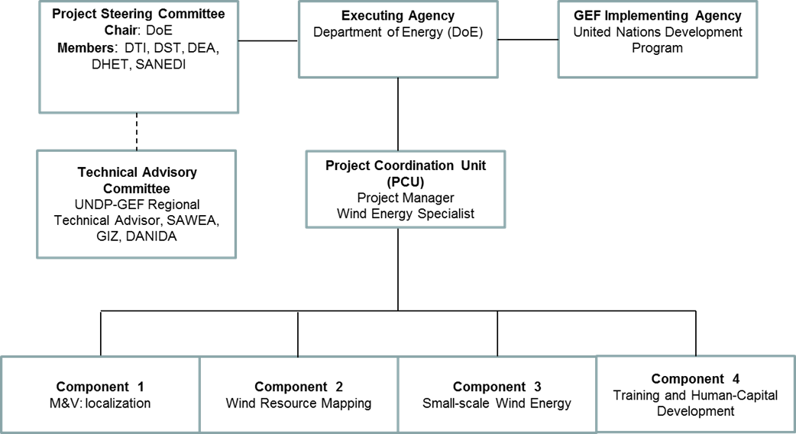

Monitoring Framework and Evaluation

The M&E framework is based on established UNDP and GEF procedures. Specifically, the results-based management (RBM) approach, which emphasizes the measurement of outputs, outcomes and impacts. The logical framework defines the outputs and outcomes, including the corresponding ‘SMART’ indicators. Provision will be made for a review of baseline indicators and validity of corresponding assumptions during the inception process. A deliberate effort to use the M&E framework to institutionalise key lessons-learned during implementation will contribute towards increasing country ownership, improving decision-making and enhancing the sustainability of project outcomes.

Given the pace at which changes have taken place in the South African energy sector in recent years, the importance of a predictable and flexible M&E framework in providing assurance of relevance, efficiency, effectiveness and sustainability cannot be over-emphasized.

The PCU, with the support of relevant stakeholders, will be responsible for implementing the M&E activities outlined herein. The corresponding budget for the activities is illustrated in Table 6.

Project start: A Project Inception Workshop will be held within the first 2 months of the project’s commencement. The workshop participants will primarily be those with assigned roles in the project organization structure, UNDP Country Office and, where appropriate/feasible, regional technical policy and programme advisors, as well other stakeholders. The Inception Workshop is crucial to building ownership for the project results and to plan the first year annual work plan.

The Inception Workshop will address a number of key issues including:

- Assist all implementation partners to fully understand and take ownership of the project. Detail the roles, support services and complementary responsibilities of UNDP CO, DoE, the regional technical advisor and the project team.
- Based on the project results framework and the relevant GEF Tracking Tool if appropriate, finalize the first annual work plan. Review and agree on the indicators, targets and their means of verification, and recheck assumptions and risks.
- Provide a detailed overview of reporting, monitoring and evaluation (M&E) requirements. The Monitoring and Evaluation work plan and budget should be agreed and scheduled.
- Discuss the staff recruitment and procurement procedures to be followed during the project’s implementation, including arrangements for oversight by relevant structures.
- Discuss financial reporting procedures and obligations, and arrangements for annual audit.
- Discuss the roles, functions, and responsibilities within the project's decision-making structures, including reporting and communication lines, and conflict resolution mechanisms. The Terms of Reference for the project’s decision-making structures will be refined and finalized as needed.
- Plan and schedule Project Steering Committee meetings. Confirm Project Steering Committee members and schedule oversight meetings, noting that such meetings may of necessity be more frequent in the initial stages of project implementation. For instance, the first two Project Steering Committee meetings may take place every 3 months, with the interval increasing to every 6 months thereafter.

An Inception Workshop report will be compiled and shared with participants to formalize various agreements and plans decided during the inception process.

Quarterly: Reporting at this level will focus on implementation progress, including the on-going management of risks. Some of the key activities will include:
- Progress monitoring by means of the UNDP Enhanced Results Based Management Platform.
- Taking into account the initial risk analysis submitted, regular updates to the risk log, using ATLAS. Based on this approach, risks become critical when both the impact and probability are high.
- Based on the information recorded in Atlas, Project Progress Reports (PPRs) can be generated in the Executive Snapshot.
- Other ATLAS logs can be used to monitor issues and lessons-learned, noting that the use of these risk management tools is a key indicator in the UNDP Executive Balanced Scorecard.

Annually: Annual reports will be used to review strategic and operational issues, as well as the project’s financial status (e.g. comparisons of actual and planned disbursement profiles). Combining both UNDP and GEF reporting requirements, the Annual Project Review/Project Implementation Reports (APR/PIR) will facilitate reporting on at least the following:
- Progress made toward project objective and project outcomes - each with indicators, baseline data and end-of-project targets.
- Project outputs delivered per project outcome, annually.
- Lesson learned/good practice.
- Annual Work Plan (AWP) implementation, including comparisons to baseline schedules.
- Expenditure reports, including comparisons with budgeted disbursements.
- Risks and the continued management thereof.
- ATLAS QPR.

Annual Project Report (APR) and Project Implementation Review (PIR)
The APR is a self-assessment report by project management to the country office and provides CO input to the reporting process and the Results Oriented Annual Report (ROAR), as well as forming a key input to the Tripartite Project Review. The PIR is an annual monitoring process mandated by the GEF. These two reporting requirements are so similar in input, purpose and timing that they can be amalgamated into a single report.

An APR/PIR is prepared on an annual basis following the first 12 months of project implementation and prior to the Tripartite Project Review. The purpose of the APR/PIR is to reflect progress achieved in meeting the project's annual work plan and assess performance of the project in contributing to intended outcomes through outputs and partnership work. The APR/PIR is discussed in the TPR so that the resultant report represents a document that has been agreed upon by all of the primary stakeholders.

A standard format/template for the APR/PIR is provided by UNDP GEF. This includes the following:
  - An analysis of project performance over the reporting period, including outputs produced and, where possible, information on the status of the outcome.
  - The constraints experienced in the progress towards results and the reasons for these.
  - The major constraints to achievement of results.
  - Annual work plans and related expenditure reports.
  - Lessons learned
  - Clear recommendations for future orientation in addressing key problems in lack of progress

Portfolio-level indicators (i.e. GEF focal area tracking tools) are used by most focal areas on an annual basis as well.

Periodic Monitoring through site visits: The relevant UNDP and Regional Coordinating Unit (RCU) staff members will conduct visits to project sites based on the agreed schedule in the project's Inception Report/AWP in order to assess project progress. Other members of the Project Steering Committee may also join these visits. A Field Visit Report/Back-to-Office Report (BTOR) will be prepared by the UNDP staff members for circulation to the project team and Project Steering Committee members, no less than one month after each visit.

Mid-term of project cycle: The project will undergo an independent Mid-Term Review (MTR) at the mid-point of project implementation (i.e. end-2016, assuming project commencement beginning-2015). The Mid-Term Review will determine progress being made toward the achievement of outcomes and identify corrective measures where necessary.

The MTR will:
- Focus on the effectiveness, efficiency and timeliness of project implementation.
- Highlight issues requiring decisions and actions, and,
- Present initial lessons-learned about project design, implementation and management.

The MTR’s findings will be incorporated as recommendations for enhanced implementation during the final half of the project’s term. The organization, terms of reference and timing of the mid-term review will be decided after consultation between the parties to the project document.

The MTR Terms of Reference will be prepared by the UNDP CO, taking into account guidance from the Regional Coordinating Unit and UNDP-GEF. The review and management response will be uploaded to UNDP corporate systems, in particular the UNDP Evaluation Office Evaluation Resource Centre (ERC).

The GEF Climate Change Mitigation Focal Area Tracking Tool will also be completed during the MTR cycle.

End of Project: An independent Final Evaluation (FE) will take place three months prior to the final Project Steering Committee meeting, in accordance with UNDP and GEF guidance. The final evaluation will focus on the delivery of the project’s results as initially planned (and as corrected after the mid-term evaluation, if any such correction took place). The final evaluation will also assess the impact and sustainability of results, including the contribution to capacity development and the achievement of global environmental benefits/goals.

The FE report should also provide recommendations for follow-up activities and be accompanied by a management response. The FE report should be uploaded to PIMS and submitted to the UNDP Evaluation Office Evaluation Resource Centre (ERC). The relevant UNDP staff members will prepare the Terms of Reference for the end-of-project evaluation, taking into account guidance from the RCU and UNDP-GEF.

The GEF Climate Change Mitigation Focal Area Tracking Tool will also be completed during the Final Evaluation cycle.

During the last three months, the project team will prepare the Project Terminal Report. This comprehensive report will summarize the results achieved (objectives, outcomes, outputs), lessons-learned, problems met and areas where results may not have been achieved. It will also lay out recommendations for any further steps that may need to be taken to ensure sustainability and replicability of the project’s results.

Learning and knowledge-sharing: Results from the project will be disseminated within and beyond the project intervention zone through existing information sharing networks and forums.

The project will identify and participate, as relevant and appropriate, in scientific, policy-based and/or any other networks, which may be of benefit to project implementation through lessons learned. The project will identify, analyse, and share lessons learned that might be beneficial in the design and implementation of similar future projects.

Finally, there will be a two-way flow of information between this project and other projects of a similar focus.

M&E Workplan and Budget

Table 6: M&E Activities, Responsibilities, Budget and Timing

M&E activity | Responsibility | Budget US$  Excluding project team staff time | Timing
Inception Workshop and Report | - SAWEP II Project Manager  - UNDP CO, UNDP GEF | 5,000 | Within first two months of project start up
Measurement and Verification of project progress in output and implementation | - M&E Expert, with the SAWEP II Project Manager exercising oversight  - Project team members, as applicable | 6,000  59,172 | Start of project then annually prior to APR/PIR and to the definition of AWPs
APR/PIR | - Project Manager and team  - UNDP CO  - UNDP-GEF | None | Annually
TPR meeting/ TPR report | - Government counterparts  - UNDP CO  - Project Manager and team  - UNDP-GEF RCU | None | Annually, upon receipt of APR
Periodic status/ progress reports | - Project manager and team | None | Quarterly
Mid-term Review | - Project Manager and team  - UNDP CO  - UNDP RCU  - External Consultants (i.e. evaluation team) | 25,000 | At the mid-point of project implementation
Final Evaluation | - Project Manager and team,  - UNDP CO  - UNDP-GEF RCU  - External Consultants (i.e. evaluation team) | 27,000 | At least three months before the end of project implementation
Project Terminal Report | - Project Manager and team  - UNDP CO | None | At least three months before the end of the project
Audit | - UNDP CO  - Project Manager and team | 8,000 | Annually
TOTAL indicative COST  Excluding project team staff time and UNDP staff and travel expenses |  | 130,172

Audit Clause: Audit will be conducted according to UNDP Financial Regulations and Rules and applicable Audit policies.

Legal Context

This document together with the CPAP signed by the Government and UNDP which is incorporated by reference constitute together a Project Document as referred to in the SBAA and all Country Programme provisions apply to this document.

Consistent with the Article III of the Standard Basic Assistance Agreement, the responsibility for the safety and security of the implementing partner and its personnel and property, and of UNDP’s property in the implementing partner’s custody, rests with the implementing partner.

The implementing partner shall:
- put in place an appropriate security plan and maintain the security plan, taking into account the security situation in the country where the project is being carried out;
- assume all risks and liabilities related to the implementing partner’s security, and the full implementation of the security plan.

UNDP reserves the right to verify whether such a plan is in place, and to suggest modifications to the plan when necessary. Failure to maintain and implement an appropriate security plan as required hereunder shall be deemed a breach of this agreement.

The implementing partner agrees to undertake all reasonable efforts to ensure that none of the UNDP funds received pursuant to the Project Document are used to provide support to individuals or entities associated with terrorism and that the recipients of any amounts provided by UNDP hereunder do not appear on the list maintained by the Security Council Committee established pursuant to resolution 1267 (1999). The list can be accessed via http://www.un.org/Docs/sc/committees/1267/1267ListEng.htm. This provision must be included in all sub-contracts or sub-agreements entered into under this Project Document.

ANNEXES

Annex 1: Letters of Co-Financing Commitment and Cooperation

i. SARETEC (Department of Higher Education and Training)

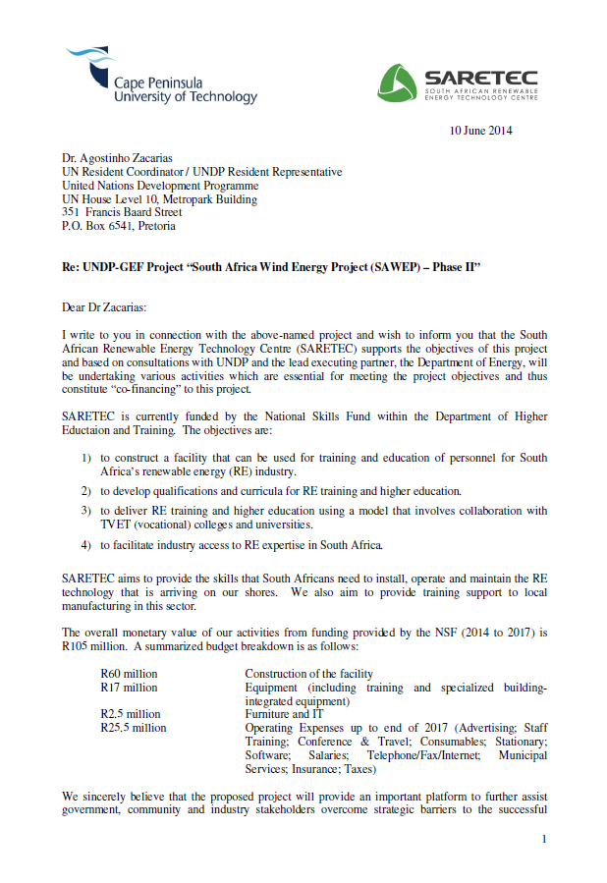

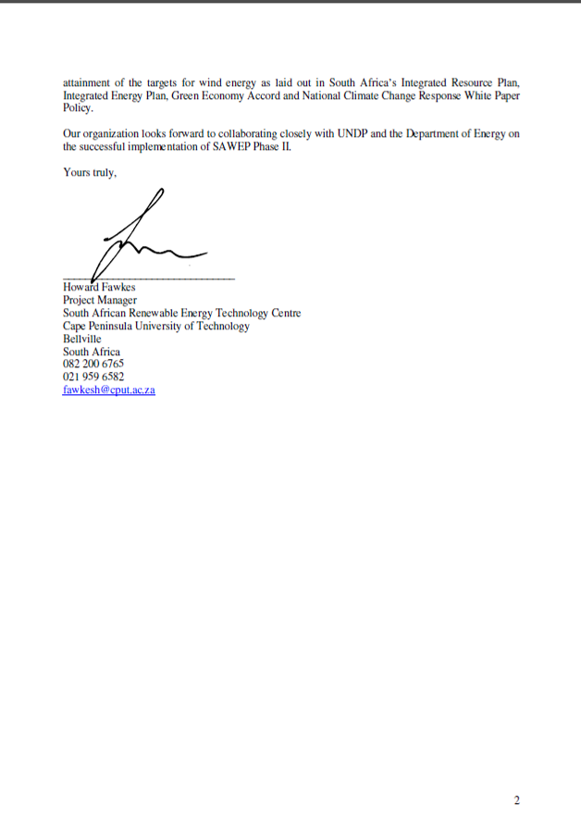

ii. Department of Energy

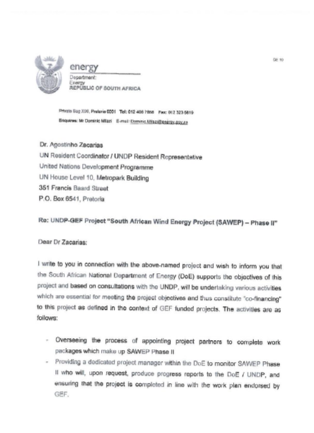

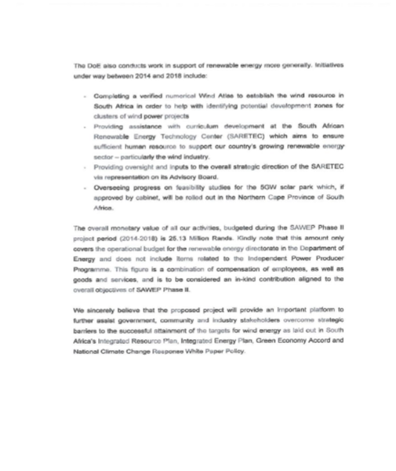

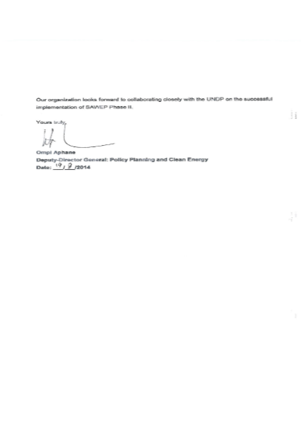

iii. Department of Trade and Industry

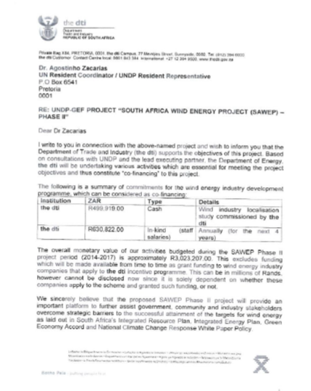



iv. Department of Environmental Affairs

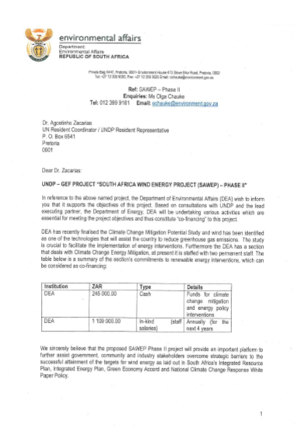

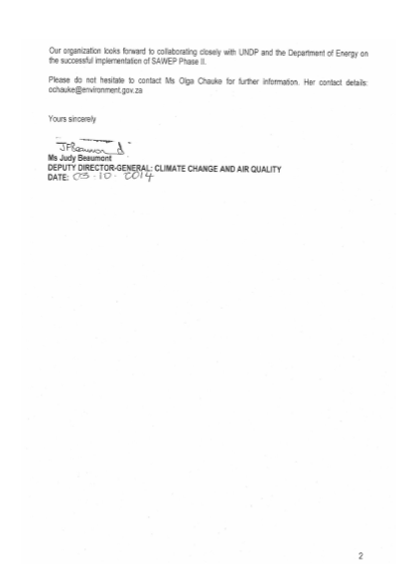

v. Department of Science and Technology

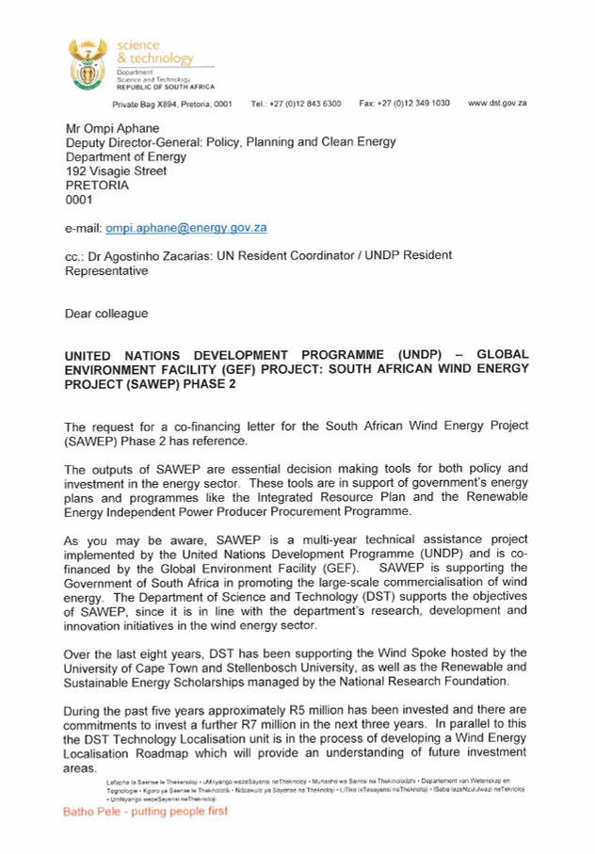

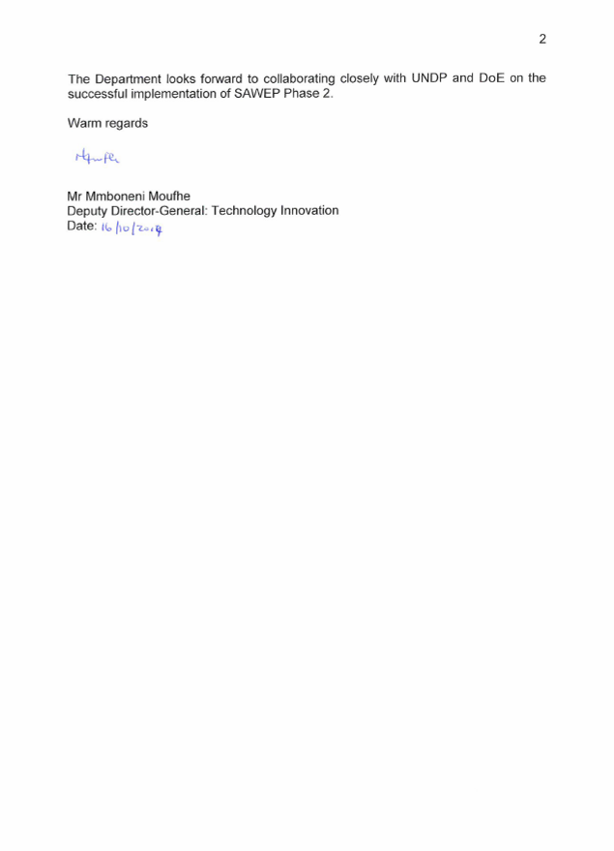

vi. Government of Germany

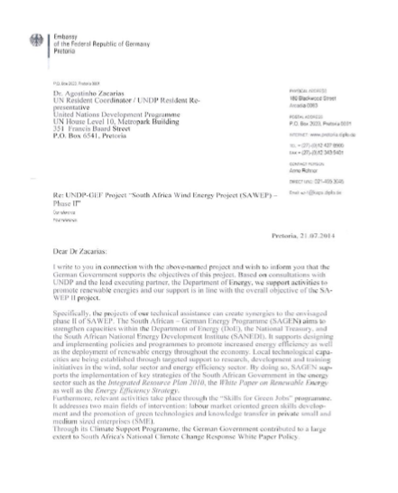

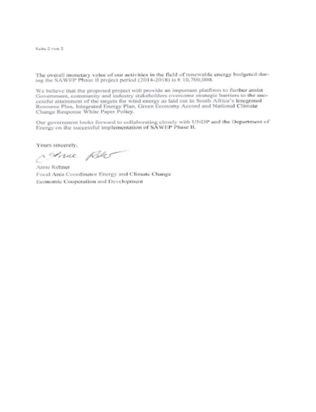

vii. Government of Denmark

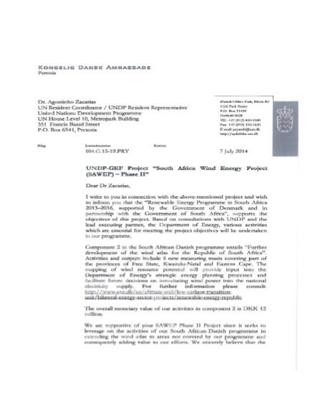

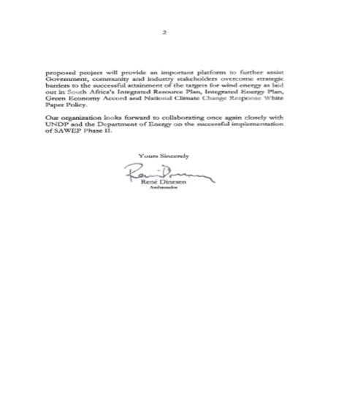

viii. South African Wind Energy Association

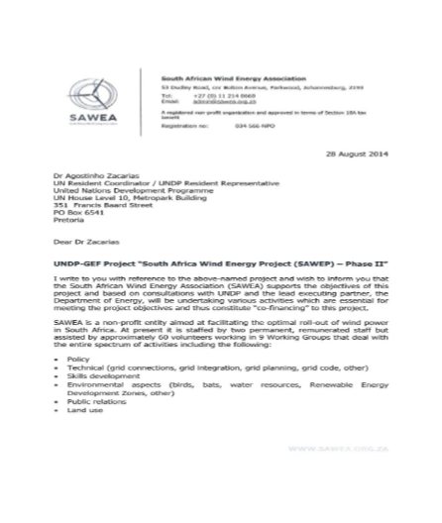

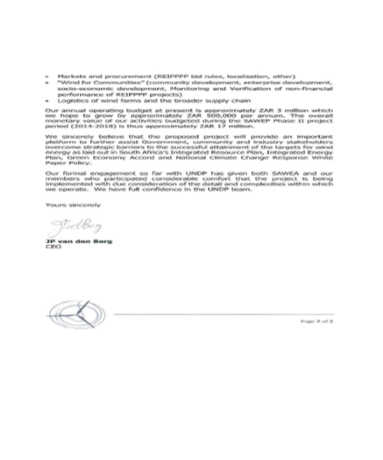

ix. Adventure Power (private sector)

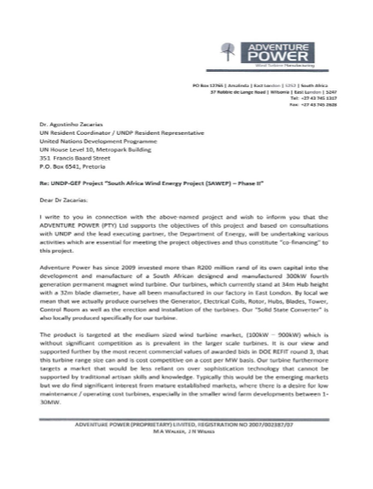

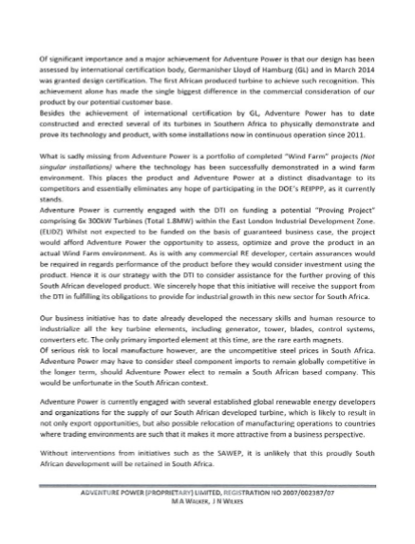

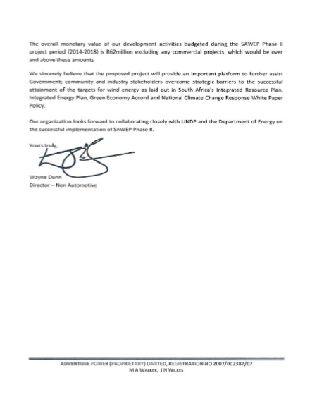

x. UNDP

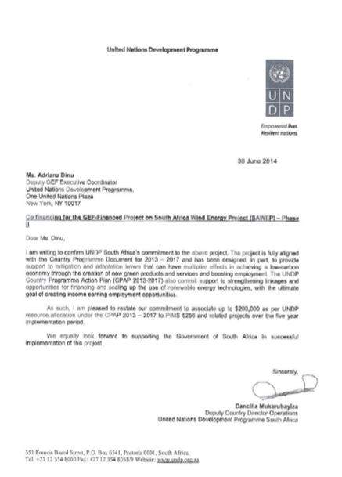

Annex 2: CCM Tracking

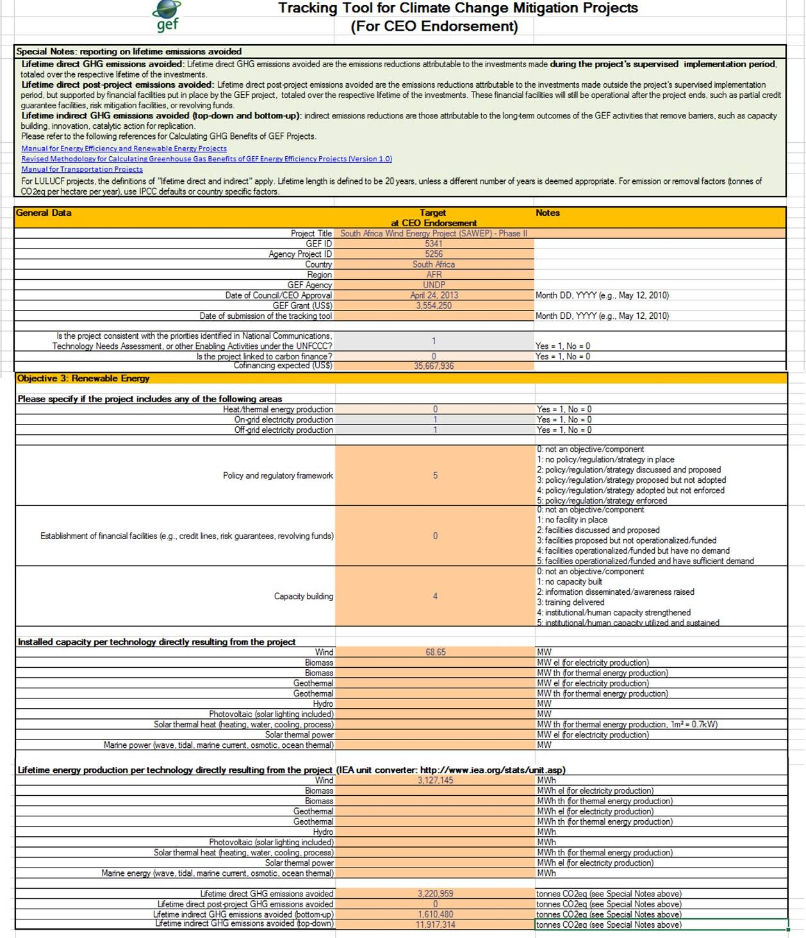

Annex 3: De-Risking Energy Investment (DREI) Analysis

Modelling Results for South Africa

20-Year Target for Wind Energy
The modelling case study assumes an 8.4 GW 20-year target for wind investment in South Africa. With its strong wind resources, wind now represents a major opening for large-scale private sector investment in the South African energy sector. Wind energy can meet the country’s increasing energy demand and can also assist in decarbonising the current coal-dominated grid. Given the ambition of the 20-year target, the opportunity exists for South Africa to become a regional leader and hub for wind energy.

Baseline Energy Mix
South Africa’s current peak demand is about 36,500 MW, which is covered by an installed capacity of 38,000 MW. With abundant domestic coal resources, coal provides in excess of 90% of South Africa’s electricity generation. Additional installed capacity includes a 1,960 MW nuclear plant, as well as a small number of gas-turbine and hydro-electric plants.

Energy generation \mix in South Africa (1971 to 2009)
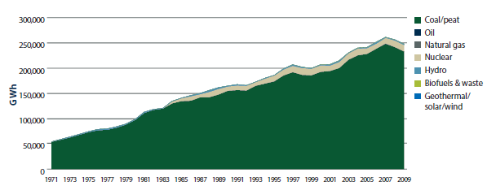
Source: IEA (2012)

The modelling case study assumes a marginal baseline mix of 100% coal, using the UNFCCC CDM methodology for determining marginal baselines (i.e. build margins). The baseline grid emission factor used for the DREI analysis is 1.050 tonnes of CO₂e/MWh, reflecting the high carbon content of coal.

Wind Resources
Some of the sites with strongest wind speeds are found along the coast in both the Western and Eastern Cape. Mainland locations can also be attractive.

Wind map of South Africa
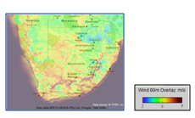
Source: 3 Tier (2012)

Using a modelling algorithm to select the best sites in the country, the case study uses an average capacity factor of 39% for the 8.4 GW target installed capacity for wind energy. An important related modelling assumption is that transmission lines and grid extensions to access these sites will be built.

Current Status of Wind Investment
The current installed capacity of wind energy in South Africa is 10 MW spread over three pilot wind farms, including a 3 MW Eskom pilot commissioned in 2003 and the 5 MW donor-funded Darling demonstration project installed in 2008. The Government’s request for proposal (RFP) for wind energy, launched in August 2011, demonstrated a high degree of interest from the private sector. The first window of the bidding process, with a submission date in November 2011, resulted in the selection of 8 preferred bidders for wind energy, totalling 634 MW. The average price of the preferred bidders was ZAR 1.143 per kWh (or USD 13.5 cents per kWh). The PPAs related to these bids were signed in November 2012. The second window of the bidding process, with a submission date of March 2012, resulted in the selection of 7 preferred bidders for wind energy, totalling 563 MW. The average price for the second window was lower at ZAR 0.897 per kWh (or USD10.5 cents per kWh). The submission date for the third window was May 2013.

Interviews
Data for Stage 1 (Risk Environment) of the modelling case study was gathered from interviews held with 6 current project developers and investors who are considering, or are actively involved in, pursuing wind investment opportunities in South Africa. An additional 4 information interviews were held with other stakeholders in South Africa.

Risk Environment (Stage 1)
The case study’s analysis of the contribution of risks to increasing financing costs for South African wind energy is shown in the risk waterfalls in the Figure below. A brief summary of the qualitative feedback that wind energy developers and investors shared in their interviews is provided in the table below. These results identify power-market risk and currency/macro-economic risk as the most significant risk categories impacting financing costs in South Africa. Other risk categories also affect financing costs, but to a lesser degree.

Impact of risk categories on financing costs for wind energy investment in South Africa, business-as-usual scenario
Business-as-Usual Financing Costs
Source: interviews with wind energy investors and developers; modelling exercise.

Investor feedback on risk categories for wind energy investment in South Africa
RISK CATEGORY | DESCRIPTION / EXAMPLES OF RISK
Power market risk | This risk category has a high impact on financing costs. On the positive side, investors comment favourably on many aspects of the regulatory framework. South Africa has a clear long-term 2030 target for wind energy in place. After a prolonged start, when the originally envisaged renewable energy feed-in tariff (‘REFIT’) was dropped, investors generally praise the replacement bidding process as well-defined and robust. The bidding process’s stringent requirements on financing to ensure projects are commissioned is viewed positively. In terms of competitiveness, investors note that fossil fuel subsidies on electricity have been rolled-back in recent years, with end-user pricing rising significantly in this period.  On the other hand, investors raise concerns in a number of areas. Some caution is expressed regarding Eskom’s monopoly and a perception of past difficult experiences for fossil fuel IPPs to enter the market in South Africa. Some investors remark that tender processes can result in aggressive bidding and question whether current bids are sustainable. Investors also raise concerns regarding delays to the tender process. Looking ahead, investors note that it will be important for the Government to closely monitor the development of the energy sector if it is to continue to maintain an effective regulatory framework going forward. Some investors expect local content requirements may become restrictive in later bidding windows.
Permits risk | This risk category has a moderate impact on financing costs. Investors generally view the licensing process with NERSA and other entities positively, noting good progress having been made in designing transparent, streamlined procedures, as well as in training staff specifically in wind energy. At the same time, some investors comment on a lack of coordination between entities issuing licences and permits.
Social acceptance risk | This risk category has a low impact on financing costs. Investors remark that public resistance to wind energy is low. They also note that the bidding process has trust-building requirements with local communities, with many communities holding stakes of up to 5%. Some investors, however, feel that social acceptance risk may increase overtime, particularly as wind farms become more widespread. Wind power can be perceived negatively as being expensive in comparison to coal-fuelled power.
Grid integration risk | This risk category has a moderate impact on financing costs. Investors comment that, after a mixed start, good recent progress has been made in coordinating with Eskom on this matter. NERSA has been regularly updating the grid code, which investors comment on as being realistic and suitable. The PPA has a 5% curtailment clause - investors note it is important that this is correctly priced into bids.
Counterparty risk | This risk category has a moderate impact on financing costs. The standard PPA is with Eskom; however, Eskom’s payments are backed by the Department of Energy. Investors are reassured by this Government backing. Nonetheless, given the large long-term targets for renewable energy in South Africa, investors comment that counterparty risk remains, even at the sovereign level.
Financial sector risk | This risk category has a moderate impact on financing costs. South Africa has a large, developed financial sector, which has welcomed and engaged with wind-energy. The successful participants in the first bidding windows have obtained commitments for financing, in the most part from domestic banks. Given the large total investments needed to meet the long-term target, investors do express concern regarding lack of capital for investors participating in future bidding windows.
Political risk | This risk category has a moderate impact on financing costs. Investors are generally attracted by South Africa’s stable political environment. Nonetheless, issues such as social inequality and good governance are identified as possible concerns.
Currency/  macroeconomic risk | This risk category has a high impact on financing costs. The standard PPA for wind-energy is Rand-denominated and inflation-linked. Investors comment that this creates significant currency risk, particularly given the historical volatility of the Rand.
Source: interviews with investors and developers.

Public Instruments (Stage 2)
As an investment-grade country, the case study assumes no need for financial derisking in South Africa, and only implements a package of policy derisking instruments. The public cost of the policy derisking package is estimated at USD 40 million over the 20-year modelling period. For a breakdown of this cost, see the table at the end of this annex. The impact of the policy derisking instruments on reducing financing cost for wind energy in South Africa are shown in the Figure below. Based on the modelling analysis, the package of policy derisking instruments is anticipated to reduce the average cost of equity over 20 years by 1.2%, and the cost of debt by 0.5%.

Impact of policy derisking instruments on reducing financing costs for wind energy in South Africa.
Post-Derisking Financing Costs
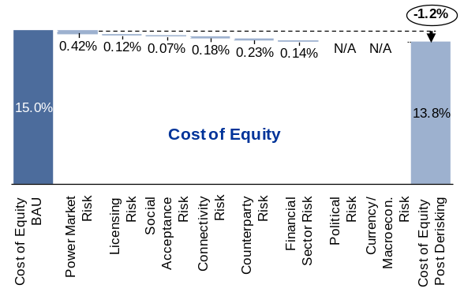 |  | 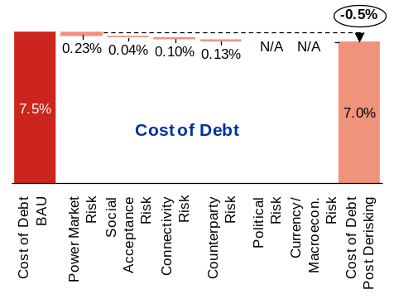
Source: interviews with wind energy investors and developers; modelling exercise.
Note: the impacts shown are average impacts over the 20-year modelling period, assuming linear timing-effects.

Levelised Cost (Stage 3)
The case study’s outputs in terms of LCOEs are shown in the Figure below, where wind energy is shown to be more expensive than the country’s marginal baseline. The current unsubsidised marginal baseline LCOE is USD 7.4 cents per kWh. The policy derisking package reduces the LCOE for wind energy from USD 9.6 cents per kWh (BAU scenario) to USD 8.9 cents per kWh (post-derisking scenario). In both scenarios, a financial incentive is required to address the incremental cost to make wind energy competitive. The second window’s preferred bidders submitted an average price of USD 10.5 cents per kWh, above the modelling BAU scenario price of USD 9.6 cents per kWh. This difference is likely a result, at least in part, of the modelling exercise having selected more attractive wind sites given its assumption of the availability of transmission lines. The sensitivity analysis on the wind capacity factor, found later in this case study, illustrates how using a lower wind capacity factor in the model can result in higher LCOEs for the BAU scenario.

LCOEs for the marginal baseline and wind investment in South Africa
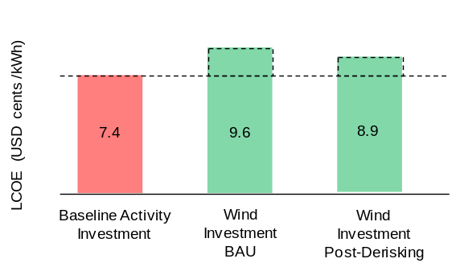

Source: modelling exercise.

Evaluation (Stage 4)
The case study’s performance metrics, evaluating the impact of derisking across the entire 8.4 GW modelling target for wind investment in South Africa, are shown in the Figure below. Taken as a whole, the performance metrics illustrate the potential for policy derisking to significantly reduce the financial incentives required to promote renewable energy in South Africa. Today in South Africa, as represented by the BAU scenario, it is likely that significant private sector investment in wind energy will occur; however, this may come at a significant cost. The case study’s investment leverage ratio for the BAU scenario is 2.3x, where a large contributor is the direct financial incentive (premium) for wind, estimated at USD 7.3 billion over 20 years. Under the post-derisking scenario, as illustrated by the savings leverage ratio of 57.8x, the USD 40 million package of policy derisking instruments can be highly impactful, resulting in a USD 2.3 billion reduction in the needed financial incentive over 20 years.

Performance metrics for the selected package of policy derisking instruments in promoting 8.4 GW of wind energy investment in South Africa
 | Investment Leverage Ratio  (Metric 1) |  |  |  | Savings Leverage Ratio  (Metric 2)
 | 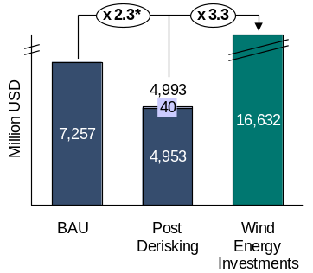 |  | 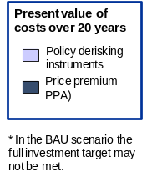 |  | 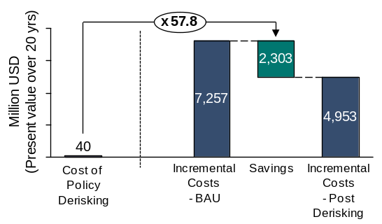
 | Affordability  (Metric 3) |  |  |  | Abatement Costs  (Metric 4)
 | 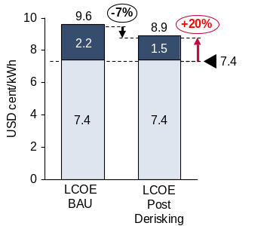 | 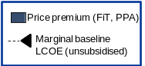 |  |  | 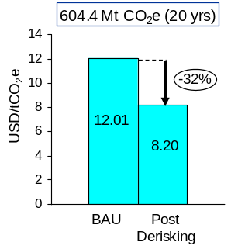
Source: modelling exercise.

The case study’s example sensitivities, for the wind energy capacity factor as well as marginal baseline fuel costs, are shown in the table below. As an illustration, for the affordability metric – which examines the incremental cost per kWh – a 10% increase in wind capacity factor in the post-derisking scenario results in a corresponding 54% reduction in the incremental cost in the post-derisking scenario.

Table 7: Example sensitivity analyses on the South Africa case study’s performance metrics when varying key inputs by +/- 10%.

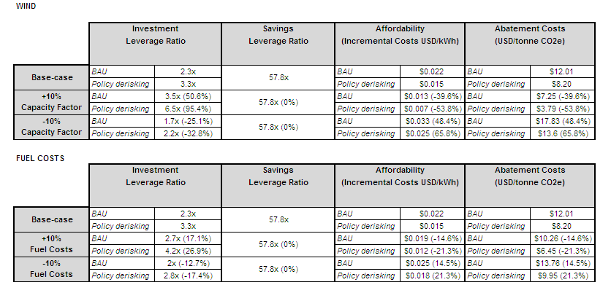
Source: modelling exercise.

Summary DREI assumptions for the South Africa case study
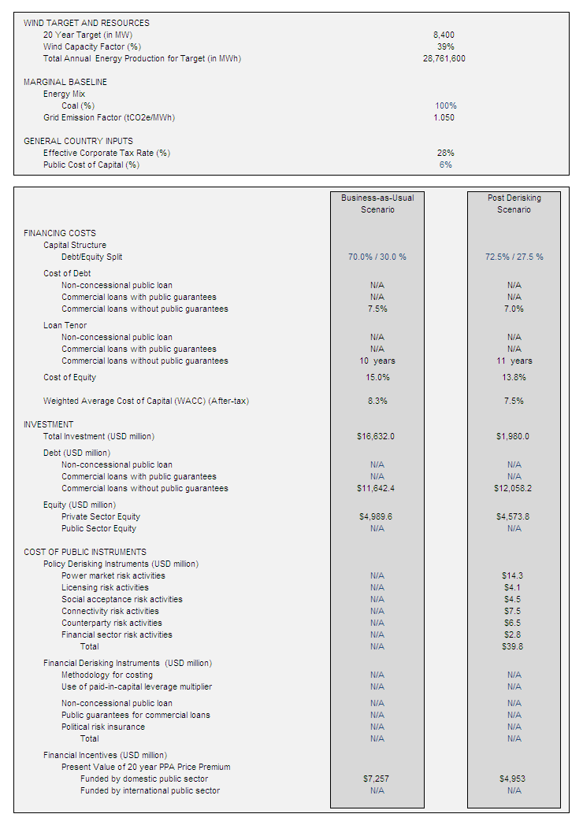

Financing costs are average cost over 20-year target.

Annex 4: Terms of Reference for Key Project Staff

1. Project Manager

I. Summary Information
Post title:  Office:  Duration of Employment: |  | Project Manager (South African National)  Department of Energy (DoE)  Two years with possibility of extension (up to four years)
II. Overview
The Project Manager (PM) will be selected jointly by the executing agency and UNDP, in consultation with the UNDP/GEF Regional Technical Adviser from the UNDP/GEF Regional Co-ordination Unit, through an open and competitive process.

The PM’s prime responsibility is to ensure that the project produces the results specified in the project document, to the required standard of quality and within the specified constraints of time and cost. As such, the PM will be responsible for the overall management of the project, including the mobilization of all project inputs; supervision of project staff, consultants and sub-contractors; and acting as a liaison with the Government, UNDP, private sector partners and other stakeholders, and maintaining close collaboration with donor agencies providing co-financing.

The PM will report to the Project Steering Committee (PSC) on overall progress of project activities. For on-going administrative and reporting functions, the PM will be responsible to the Department of Energy (DoE) and UNDP for administrative and financial matters, and DoE for technical matters. The PM will be based at the offices of DoE in Pretoria, and the will benefit from support services of the UNDP Country Office. Such services will include financial reporting, as well as the procurement of consultants for the implementation of specific technical assistance (TA) components of the project. The PM will also be supported by a nationally -recruited Wind Energy Specialist.

The services of either individual consultants or consulting companies will be procured in accordance with applicable UNDP/GEF guidelines.
II. Duties & Responsibilities
- Supervise and coordinate the production of project outputs, as per the project document;
- Mobilise all project inputs in accordance with procedures for nationally implemented projects;
- Lead the preparation of consultants’ and sub-contractors’ terms of reference, identification and selection of national and international sub-contractors/consultants, cost estimation, time scheduling, contracting, and reporting on project activities and budget, and supervise and coordinate the work of all consultants and sub-contractors;
- In close liaison with the implementing partners, prepare and revise project work and financial plans;
- Liaise with relevant Government agencies, private partners, and all other partners for effective coordination of all project activities;
- Oversee and ensure timely submission of the Inception Report, Combined Project Implementation Review/Annual Project Report (PIR/APR), technical reports, quarterly financial reports, and other reports as may be required by UNDP, GEF, and other oversight agencies;
- Disseminate project reports and respond to queries from stakeholders;
- Report progress of project to the PSC, and ensure the fulfilment of PSC directives;
- Oversee the exchange and sharing of experiences and lessons learned with relevant projects nationally and internationally;
- Ensure the timely and effective implementation of all components of the project;
- Assist relevant Government agencies and implementing partners with development of essential skills through training workshops and on the job training, thereby upgrading their institutional capabilities;
- Carry out regular, announced and unannounced inspections of all sites and activities;
- Undertake other management duties that contribute to the effective implementation of the project.
III. Qualifications and Experience
Education: | - Master’s degree or equivalent in engineering, economics, energy or other relevant field.
Experience: | - Minimum of 5 years of experience in the utility/energy field;  - Experience in project management;  - Proven ability to draft, edit and produce written proposals and results-focused reports.  - Strong presentation and reporting skills;  - Ability to administer budgets, train and work effectively with counterpart staff at all levels and with all groups involved in the project;  - Proven experience working with Government, private sector, civil society, international organisations or donors in combination with the knowledge of economic and financial analysis, institutional, regulatory and policy frameworks;  - Good knowledge of climate change and energy issues;  - Prior knowledge and experience of the political, social and environmental factors and issues related to energy development and climate change mitigation;  - Knowledge of and experience with operational modalities and procedures of UNDP and/or GEF highly desirable;  - Experience in the use of computers and office software packages (MS Word, Excel, etc.).
Language Requirements: | - Excellent English, both written and oral.

2. Wind Energy Specialist

I. Summary Information
Post title:  Office:  Organisation:  Duration of Employment: |  | Wind Energy Specialist (South African national)  In Country  DoE  17 months part-time, over two years
II. Overview
The Wind Energy Specialist (WES) will be nationally recruited based on an open competitive process. The WES will report to the Project Manager (PM). The WES will work on a part-time basis during the four year implementation period, with more of the total time being allocated in the first two years. The WES will provide 12 weeks of support during the first two years, and 5 weeks in the remaining 2 years. The WES will provide specialist support in regard of wind energy, focusing on technical issues.
II. Duties & Responsibilities
The WES will provide ad-hoc advice on technical matters related to wind energy, with specific reference to the following:
- Provide advisory support to the Project Manager (PM) and Project Steering Committee (PSC) on the technical aspects of the project’s components (e.g. project plans, ToRs and M&E planning);
- Review the technical aspects of reports submitted to PM by consultants and contracted organisations;
- Assist in the implementation of other technical aspects of the project as needed and mutually agreed.
III. Qualifications and Experience
Education: | Minimum of a Master’s degree in an engineering discipline related to wind energy (e.g. electrical, mechanical, etc.).
Experience: | - Minimum of 10 years of experience in the renewable resources sector with working knowledge of wind energy;  - Practical experience in similar assignments;  - Demonstrated leadership ability and technical ability to communicate complex ideas verbally and in writing;  - Prior UNDP/GEF project experience and knowledge of UNDP and GEF procedures and guidelines is an advantage.
Language Requirements: | - Excellent English, both written and oral.

Annex 5: Project Implementation Schedule

 |  |  | 2015 |  |  | 2016 |  |  |  | 2017 |  |  |  | 2018 |  |  |  | 2019 | Lead Responsibility for Implementation
Outputs |  | Jan-Mar | Apr-Jun | Jul-Sep | Oct-Dec | Jan-Mar | Apr-Jun | Jul-Sep | Oct-Dec | Jan-Mar | Apr-Jun | Jul-Sep | Oct-Dec | Jan-Mar | Apr-Jun | Jul-Sep | Oct-Dec | Jan-Mar | Lead Responsibility for Implementation
 | Component 1: Optimisation and improvement of local content targets in wind energy procurement mechanisms
Output 1.1: Additional investments in wind farms by Year 4 of project implementation |  |  |  |  |  |  |  |  |  |  |  |  |  |  |  |  |  |  | DoE, DTI, SAWEA
Output 1.2: Increased share of procurement spend attributed to locally-produced components and related services, in support of DTI’s Localisation Roadmap |  |  |  |  |  |  |  |  |  |  |  |  |  |  |  |  |  |  | DoE, DTI, SAWEA
Output 1.3: Sustained competitive prices resulting from increased local procurement of components |  |  |  |  |  |  |  |  |  |  |  |  |  |  |  |  |  |  | DoE, DTI, SAWEA
Output 1.4: Local content Monitoring and Verification (M&V) system developed |  |  |  |  |  |  |  |  |  |  |  |  |  |  |  |  |  |  | Consultants
Output 1.5: Based on M&V system, capacity developed in government and targeted areas of the value-chain to support local content requirement |  |  |  |  |  |  |  |  |  |  |  |  |  |  |  |  |  |  | Consultants
 | Component 2: Resource-mapping and wind corridor development support for policy-makers
Output 2.1: Verified Wind Atlas extended to the Free State and remaining parts of the Northern Cape |  |  |  |  |  |  |  |  |  |  |  |  |  |  |  |  |  |  | PCU, SANEDI, Consultant
Output 2.2: Preliminary WASA II results analysed through the SEA tool for policy-makers to identify wind development corridors in WASA II sites as per DEA criteria. (from 2016) |  |  |  |  |  |  |  |  |  |  |  |  |  |  |  |  |  |  | PCU, SANEDI, DEA, Consultants
Output 2.3: Final WASA II results analysed through the SEA tool for policy-makers to identify wind development corridors in WASA II sites as per DEA criteria. (Between 2017 and 2018) |  |  |  |  |  |  |  |  |  |  |  |  |  |  |  |  |  |  | PCU, SANEDI, DEA, Consultants
Output 2.4: Capacity developed within Government to enable the use of wind resource data for energy planning at policy and strategic levels |  |  |  |  |  |  |  |  |  |  |  |  |  |  |  |  |  |  | PCU, SANEDI, DEA, Consultants
Output 2.5: Wind resource data and information related to new Renewable Energy Development Zones (REDZ) publicly disseminated. |  |  |  |  |  |  |  |  |  |  |  |  |  |  |  |  |  |  | PCU, SANEDI, DEA, Consultants
 | Component 3: Support for the development of small-scale wind sector
Output 3.1: Report on options to support of the small-scale wind sector outlined, including specification for a pilot project |  |  |  |  |  |  |  |  |  |  |  |  |  |  |  |  |  |  | PCU, DoE, DTI, SAWEA, Consultants
Output 3.2: Demonstration project for small-scale wind implemented |  |  |  |  |  |  |  |  |  |  |  |  |  |  |  |  |  |  | PCU, DoE, DTI, SAWEA, Consultants
 | Component 4: Training and human capital development for the wind energy sector
Output 4.1: Vocational apprenticeship program established between Eastern Cape-based TVETs, universities of technology/SARETEC and wind farms. |  |  |  |  |  |  |  |  |  |  |  |  |  |  |  |  |  |  | PCU, DHET, SARETEC, TVET College(s), Consultants
Output 4.2: Financial support provided for trainees that do not have adequate resources. |  |  |  |  |  |  |  |  |  |  |  |  |  |  |  |  |  |  | PCU, DHET, SARETEC
Output 4.3: The participation of women in training programs promoted. |  |  |  |  |  |  |  |  |  |  |  |  |  |  |  |  |  |  | PCU, DHET, SARETEC, SAWEA
Output 4.4: Training provided at SARETEC for lecturers in TVETs situated in WASA II sites and additional lectures in WASA I sites. |  |  |  |  |  |  |  |  |  |  |  |  |  |  |  |  |  |  | PCU, DHET, SARETEC, TVET Colleges(s),
Output 4.5: SARETEC and participating TVETs equipped with standardized training kits or equipment in support of the delivery of approved wind energy related curricula. |  |  |  |  |  |  |  |  |  |  |  |  |  |  |  |  |  |  | PCU, SARETEC, TVET College(s)
Output 4.6: Artisan development program involving the National Artisan Development (NAD) programme, TVETs, selected Original Equipment Manufacturers and Tier 1 and 2 suppliers, established. This will be linked to the localization roadmap. |  |  |  |  |  |  |  |  |  |  |  |  |  |  |  |  |  |  | PCU, DHET NAD, NSF, HRCSA, SAWEA, manufacturing sector
Output 4.7: Technical advisory provided in the development of a bespoke curriculum for wind energy fabrication. |  |  |  |  |  |  |  |  |  |  |  |  |  |  |  |  |  |  | PCU, DHET, NAD, Consultant
Output 4.8: Training provided for additional lecturers in TEVTs to provide wind energy-related training in terms of fabrication curriculum. |  |  |  |  |  |  |  |  |  |  |  |  |  |  |  |  |  |  | PCU, DHET, NAD, SARETEC
Output 4.9 Training provided at SARETEC for government officials on wind energy. |  |  |  |  |  |  |  |  |  |  |  |  |  |  |  |  |  |  | PCU, DHET, DoE, DTI, SARETEC
 | Project Management
Recruit/Procure Project Manager and Administrator |  |  |  |  |  |  |  |  |  |  |  |  |  |  |  |  |  |  | UNDP CO and DoE
Recruit/Procure Wind Energy Specialist |  |  |  |  |  |  |  |  |  |  |  |  |  |  |  |  |  |  | UNDP CO and DoE
Inception Workshop |  |  |  |  |  |  |  |  |  |  |  |  |  |  |  |  |  |  | PM, UNDP CO and DoE
Monitoring and Evaluation: Mid-term Review |  |  |  |  |  |  |  |  |  |  |  |  |  |  |  |  |  |  | UNDP CO and DoE
Monitoring and Evaluation: Final Evaluation |  |  |  |  |  |  |  |  |  |  |  |  |  |  |  |  |  |  | UNDP CO and DoE
Monitoring and Evaluation: Project Terminal Report |  |  |  |  |  |  |  |  |  |  |  |  |  |  |  |  |  |  | Project Team
PSC Meetings/Quarterly Project Reports |  |  |  |  |  |  |  |  |  |  |  |  |  |  |  |  |  |  | Project Team, PSC
Annual Project Reviews |  |  |  |  |  |  |  |  |  |  |  |  |  |  |  |  |  |  | Project Team
On-going coordination |  |  |  |  |  |  |  |  |  |  |  |  |  |  |  |  |  |  | Project Team

Annex 6: Comments from SAWEA Workshop (29 May 2014, Cape Town)

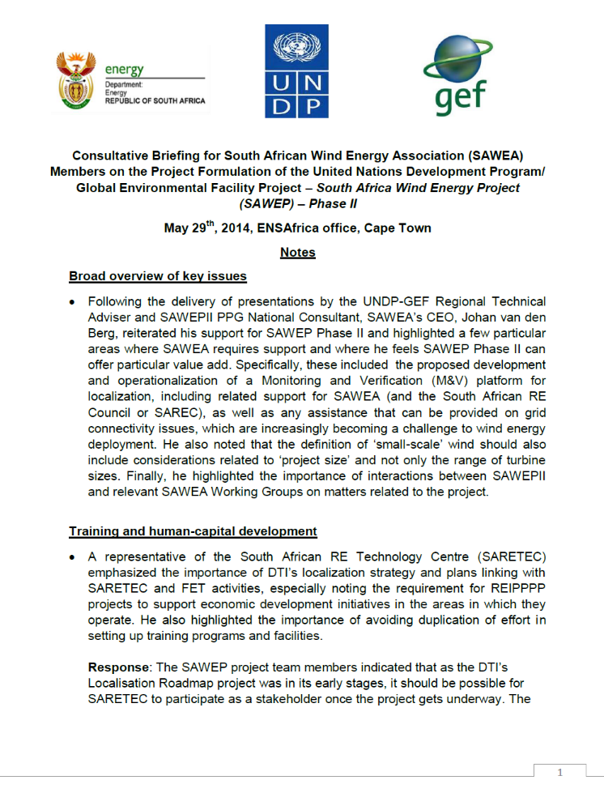

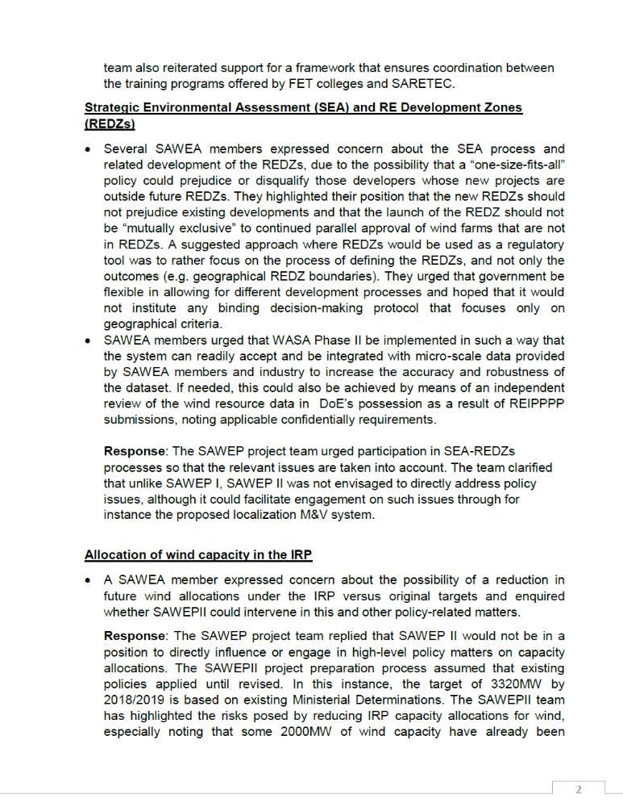

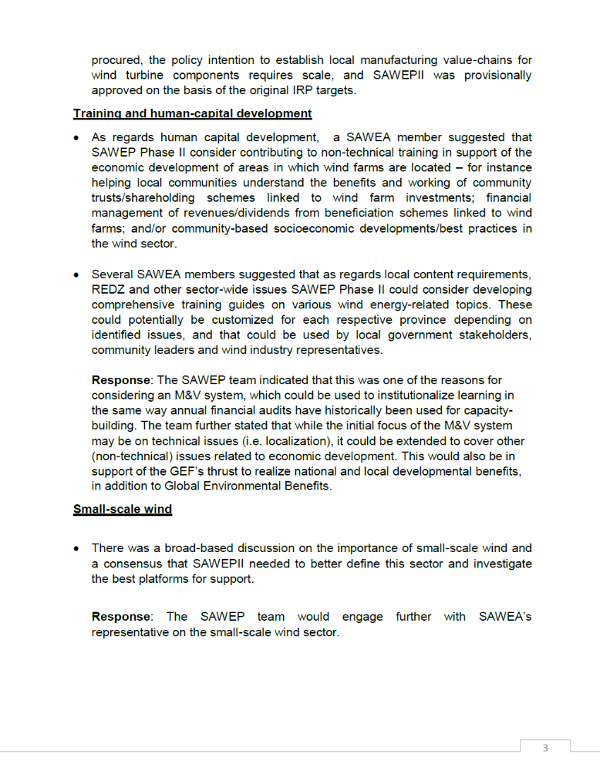

Annex 7: Greenhouse Gas Emissions Reduction Analysis

Considering the downward pressure on prices over the first three REIPPPP Bidding Windows, the relationships among future wind capacity allocations, investments in wind farms and localization requirements have become increasingly important in this regard.

For instance, a reduction in future wind capacity allocations would reduce investments in local manufacturing capacity – due to inadequate demand for locally produced components. A sustainable reduction in REIPPPP prices, on the other hand, requires large future wind capacity allocations – as a way of fostering economies of scale. An additional factor that requires consideration is the cost of building human capital, which would be required to fall if prices are to exhibit a downward trend.

SAWEP II is envisaged to contribute towards addressing these issues, by facilitating the following project components:
- Component 1: The development and implementation of the localization M&V system, which will, for instance, be used to assess the effect of local content requirements on such attributes of the REIPPPP as costs, prices and investment, as well as provide a platform for learning and engagement for the Government, the wind energy industry and stakeholders (e.g. socio-economic development practitioners).
- Component 2: The use of wind resource data for the delineation of Renewable Energy Development Zones (REDZs) is expected to contribute to the streamlining of environmental permitting and grid expansion planning processes, thus lowering the related durations and costs, in support of further RE investments.
- Component 4: Support for vocational training programmes, focusing on wind farm operations and maintenance (e.g. wind energy service technicians), selected aspects of wind energy manufacturing value-chain (e.g. artisans), as well as training equipment for SARETEC and participating TVET colleges. This is expected to reduce the costs of acquiring skills and socio-economic development (e.g. employment creation).

In this way, SAWEP II is expected to contribute directly to the realization of the remaining capacity additions by 2018/19 (i.e. a maximum of 1,337 MW), and beyond this period through the replication of its interventions by the wind energy sector. This will take place in the context of the Ministerial Determination process, which prescribes the quanta of capacity additions over time. Although possible, it is not envisaged that SAWEP II will directly motivate additional wind capacity, which means the remaining capacity after the third Bidding window – equal to 1,337 MW – is taken as a given.

Direct GHG emission reductions (ERs)
The calculation of direct ERs is based on a grid emission factor of 1.03 tCO₂/MWh for the South African electricity system, as well as the cumulative capacity of baseline REIPPPP wind projects that are expected to reach financial close between 2015 and 2018. Such projects are expected to proceed as part of the REIPPPP process, even without support from SAWEP II. However, the proposed SAWEP II interventions will contribute towards reducing costs on an industry-wide basis, thus increasing prospects for further investments in the period 2015 to 2018.

Based on experience from the REIPPPP process – for instance, regarding the effect of such issues as constrained grid capacity – a key assumption is that a maximum of 50 percent of projects in each Bidding Window (BW) attain their commercial operation status two years after each respective financial close date. The time lapse between financial close and commercial operation means that the baseline electricity capacity that is relevant to SAWEP II will be added to the system between 2017 and 2021 – having reached financial close between 2015 and 2018.

This model is summarised in Table 7. The model does not in any way purport to be representative of the manner in which additional REIPPPP capacity will be added to the year 2021, but is adequate for calculating emission reductions (ERs).

Table 7: Generation capacity additions (2017 to 2021)
Bidding Window | Bidding Window Year | Financial Close Year | Capacity (MW) | COD | Capacity online as at COD (MW) | Capacity added during SAWEP II (MW) | Annual generation during SAWEP II (GWh) | Cumulative generation during SAWEP II (GWh)
1 | 2011 | 2012 | 634 | 2014 | 317 | -
2 | 2012 | 2013 | 562 | 2015 | 598 | -
3 | 2013 | 2014 | 787 | 2016 | 674.5 | -
4 | 2014 | 2015 | 400 | 2017 | 593.5 | 200 | 455.52 | 525.60
5 | 2015 | 2016 | 400 | 2018 | 400 | 400 | 911.04 | 1,366.56
6 | 2016 | 2017 | 400 | 2019 | 400 | 400 | 911.04 | 2,277.60
7 | 2017 | 2018 | 137 | 2020 | 268.5 | 268.5 | 611.54 | 2889.14
 |  |  |  | 2021 | 68.5 | 68.5 | 156.02 | 3,045.15
Total |  |  | 3,320 |  | 3,320 | 1,337 | 3,045.15

Adjusted direct emissions reductions

During the SAWEP II implementation period – from 2015 to 2018 – assuming a capacity factor of 26 percent, the baseline projects generate a cumulative 1,366.56 GWh. This corresponds to 1,407,557 tCO₂ in cumulative ERs.

Over a 20-year useful lifetime for each group of projects that comes online between 2017 and 2021, the combined cumulative ERs amount to 62,730,115 tCO₂, at an abatement cost of 0.07 US$GEF/tCO₂.

Applying a causality factor of 5% to the cumulative baseline ERs results in adjusted direct project ERs of 3,136,506 tCO₂. This approach gives a conservative estimate of direct ERs that takes into account that the baseline projects are part of existing Ministerial Determinations, but will benefit from SAWEP II’s interventions (e.g. use of wind resource data in the definition of RE Development Zones or REDZs and training). The causality factor provides a measure of the enhancements that SAWEP II interventions will likely bring to the baseline projects, which also allows a more realistic calculation of the cost-effectiveness of such interventions. In this scenario, the abatement cost is 1.13 US$GEF/tCO₂.

Additional direct ERs are possible as a result of SAWEP II’s support for a 1.8 MW small-scale pilot project. The project is expected to be commissioned jointly with the Department of Trade and Industry and the East London Industrial Development Zone (EL IDZ), in order to address issues that are relevant to the development of the small-scale wind energy sector. These include economics, finance, technical performance and the certification thereof, localisation and socio-economic development. The direct emission reductions attributable to 1.8 MW wind capacity operated over 20 years at a capacity factor of 26 percent are 84,453 tCO₂.

In total, therefore, direct emission reductions are estimated as 3,220,959 tCO₂, at an abatement cost of 1.10 US$GEF/tCO₂.

Replication and indirect impacts – Bottom-up approach and top-down approach

Indirect benefits in terms of emissions reductions can be estimated using both a top-down and a bottom-up approach. These estimates, together with the direct emission reductions, are reported in the CCM Tracking Tool.

Bottom-Up Approach

The indirect emission reductions using the bottom-up approach are calculated using the formula:

CO₂ indirect_{BU} = CO₂ direct * Replication Factor

Using the bottom-up approach, and assuming a (conservative) replication factor of 0.5, the total indirect CO₂ emission reductions can be estimated as: 3,220,959 x 0.5 = 1,610,480 tCO₂.

Top-Down Approach

Taking into account the IRP target of 8,400 MW wind generation capacity by 2030, and assuming 3,320 MW thereof would have been procured through the REIPPPP by 2020, the remaining market potential is 5,080 MW over 10 years. Assuming an average capacity factor of 26 percent, this translates into a cumulative 115,702 GWh over ten years, or 11,570 GWh per annum. Over a useful lifetime period of 20 years, the equivalent wind generation is 231,404 GWh, which corresponds to ERs of 238,346,285 tCO₂. Using a weak causality factor of 5 percent results in indirect ERs of 11,917,314 tCO₂.

In order to determine the indirect emissions reductions by means of the top-down approach, a causality factor of 5 percent is used, which implies less than “Level 1 causality” according to the GEF GHG manual (i.e. “the GEF contribution is weak, and most indirect emission reductions can be attributed to the baseline”). This conservative causality factor recognises that the RE IPP programme is already underway in South Africa, and SAWEP II’s focus is to address targeted areas to ensure that the programme’s momentum is not lost – for example, by supporting monitoring and evaluation of localization process, resource-mapping to enable definition of renewable energy corridors and development of wind energy skills.

A summary of the electricity generated and emission reductions is provided below:

Table 8: Summary of project emissions reductions
All Components | Cumulative (over 20 years)
Electricity produced by REIPPPP projects that come online between 2017 and 2040 (GWh) | 60,903
Direct emissions reductions (tCO₂) | 62,730,115
Adjusted direct emissions reductions (tCO₂) – causality factor of 5% | 3,136,506
Indirect Bottom-up emissions reductions (tCO₂) – replication factor of 0.5 | 1,610,480
Indirect Top-down Emission Savings (tCO₂) | 11,917,314

Summary of Emission Reductions & Cost-Effectiveness

The emissions reductions that will result from the project and their cost-effectiveness based on the different estimation methodologies are presented in Table 9:

Table 9: Cost-effectiveness of emissions reductions
Source of Emission Reductions | Tonnes CO₂
Adjusted direct emissions reductions | 3,220,959 tCO₂
Indirect Emission reductions
Bottom-up | 1,610,480 tCO₂
Top-down | 11,917,314 tCO₂
Cost Effectiveness of emission reductions | USD
GEF Contribution (USD) | 3,554,250
Adjusted direct Cost-Effectiveness (USD/tCO₂) | $1.10
Indirect Cost-Effectiveness (USD/tCO₂) – range | $0.30-$2.21

Annex 8: UNDP Environmental and Social Safeguards

QUESTION 1:
Has a combined environmental and social assessment/review that covers the proposed project already been completed by implementing partners or donor(s)?

Select answer below and follow instructions:
→NO: Continue to Question 2 (do not fill out Table 1.1)

→YES: No further environmental and social review is required if the existing documentation meets UNDP’s quality assurance standards, and environmental and social management recommendations are integrated into the project. Therefore, you should undertake the following steps to complete the screening process:
1. Use Table 1.1 below to assess existing documentation. (It is recommended that this assessment be undertaken jointly by the Project Developer and other relevant Focal Points in the office or Bureau).
2. Ensure that the Project Document incorporates the recommendations made in the implementing partner’s environmental and social review.
3. Summarize the relevant information contained in the implementing partner’s environmental and social review in Annex A.2 of this Screening Template, selecting Category 1.
4. Submit Annex A to the PAC, along with other relevant documentation.

Note: Further guidance on the use of national systems for environmental and social assessment can be found in the UNDP ESSP Annex B.

TABLE 1.1: CHECKLIST FOR APPRAISING QUALITY ASSURANCE OF EXISTING ENVIRONMENTAL AND SOCIAL ASSESSMENT | Yes/No
1. Does the assessment/review meet its terms of reference, both procedurally and substantively? | Yes
2. Does the assessment/review provide a satisfactory assessment of the proposed project? | Yes, except for Component #3
3. Does the assessment/review contain the information required for decision-making? | Yes
4. Does the assessment/review describe specific environmental and social management measures (e.g. mitigation, monitoring, advocacy, and capacity development measures)? | Yes, except for Component #3
5. Does the assessment/review identify capacity needs of the institutions responsible for implementing environmental and social management issues? | Yes
6. Was the assessment/review developed through a consultative process with strong stakeholder engagement, including the view of men and women? | Yes
7. Does the assessment/review assess the adequacy of the cost of and financing arrangements for environmental and social management issues? | Yes
Table 1.1 (continued) For any “no” answers, describe below how the issue has been or will be resolved (e.g. amendments made or supplemental review conducted).
The objective of this project is “To assist government and industry stakeholders overcome strategic barriers to the successful attainment of South Africa’s Integrated Resource Plan target of 3,320 MW of cumulative wind power online by 2018/2019.”
The main implementation vehicle for the IRP is the Department of Energy’s REIPPPP (Renewable Energy IPP Procurement Programme). The RE IPP Procurement Programme has been designed so as to contribute towards the stated energy generation targets (disaggregated by technology type) and towards socio-economic and environmentally sustainable growth, and to start and stimulate the renewable industry in South Africa. The following technologies are considered as qualifying technologies for selection under the RE IPP Procurement Programme:
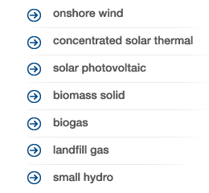
In terms of the REIPPPP, all bidders are required to bid on tariff and identified socio-economic development objectives of the Department of Energy, as well as to comply with rigorous environmental safeguards and have completed an Environmental Impact Assessment (EIA) in line with the applicable laws of the Government of South Africa, specifically the National Environmental Management Act (NEMA).
Components #1, #2 and #4 of this project (three out of the four Components) focus exclusively on support for REIPPPP processes and stakeholders in the context of wind energy. Activities under these components are therefore already subject to the environmental and social assessment mechanisms provided for in the procurement mechanisms and selection processes that are part of the REIPPPP and implemented by the Department of Energy and Department of Environmental Affairs.
Assuming an REIPPPP project triggers the need for Basic Assessment (BA) or an Environmental Impact Assessment (EIA) under the NEMA, included in the assessment process is the preparation of an environmental management plan (EMP). Project-specific measures designed to mitigate negative impacts and enhance positive impacts should be informed by good industry practice and are to be included in the EMP. Should an environmental assessment practitioner be employed, they can prepare the BA, S&EIR, and EMP to applicable standards.
Possible mitigation measures associated with wind energy installations under the REIPPPP include but are not limited to:
- Minimising the project footprint by utilising existing roads and already-disturbed areas as much as practicable;
- Implementing adequate dust, visual disturbance, erosion control, and noise reduction measures such as careful project siting, tarring or spraying water, planting trees, and constructing berms;
- Site developments outside of bird and bat migratory, nesting, and hunting corridors, as well as fog and mist-prone areas;
- Locating developments outside of important habitats for bird species, in particular those species which are threatened or have restricted ranges and are prone to colliding with wind turbines. Also those species which are particularly prone to disturbance;
- Develop and implement a site-specific spill management plan;
- Conduct pre-disturbance environmental and social surveys as appropriate to assess presence of sensitive resources, receptors, habitats and species; bury electrical transmission infrastructure;
- Configure turbines and re-vegetation planning to avoid landscape features particularly attractive to nesting raptors or other species prone to colliding with turbines;
- Minimise development lighting in order to minimise light pollution, disturbance to visible communities, and attraction of insects, birds, and animals at night;
- Schedule activities to avoid operations at night and during breeding seasons; and Install raptor-proof poles or similar measures on appropriate infrastructure to deter nesting, hunting and migrating birds.
The Department of Environmental Affairs has recently published specific EIA Guidelines for Renewable Energy Projects. The Guidelines seek to facilitate project planning, financing, permitting and implementation for both developers and regulators in the renewable energy sector in light of the REIPPPP.
The Guidelines were developed in an attempt to combat the permitting barriers arising from a lack of co-ordination between the various authorities and a lack of clarity on the permitting requirements for renewable energy projects under the first three rounds of the REIPPPP. The Guidelines have been informed by the three rounds of the renewable energy projects that have already (with the exception of round 3) been concluded. The guidelines can be found at:
https://www.environment.gov.za/legislation/guidelines
All of the potential environmental impacts from wind energy projects and the relevant regulatory approvals are covered in the EIA guidelines as noted below:
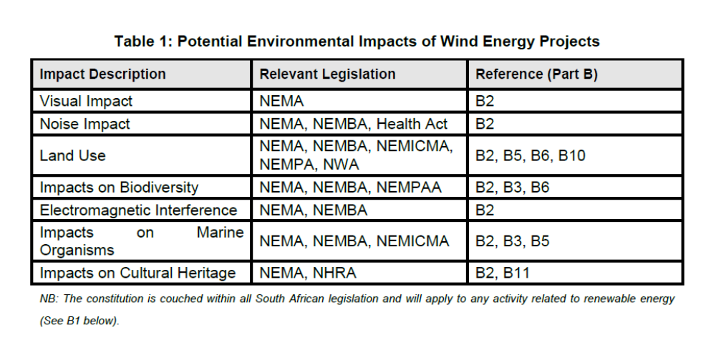
Part B of the guidelines includes a full list of all relevant legislation that applies to the REIPPPPP and hence activities under this project.

As regards socioeconomic standards and assessment, the DTI, through the REIPPPP, has already set local content requirements for renewable energy bids. For the first REIPPPP bidding window, the requirements as per the RFP were set at a 25% threshold for local content for wind. Local content is defined as “a portion of the tender price that is not included in the imported content, provided that local manufacturing takes place and is calculated in accordance with the local content formula [LC =(1-x/y)*100] (SATS 1286:2011)”. Local content is based on share of costs at commissioning (excluding finance and land costs) minus the cost of imported components. In line with the commitments above, the DTI has publicly stated that to ensure optimal localization it is necessary to increase local content requirements gradually with every bid submission window. The requirements for windows 1 to 3 have now been announced as indicated below:

Table 1: Local Content Requirements over REIPP bid submission windows one to three

Source: REIPPP briefing Note 8,
DTI Wind Sector Strategy
These local content requirements are a testament to just how seriously the government is prioritizing social impacts and job creation from the REIPPPP. Taking into account the high unemployment rate in South Africa, the government has prioritized job-creation from the introduction of new industries (e.g. ‘green industries’) and restoration of the country’s industrial base. The UNDP-implemented, GEF-financed project will directly support these government standards by supporting mechanisms that allow for objective, evidence-based assessment and verification of progress in implementing localization initiatives, taking into account any correlations between local content requirements, investment metrics (e.g. generation capacity, financial returns, costs, prices, etc.) and socio-economic development (e.g. employment creation).
The only case where project activities are not covered by existing GoSA social and environmental standards and safeguard processes is Component #3 – Support for the development of the small-scale wind sector. This Component was originally intended to “promote participation in the small RE IPP programme” but it has been re-framed to focus on the development and implementation of a pilot project for small-scale wind energy. This was a result of extensive stakeholder consultations that were undertaken during the PPG phase which revealed the small-scale wind sector still faces substantial barriers that prevent its meaningful representation in the competitive small REIPP programme.
As a result, the revised approach focuses on a targeted assessment of the small-scale wind sector as a way of building the necessary capacity. A key outcome will be the definition of a demonstration project that will be used to assess the practical considerations on which the viability of the small-scale wind sector will likely depend. The key activities will include: 1) a review of the performance of small-scale wind sector in regard to the small RE programme, including consideration of such aspects as complexity, pricing, programme size (MW), grid-connection requirements and arrangements, local content requirements, review of ownership arrangements and community involvement in project life-cycle activities; and 2) establishing a demonstration project for small-scale wind.
From a regulatory perspective, both of these outputs will fall outside the scope of the relevant social and environmental standards and safeguard processes governing the REIPPPP because they are not directly related to the implementation of the small-scale RE IPPPP. However, this issue will be resolved by voluntarily considering and applying all the environmental considerations already mentioned that apply to the REIPPPP to activities under this Component. Moreover the capacity-building activities supported under this Component (on technical, financial, regulatory and socio-economic aspects of small-scale wind projects) will be directly informed by the relevant REIPPPP guidelines and local content criteria established by DTI under the new roadmap for the localization of wind energy components. In this way, the environmental and social safeguards and standards for the other Components will be extended to this Component and all its outputs and activities.

ANNEX A.2: ENVIRONMENTAL AND SOCIAL SCREENING SUMMARY
(to be filled in after Annex A.1 has been completed)

Name of Proposed Project: South African Wind Energy Project – Phase II

A. Environmental and Social Screening Outcome

Select from the following:
Category 1. No further action is needed
Category 2. Further review and management is needed. There are possible environmental and social benefits, impacts, and/or risks associated with the project (or specific project component), but these are predominantly indirect or very long-term and so extremely difficult or impossible to directly identify and assess.
Category 3. Further review and management is needed, and it is possible to identify these with a reasonable degree of certainty. If Category 3, select one or more of the following sub-categories:
Category 3a: Impacts and risks are limited in scale and can be identified with a reasonable degree of certainty and can often be handled through application of standard best practice, but require some minimal or targeted further review and assessment to identify and evaluate whether there is a need for a full environmental and social assessment (in which case the project would move to Category 3b).
Category 3b: Impacts and risks may well be significant, and so full environmental and social assessment is required. In these cases, a scoping exercise will need to be conducted to identify the level and approach of assessment that is most appropriate.

B. Environmental and Social Issues (for projects requiring further environmental and social review and management)

In this section, you should list the key potential environmental and social issues raised by this project. This might include both environmental and social opportunities that could be seized on to strengthen the project, as well as risks that need to be managed. You should use the answers you provided in Table 4.1 as the basis for this summary, as well as any further review and management that is conducted.

Wind is clean, free, indigenous and inexhaustible. Wind turbines do not need any type of fuel, so there are no environmental risks or degradation from the exploration, extraction, transport, shipment, processing or disposal of fuel. Not only is generation produced with zero emissions of carbon dioxide (during the operational phase) but it also does not release toxic pollutants (for example, mercury) or conventional air pollutants (for example, nitrogen dioxide and acid rain-forming sulphur dioxide). Furthermore, the adverse impacts caused by the mining of coal, including acid mine drainage and land subsidence, are avoided (which are major problems in South Africa’s coal-fired power plants), and the negative effects of nuclear power, including radioactive waste disposal, security risks, and nuclear proliferation risks, are not created. Finally, wind power can have a long-term positive impact on biodiversity by reducing the threat of climate change, which is generally accepted as representing the greatest threat to biodiversity.
At the same time, however, the construction and operation of wind turbines may possibly lead to unfavourable local environmental impacts on birds, bats and cetaceans, landscapes, sustainable land use (including protected areas), and the marine environment. In addition to species disturbance and mortality, the issues of habitat loss and fragmentation need to be considered. The negative environmental impacts from wind energy installations are much lower in intensity than those produced by conventional energies, but they still have to be assessed and mitigated when necessary. The National Environmental Management Act (Act 107 of 1998; as amended in 2010 NEMA) defines the environmental impact assessment (EIA) as the procedure that ensures that environmental consequences of projects are identified and assessed before authorisation is given. The main objective is to avoid or minimise negative effects from the beginning of a project rather than trying to counteract them later. Thus, the best environmental policy consists of preventing pollution or nuisances at source so the environment is not damaged.
A full overview of the applicable national regulatory standards, criteria and legislation that apply to the development of wind projects in South Africa (and in turn the activities of this project) are described in Table 1.1. As noted, the Department of Environmental Affairs has recently published EIA Guidelines for Renewable Energy Project (“the Guidelines”) for comment by 8 October 2014. The Guidelines seek to facilitate project planning, financing, permitting and implementation for both developers and regulators in the renewable energy sector in light of the Department of Energy’s Renewable Energy Independent Power Producers Programme (“REIPPP”).
The Guidelines are comprised of 4 parts. Part A reviews the relevant technologies associated with wind, biomass and waste, waves and ocean currents, solar and small-scale hydro projects and cross-references the relevant authorisations, legislation and policies required for each of these technologies listed in Part B. Part B contains a brief summary of the relevant legislation. Part C sets out each of the stakeholders’ roles and responsibilities. Part D sets out the National Environmental Management Act, Environmental Authorisation approval process.
Under the REIPPPP, the National Department of Environmental Affairs (DEA) has been inundated with renewable energy projects seeking environmental approvals. The work load is very heavy and the present authorization system has been found to be sub-optimal. To address these concerns, a Strategic Environmental Assessment (SEA), led by the Department of Environmental Affairs and CSIR, has been initiated. The objective is to identify geographical areas most suitable for the roll-out of wind and solar PV energy projects and the supporting electricity grid network. The process will also provide a platform for coordination between the various Government Departments that have a mandate in terms of issuing environmental authorizations or consents to allow for a more streamlined authorization process. It is intended that, through the SEA process, all participating Departments will be able to pre-assess the requirements for which they have a mandate and be in a position to either issue general authorizations and exemptions or delist energy applications based on adherence with certain conditions or guidelines. In short, then, the aim is to create zones where doing business will be easier and quicker for developers of wind and solar projects. Strategic Infrastructure Projects (SIPs) - of which renewable energy is a part - have been decreed by the President. There is thus political will at the highest level to improve the efficiency of doing business in South Africa.
By mid-2014, the Renewable Energy Development Zones (REDZs) were submitted for Cabinet approval for the roll-out of wind in the Northern Cape, Eastern Cape and Western Cape provinces. The REDZs will allow for wind and solar PV energy projects and the associated grid infrastructure to be developed in these preferred areas without requiring environmental authorization on a case-by-case basis, subject to certain conditions and development protocols.
Based on wind resource potential and taking into consideration environmental and social sensitivities and constraints, the best suited zones for renewable energy development in each of the provinces under investigation will be identified through GIS methods. The latest available data from all relevant departments will be utilized. Specialist inputs will be used where required. Issues that cannot be adequately addressed at a level to allow authorization or delisting by any of the competent departments will be addressed by site-specific protocols. A thorough assessment of the various environmental attributes associated with the sites has been undertaken and spatially mapped through a series of overlays. The attributes that were assessed include the following:
• Topography
• Geology
• Hydrology features
• Geohydrology
• Fauna and flora (including red data species and threatened and protected species)
• Wetlands
• Heritage resources
• Exclusive habitats
• Protected and conservation areas and possible expansion plans for the surrounding area
• Avifaunal activity and migratory paths
• Agricultural potential
• Mineral potential
• Operating mines
• Mining rights
• Land claims
• Ownerless and derelict mines
• Government land
• Land values
• Karoo Central Astronomy Advantage Areas
• Current land use
• Current zoning
• Current infrastructure including roads and rail
• The existing and planned electricity grid connection network including sub-stations
• Aviation routes related to the study area
• Local government integrated development plans
• The location of current wind or solar energy applications in the study area
Some studies at a level required by an EIA are likely to still be required.
The SEA will include a comprehensive stakeholder consultation process aimed at allowing all interested and affected parties to be part of the decision-making process.
The SEA process, including the development of the site-specific guideline document and associated approvals, will be designed to function within the existing legal framework and satisfy all relevant legislation to allow the competent authorities to provide general conditional authorizations for the REDZs. The SEA outcome (REDZs) will be based on a defensible process that will allow the delisting of geographical areas from NEMA listed activities.
SAWEP Phase II will directly support further resource mapping (for wind) and wind corridor development support for policy-makers (SEA and REDZ). Firstly, SAWEP II will support the extension of the Wind Atlas of South Africa (WASA) to sites in the Northern Cape that could not be included in the first phase of the Wind Atlas (WASA I) due to budgetary constraints. Working closely with SANEDI, SAWEP II’s contribution will primarily be in support of the acquisition and installation of wind masts and related equipment, as well as the required modelling, analysis and application of the wind resource data generated. The Wind Atlas for South Africa (WASA) Project started in 2009 as an initiative of the South African Department of Energy (DoE) with the principal funders the South African Wind Energy Programme (SAWEP) Phase I (funded by GEF) and the Royal Danish Embassy, with the South African National Energy Development Institute (SANEDI) as the Executing Partner and implementation partners the South African Council for Scientific and Industrial Research (CSIR), the University of Cape Town (Climate Systems Analysis Group) (UCT CSAG), the South African Weather Service (SAWS) and the Department of Wind Energy, and the Technical University of Denmark (DTU Wind Energy). WASA Phase I activities have already been reviewed and assessed for all social and environmental safeguards and these will continue to apply as part of WASA Phase II.

With support from the UNDP-implemented, GEF-financed project, preliminary WASA II results will then be analysed through the SEA tool for policy-makers to identify wind development corridors in WASA II sites as per DEA criteria.
This will entail:
- Coordination with the DEA and SANEDI on requirements for implementing the SEA process in respect of WASA II sites;
- In conjunction with the DEA, overseeing the initial delineation of Renewable Energy Development Zones (REDZs) on the basis of the new sites;
- Jointly with the DEA and Eskom, overseeing the initial specification of transmission grid corridors around the new sites;
In this way it is envisaged that SAWEP Phase II will ensure that strategic wind corridors/areas (REDZs) are identified and formally approved for all WASA Phase II sites and that there are fully capable policy-makers, regulators and local authorities efficiently dealing with grid connections in all WASA sites. All activities in this regard will be undertaken in full compliance with existing DEA protocols and standards.

With regard to local content requirements and socioeconomic issues, the local content requirements of the REIPPPP (in the context of wind projects) are already described in the project. SAWEP Phase II will build capacity among wind industry government stakeholders to objectively monitor and verify factors related to the success or failure of project sponsors to meet local content requirements and socio-economic development commitments. It will only be involved in supporting capacity to meet social standards already set by government via national legislation and processes; it will not be involved in the actual formulation or decision-making process on the criteria.

C. Next Steps (for projects requiring further environmental and social review and management):

In this section, you should summarize actions that will be taken to deal with the above-listed issues. If your project has Category 2 or 3 components, then appropriate next steps will likely involve further environmental and social review and management, and the outcomes of this work should also be summarized here. Relevant guidance should be obtained from Section 7 for Category 2, and Section 8 for Category 3.

As noted in Table 1.1, the only case where project activities are not covered by existing GoSA social and environmental standards and safeguard processes under the REIPPPP or other related processes is Component #3 – Support for the development of the small-scale wind sector. This Component was originally intended to “promote participation in the small RE IPP programme” but it has been re-framed to focus on the development and implementation of a pilot project for small-scale wind energy. This was a result of extensive stakeholder consultations that were undertaken during the PPG phase which revealed the small-scale wind sector still faced substantial barriers that prevented its meaningful representation in the competitive small REIPPP programme.
As a result, the revised approach focuses on a targeted assessment of the small-scale wind sector as a way of building the necessary capacity. A key outcome will be the definition of a demonstration project that will be used to assess the practical considerations on which the viability of the small-scale wind sector will likely depend. The key activities will include: 1) a review of the performance of small-scale wind sector in regard to the small RE programme, including consideration for such aspects as complexity, pricing, programme size (MW), grid-connection requirements and arrangements, local content requirements, review of ownership arrangements and community involvement in project life-cycle activities; and 2) establishing a demonstration project for small-scale wind.
From a regulatory perspective both of these outputs will fall outside the scope of the relevant social and environmental standards and safeguard processes governing the REIPPPP because they are not directly related to the implementation of the small-scale RE IPPPP. However this issue will be resolved by voluntarily considering and applying all the environmental considerations already mentioned that apply to the REIPPPP to activities under this Component. The development and commissioning of any small-scale wind pilot demonstration plant with GEF funds will be subject to the criteria covered under the Basic Assessment (BA) or an Environmental Impact Assessment (EIA) process under the NEMA, including the preparation of an environmental management plan (EMP). Moreover the capacity-building activities supported under this Component (on technical, financial, regulatory and socio-economic aspects of small-scale wind projects) will be directly informed by the relevant REIPPPP guidelines and local content criteria established by DTI under the new roadmap for the localization of wind energy components. In this way, the environmental and social safeguards and standards for the other Components will be extended to Component 3 and all its outputs and activities so as to ensure full compliance with the relevant regulatory standards already established for the wind sector.

D. Sign Off

Project Manager Date

PAC Date

Programme Manager Date

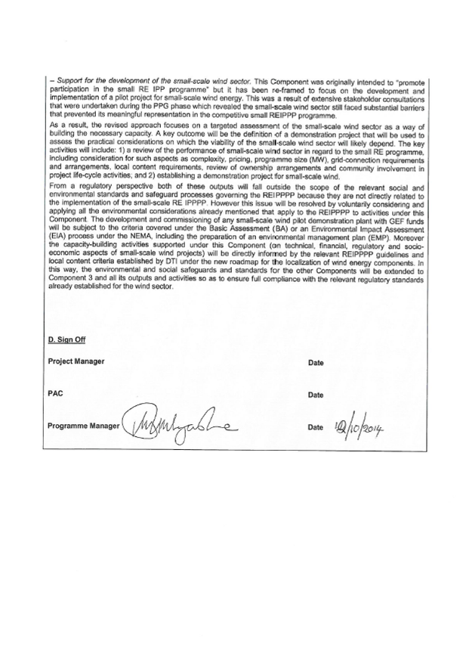

COP17 Fact Sheet: www.eskom.co.za/AboutElectricity/FactsFigures/Documents/Kusile_and_Medupi.
BP Statistical Review of World Energy, June 2013, www.bp.com.
GHG Inventory for South Africa, 2000-2010, Department of Environmental Affairs (DEA).
Ibid.
South Africa’s Renewable Energy IPP Procurement Programme: Success Factors and Lessons, Public-Private Infrastructure Advisory Facility (PPIAF), May 2014.
For each Bidding Window (BW), the first and second dates refer to the bid sumission deadline and financial close date, respectively.
The financial close date for Bidding Window 3 had not been confirmed as at 20 October 2014. What is indicated herein is therefore a projection.
Integrated Resource Plan for Electricity (IRP) 2010-2030, Update Report, November 2013, South African Department of Energy.
Ibid.
Ibid.
South Africa Country Analysis Brief, US Energy Information Administration, www.eia.gov.
The Identification of Suitable Routing Corridors for the Efficient and Effective Expansion of the Electricity Grid Infrastructure (EGI), Department of Environmental Affairs (DEA), South African National Biodiversity (SANBI), Eskom and CSIR, www.egi.csir.co.za.
According to South Africa’s Quarterly Labour Survey for April to June 2014, the unemployment rate in the country is 25.5 percent (Source: http://beta2.statssa.gov.za/?p=2951, accessed 16 October 2014).
Defined as “a portion of the tender price that is not included in the imported content, provided that local manufacturing takes place and is calculated in accordance with the applicable local content formula. It is based on the share of costs at commissioning (excluding finance and land costs) minus cost of imported components.
PMIS 1338: www.wasaproject.info
Waissbein, O., Glemarec, Y., Bayraktar, H. and Schmidt, T. S. (2013), De-Risking Renewable Energy Investment: A Framework to Support Policymakers in Selecting Public Instruments to Promote Renewable Energy Investment in Developing Countries, UNDP: New York.
Further Education Training (FET) colleges have been renamed Technical and Vocational Education and Training (TVET) colleges. Depending on the context, “FET” and “TVET” are used interchangeably.
This is based on a 7-step process: (i) career guidance and management; (ii) general vocational learning; (iii) learner registration and contracting; (iv) occupational learning;(v) work-place learning; (vi) trade testing and recognition of prior learning; (vii) quality assurance and certification.
Members of the HRDCSA include national Government (e.g. DHET, DTI, DST, etc.), organised business (e.g. Business Unity South Africa and Business Leadership South Africa) and labour federations (e.g. COSATU, FEDUSA and NACTU).
As part of this process, the NAD Branch requires an indication of the companies likely to be involved and an indication of the skills or trades of interest and facilitates work-place approvals in order to apply for grants.
These programmes will, where possible, be based on existing trades, such as ‘reinforced plastics and composites trades’ (relevant for turbine blade manufacturing), as well as tool-maker and pattern-maker trades (relevant for castings such as hubs, nacelle base-plates, etc).
PMIS 2692.
PMIS 5237.
PMIS 5704.
Electricity Infrastructure/Industry Transformation, DoE presentation, June 2014, www.energy.gov.za.
PMIS 1338.
Waissbein, O., Glemarec, Y., Bayraktar, H., & Schmidt, T.S., (2013). Derisking Renewable Energy Investment. A Framework to Support Policymakers in Selecting Public Instruments to Promote Renewable Energy Investment in Developing Countries. New York, NY: United Nations Development Programme.
The targets were used in assessing the effect of various energy generation technologies on carbon emissions, as part of developing the Integrated Resource Plan (IRP).
Level 4 forms part of the National Certificate (Vocational), and represents the highest level vocational training offered at TVET colleges. It forms part of a qualifications framework that includes practical experience gained at a workplace or in a simulated environment. Of relevance to SAWEP II will be the curriculum for Electrical Infrastructure Construction, which includes such subjects as Electrical Systems and Construction, as well as Electronic Control and Digital Electronics.
Examples include the electricity prices required to render small-scale wind projects viable (e.g. as compared to small-scale solar PV), as well as the appropriate capacity (MW) to be specified as the maximum threshold for each project.
More than 60% of youths between 15 and 19 years and more than 50% of youths between 20 and 24 years in the Eastern Cape are unemployed.
Selected due to the relative scale of economic development challenges in this region. Consideration will be given to the proximity of the colleges to wind farms, taking into account WASA I and II areas.
This will form part of the Fabrication stream of the National Certificate (Vocational) programme for accreditation purposes, if required.
For example, the National Skills Development Strategy, Skills Accord, National Development Plan, etc.
The demand that was initially assumed in the 2010/11 Integrated Resource Plan (IRP) model has turned out to be an over-estimate, resulting in a review of new generation capacity requirements. Also, with respect to wind the IRP model places a limit of 1,600 MW new capacity per annum, and uses outdated wind resource data. The draft updated IRP document does state that changes to the assumptions pertaining to annual capacity additions and wind resource data will substantially change the allocation for wind energy. SAWEA - the industry association - made submissions regarding these issues when the document was initially published for comment. Whether the proposed changes will be made will depend on policy decisions. However, as the revised document has not yet been adopted as policy, the allocation in the initial version of the IRP (i.e. 9,200 MW) remains in force.
At a maximum capacity of 1.8 MW, the small-scale demonstration project (Component 3) will have insiginficant impacts, compared to activities in Components 1, 2 and 4. Hence this component is not included in the assessment of Global Environmental Benefits (GEBs).
Source: Eskom 2012 Annual Report (http://financialresults.co.za/2012/eskom_ar2012).
According to a DoE presentation, as of June 2014, 40 percent of Bidding Window One projects (i.e. 255 MW of 634 MW), which had reached financial close in November 2012 had attained commercial operations status. This forms the basis for the assumption that 50 percent of the capacity approved in each Bidding Window comes online two years after the financial close date (i.e. based on Bidding Window One, 50 percent of projects will reach commercial operation by November 2014, if 40 percent had become operational by June 2014).
Commercial Operation Date.
Capacity factor of 26 percent is based on REIPPPP wind generating plants that were operational between November 2013 and Septeber 2014. The information was sourced from Eskom’s National Control Centre.
IRP Update Report, Department of Energy, November 2013, page 9.
Section 4.1 (c) of the Women Empowerment and Equality Bill (2013) provides for a target of 50 percent women’s participation in decision-making roles, while section 4.1 (b) of the same Bill provides for training to progressively realise the development of women in support of gender equality. The target of 30 percent is aimed at contributing towards these aims.
Estimated as follows: 1,983 MW of wind to be installed under Windows 1-3 of the REIPPPP. With an average capacity factor of 26%, this implies 4,516 GWh of wind-generated electricity per year. Annual per capita electricity consumption in South Africa (2011) is 4,604 kWh (i.e. 0.004604 GWh). This implies the electricity generated by wind is sufficient to provide the equivalent of 980,990 individuals with their annual electricity needs.
Using a similar estimation methodology: 1,367 GWh to be generated cumulatively by project-supported new wind capacity, implying an annual average of 342 GWh – equivalent to the average annual electricity consumption of 74,230 South Africans.
This will be complemented by a process to determine Desired Emission Reduction Objectives (DEROs), which is expected to be completed by end-2014, as well as the planned update of South Africa’s GHG inventory.
For the benefit of at least DoE, DTI, SAWEA and participating local manufacturers.
Wind Atlas of South Africa.
Includes selected staff members and officials from relevant state-owned agencies and the local government sphere.
This will result in a cumulative total of 9 masts being installed for phase two WASA.
South African Local Government Association and Association of Municipal Electricity Utilities, respectively.
Department of Public Enterprises’s Competitive Supplier Development Programme.
Human Resources Development Council of South Africa.
Should it not be possible to recruit a suitable Project Manager, provision will be made to procure the services of a consultant for this role, on the basis of a professional services contract.
Specific Measurable Achievable (and Attributable) Relevant (and Realistic) Time-bound (Timely, Trackable and or Targeted) – as described in the GEF Monitoring and Evaluation Policy, 2010
This modelling target aligns with the South African Government’s 2030 target of 8.4 GW in wind energy investment, as set out in the 2010 Integrated Resource Plan (IRP).
Source: SAWEA.
Calculated using an exchange rate of USD: ZAR 1:8.5 as of January 2013.
Source: Department of Energy presentation “Window Two Preferred Bidders Announcement, 21 May 2012”.
Budget does not allow SAWEP II support beyond four new sites in the Northern Cape.
Project Coordination Unit.
Includes selected NERSA and local government staff members.
Source: Eskom 2012 Annual Report (http://financialresults.co.za/2012/eskom_ar2012).
According to a DoE presentation, as at June 2014, 40 percent of Bidding Window One projects (i.e. 255 MW of 634 MW), which had reached financial close in November 2012, had attained commercial operations status. This forms the basis for the assumption that 50 percent of the capacity approved in each Bidding Window comes online two years after the financial close date.
Commercial Operation Date.
The capacity factor of 26 percent is based on REIPPPP wind generating plants that were operational between November 2013 and September 2014. The information was sourced from Eskom’s National Control Centre.
A conservative replication factor acknowledges that the Renewable Energy Independent Power Producer Procurement Programme (REIPPPP) will be a major factor in the further development of the grid-connected wind energy sector in South Africa. This limits the extent to which the replication of such developments as capacity-building will be due to SAWEP II only. Because of their nature, some of the activities will not be replicated beyond SAWEP II – examples include wind resource-mapping and localisation M&V.
Manual for Calculating GHG Benefits for GEF Projects: Energy Efficiency and Renewable Energy Projects, GEF/C.33/Inf.18, April 16, 2008.
As developed and defined by the South Africa Bureau of Standards

